Pre-requisites

Before we can get into UE4 Gear VR development we first must make sure that the following prerequisites are fulfilled as if we do not, we run the risk of our Gear VR projects not working with the Gear VR Headset.

* Make sure you have the USB cord used for charging your Samsung Galaxy Note 4 Smartphone available and plugged into a USB port on the PC you are developing on. The USB cord is of vital importance as this is how you transfer data between your development PC and your Smartphone.
* Only certain types of Samsung Galaxy Smartphone's will work with the Gear VR Headset. The Oculus website has a list of phone models that will work with the Gear VR Headset. Make sure to double check that the Samsung Galaxy Note 4 Smartphone you are buying is the correct model that will work with the Gear VR Headset.
* Make sure to download and install the specific USB drivers for your Galaxy Note 4 from the [Samsung Website](http://www.samsung.com/us/support/downloads).
* Download Unreal Engine newest version.
* Install the Tegra Android Development Pack which can be found in Engine\Extras\Android.
* Check to see if Developer Mode has been enabled on your Samsung Galaxy Note 4 Smartphone and if not, enable it.
* Also make sure to check that USB Debugging has been enabled to ensure that you can load data onto your Smartphone from your PC.

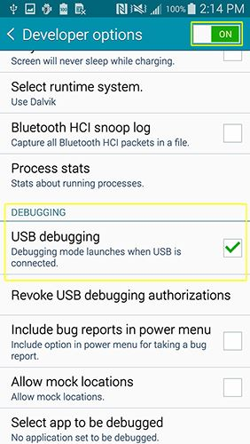

* With your Smartphone plugged into your development PC via USB, make sure to accept the RSA Fingerprint key from your PC. This way your development PC and Smartphone can send data back and forth. Also make sure to check Always allow this computer to ensure that your development PC can always interact with this Smartphone when plugged in.

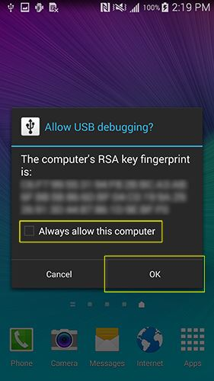

**How to get Device ID**

Locate your device ID. Note that this is not your phone’s serial number. To retrieve your phone’s device ID, connect to your device via USB, open an OS shell or command window, and enter:

|  |
| --- |
| adb devices |

You should see a list of attached devices like this:

|  |
| --- |
| List of devices attached  ce0551e7 device |

In this example the Device ID is ce0551e7.

Generate and download the OSIG File for your Samsung Smartphone using your Smartphone's Device ID and the [Oculus](https://developer.oculus.com/tools/osig/) website. If you are not sure how to get your Smartphone's Device ID the [Oculus website](https://developer.oculus.com/tools/osig/) has detailed directions on how to do this.

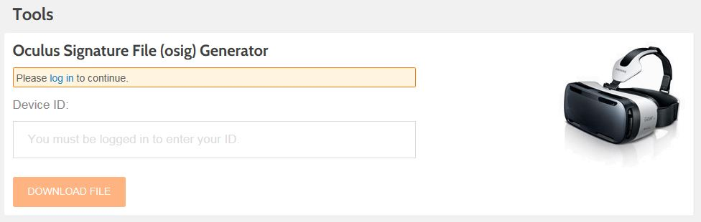

* After you download the OSIG file, create a folder called assets and place the OSIG file inside of it. Then place that folder in Engine/Build/Android/Java.  If you do not do this your project will not be able to run on your Galaxy Smartphone.

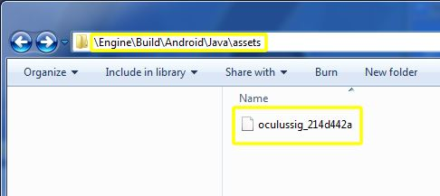

It is very important that you make sure all items listed in the Gear VR Prerequisites section are completed before moving on to the next section. Skipping a step could result in your project not working with the Gear VR Headset.

**Gear VR Project Creation**

In the following section we will go over everything you need to know in order to create a new project that will work with the Gear VR headset.

* First make sure that you have UE4 version 4.7.4 or later downloaded and installed on your development PC. You can get UE4 version 4.7.4 or later from the Unreal Engine Launcher

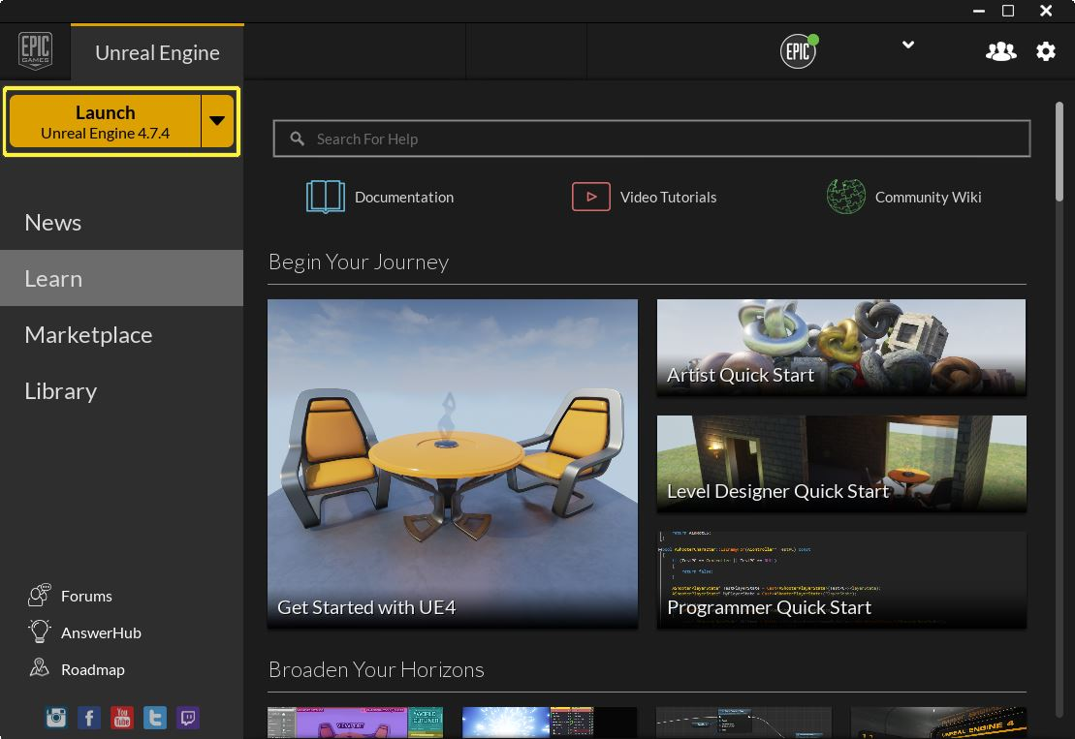

* Once you have a version of UE4 4.7.4 or later installed on your development PC create a new C++ Project from the New Project Tab.

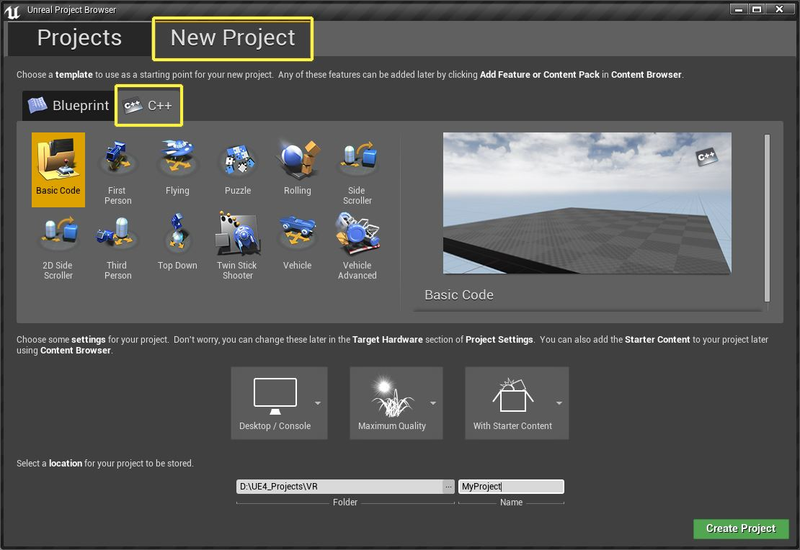

* Next select the First Person Template as the template to be used and make sure to change the following options.
  1. Mobile / Tablet
  2. Scalable 3D / 2D
  3. Also make sure to not include the Starter Content to help reduce project size.

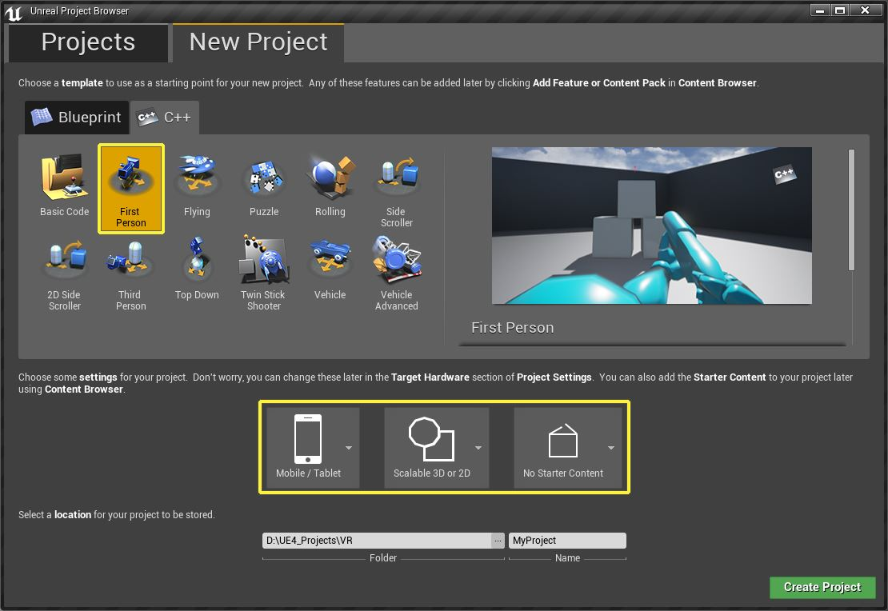

* Finally give the project a location to be saved to and a name. The name for this example the project name will be GearVR QS. Once everything has been completed press the green Create Project button to create the project

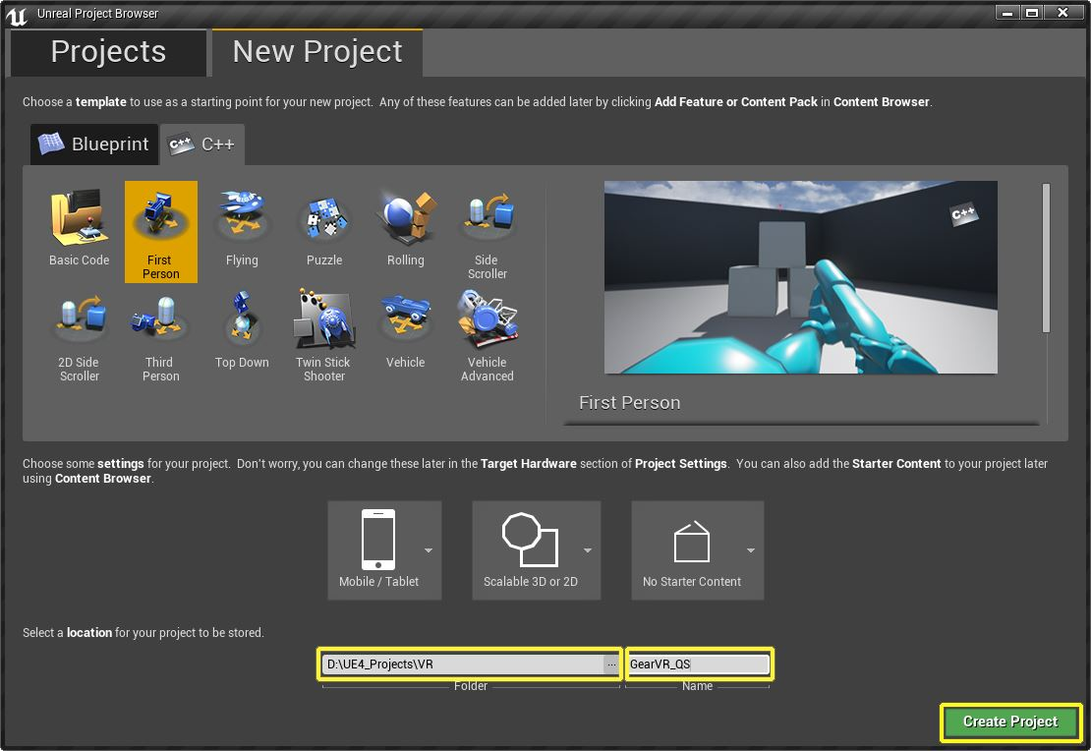

**Gear VR Project Setup**

* Once the project has finished being created and compiled, Visual Studio 2013 will automatically open (If already installed) along with the editor.

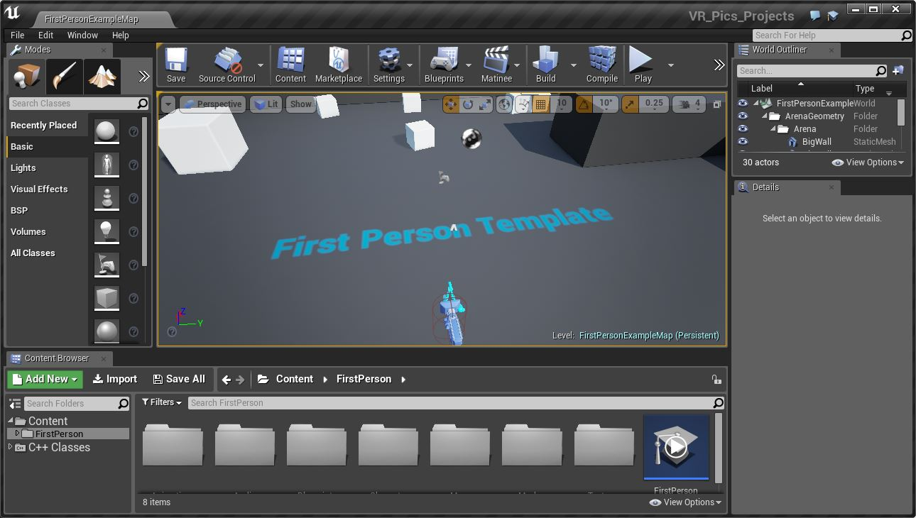

* Once the UE4 Editor has loaded, from the **Main Toolbar**, open the **Windows** tab and select the **Plugins** menu item.
* From the Plug-In menu go to the **Head Mounted Displays** section and **disable** the **Oculus** option and **enable** the **Gear VR** option. Then click the **Restart Now** button to re-start the editor so the changes can take place.

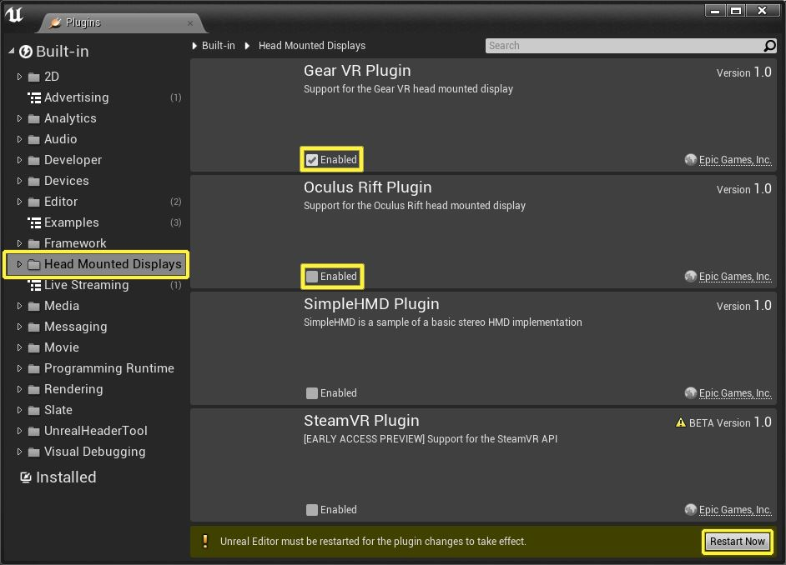

* Once the Editor has re-started, select **Edit** from the **Main Toolbar** and then select **Project Settings** and click the **Configure Now**button for Android support in the **APKPacking** section.
* Next change the **Minimum SDK Version** from **9** to **19**.

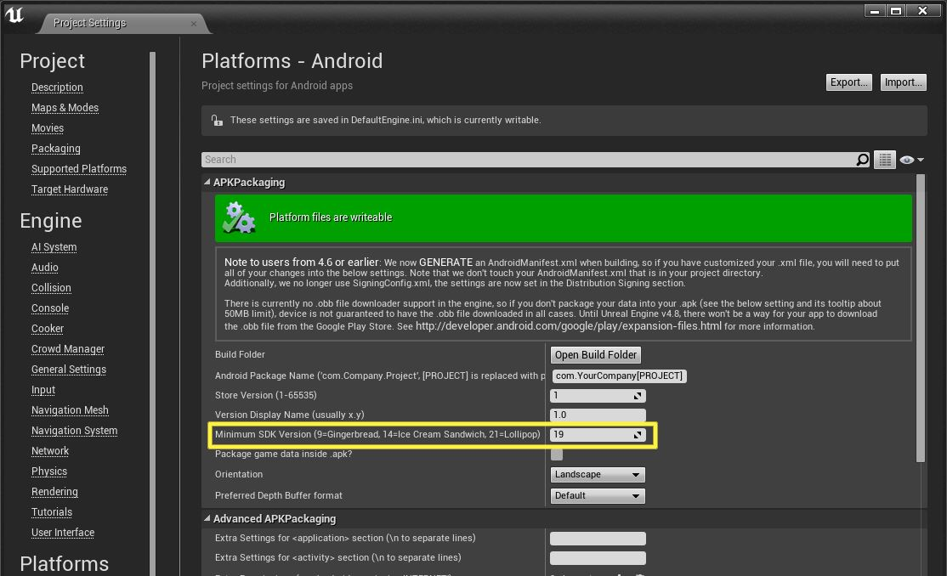

* Next scroll down till you see the **Configure the Android Manifest for deployment to Gear VR** checkbox and enable it.

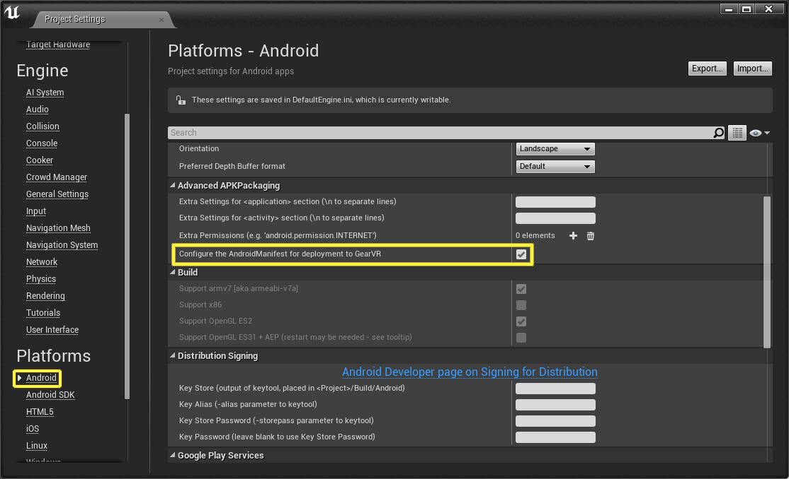

* Next, under the **Android SDK** section fill, in the location of the required Android SDK files on your development PC. You can find the needed folders in the location where you installed the Tegra files.

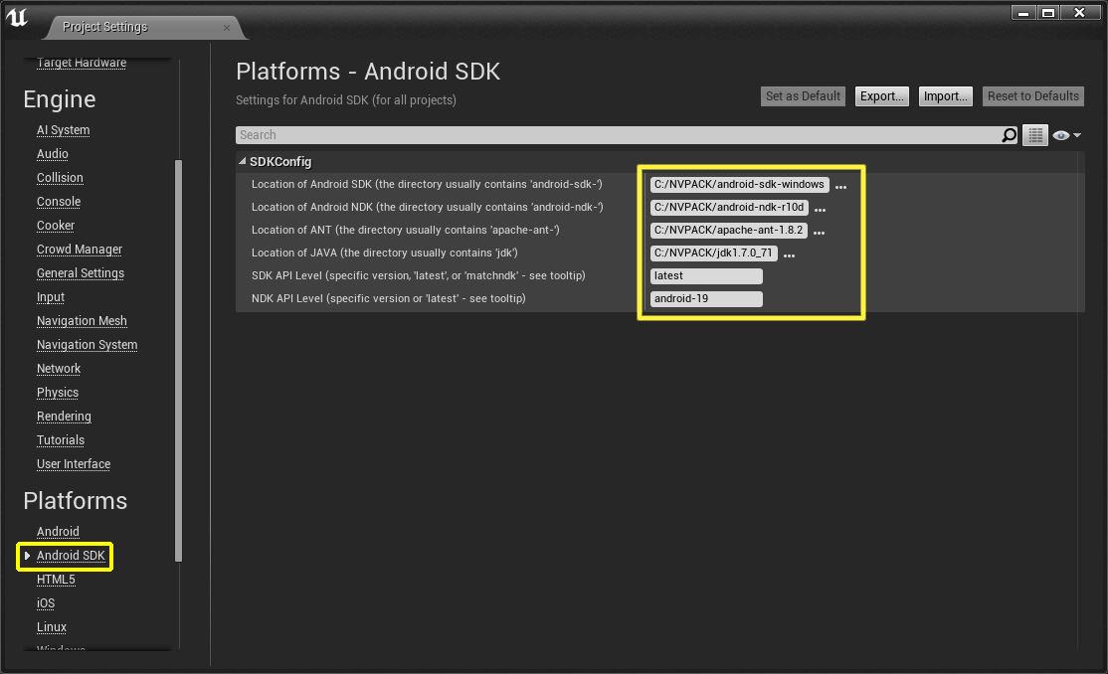

* Finally under **File** > **Package Project** > **Packing Settings** un-check **Full Rebuild** to help speed up iteration times.

# Gear VR Project Packaging & Deployment

* First make sure that your Samsung Galaxy Note 4 Smartphone is connected to a USB cord and plugged into a USB port on the PC you are developing on.

* Next start the packaging process by going to the **Main Toolbar** and selecting **File** > **Package Project** > **Android** > **Android ETC 2**.

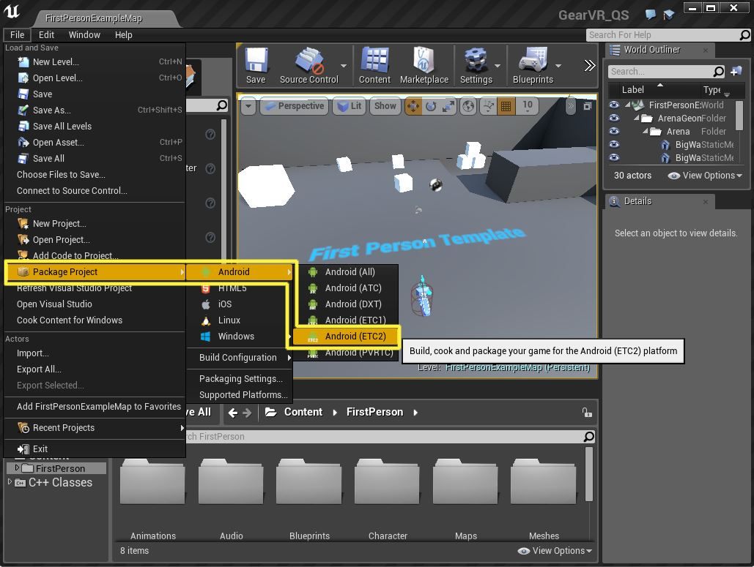

* Once you click on the **Android ETC 2** option, a Windows dialogue box will be displayed. From this dialogue box, select or create a folder to save your packaged project to and then press the **OK** button to begin the packaging process.

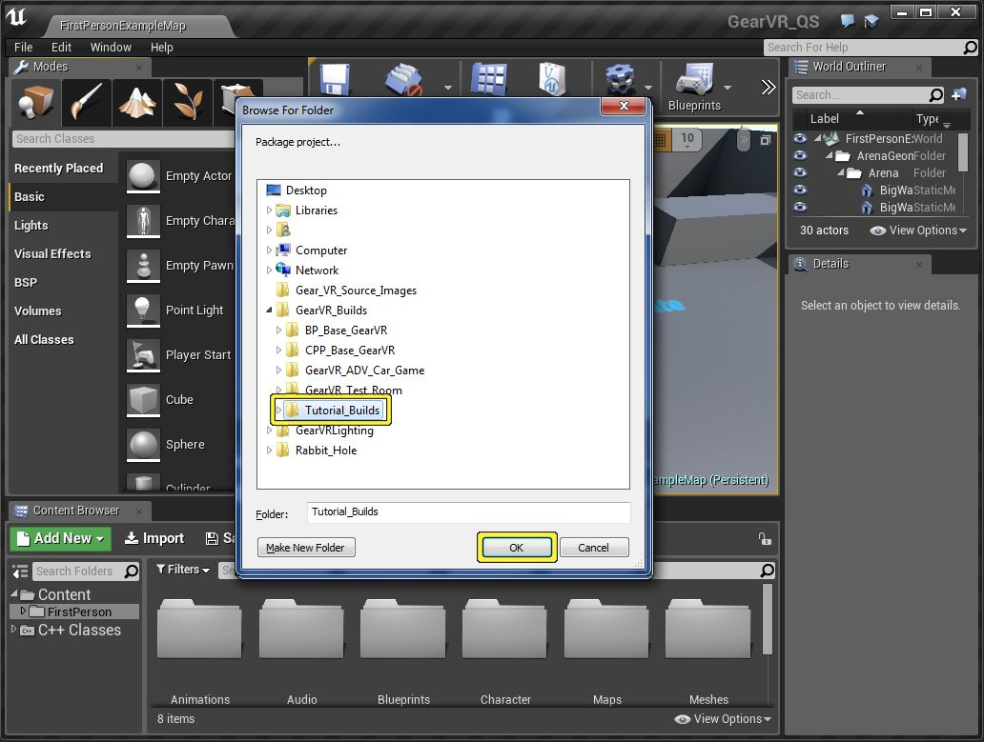

* Depending on the size of your project, the packaging process could take a few minutes or a few hours to complete. When it is completed the folder that you selected/created to save the build to should now have three files in it and should look similar to the image below.

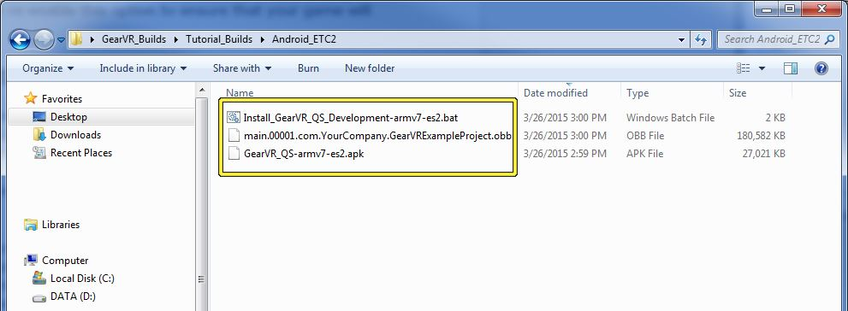

* Next, run the .bat file which is located in the folder that the build was packaged to by **Double-clicking** on it with your **Left Mouse Button**. Once you run the .bat file, a command line window will be displayed that shows the current progress of the deployment to your Smartphone. When your project has been successfully deployed to your Smartphone, the command line window will shut itself down.

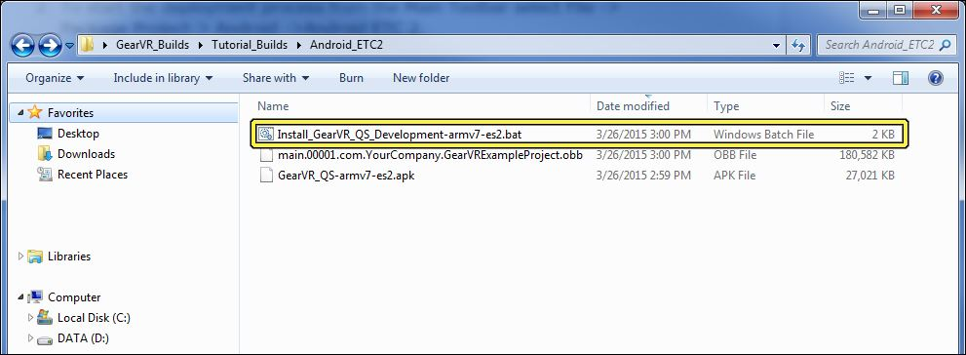

* Once you run the .bat file, a command line window will be displayed that will show you the deployment progress as well as any errors that may have occurred.

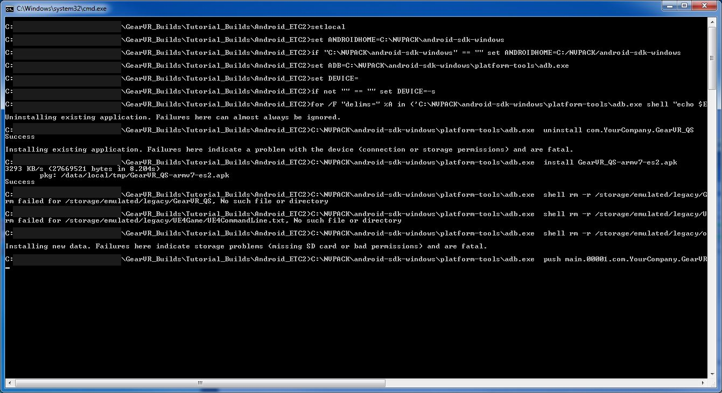

* Finally, after the command line window has closed, check your Smartphone for your newly created application which should use the same name used for your UE4 C++ project that it was created from. Launch the application and then place your Smartphone into the Gear VR Headset.

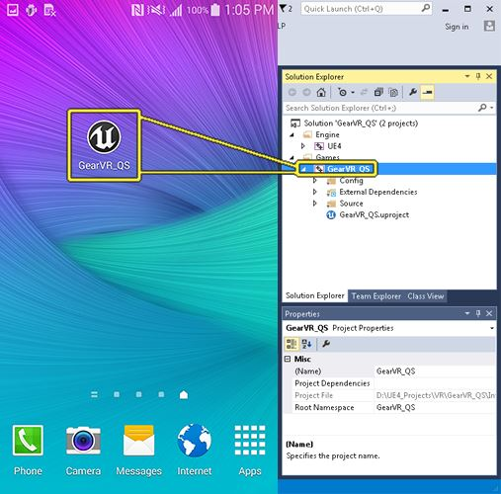

# Samsung Gear VR Debugging

### Enabling Gear VR Developer Mode

* First on your Samsung Galaxy Note 4 Smartphone go to **Settings** > **Application Manager** > **Gear VR Service**.

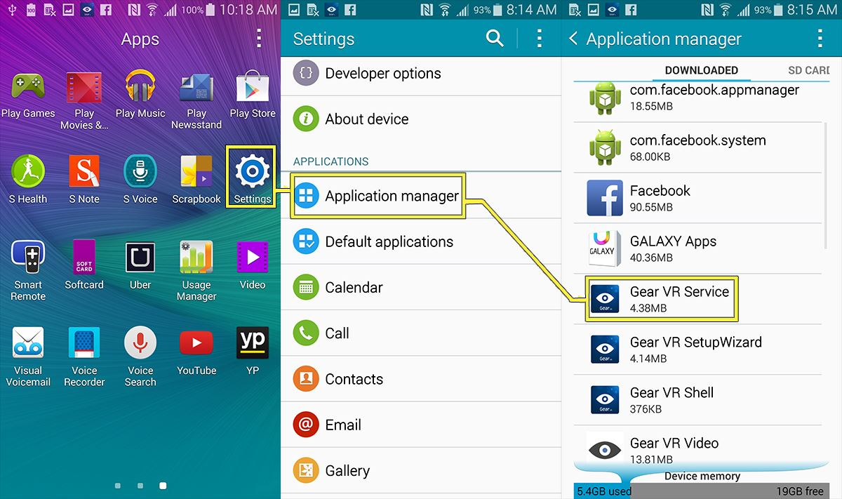

* Next tap on the **Manage Storage** option.

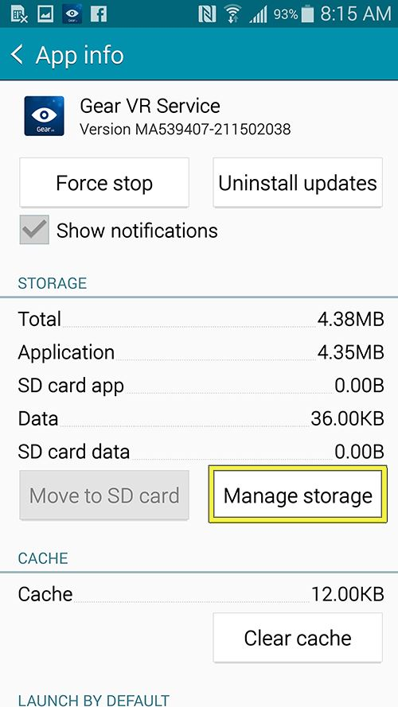

* Then tap on the **VR Service Version** **6** times.

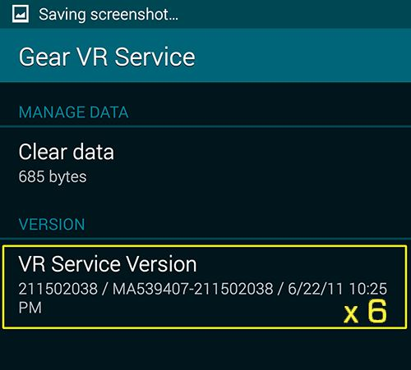

* You should now see a scan process happen and when completed you should see the **Developer Mode** toggle on the screen.

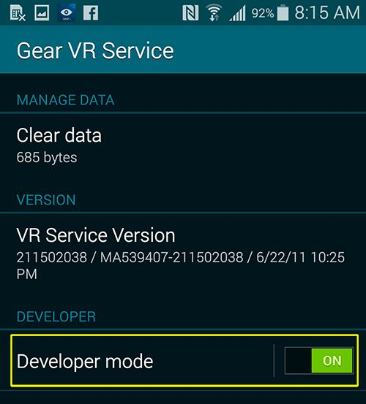

* Now you should be able to launch your Gear VR Project and have it display without having to use the Gear VR Headset.
* If for any reason you need to disable VR Developer mode just slide the **Developer Mode** slider from **On** to **Off** and VR Developer mode will be disabled.

### Enabling the UE4 Console

* First make sure that you have enabled Gear VR Developer mode on your phone. This way you can launch your project and see it without having to use the Gear VR Headset which, if used, would prevent you from being able to touch your phone's screen.



* Next launch your Gear VR project by tapping on the projects icon to launch it. When the project has been launched, you should see something looking like this on your phone.

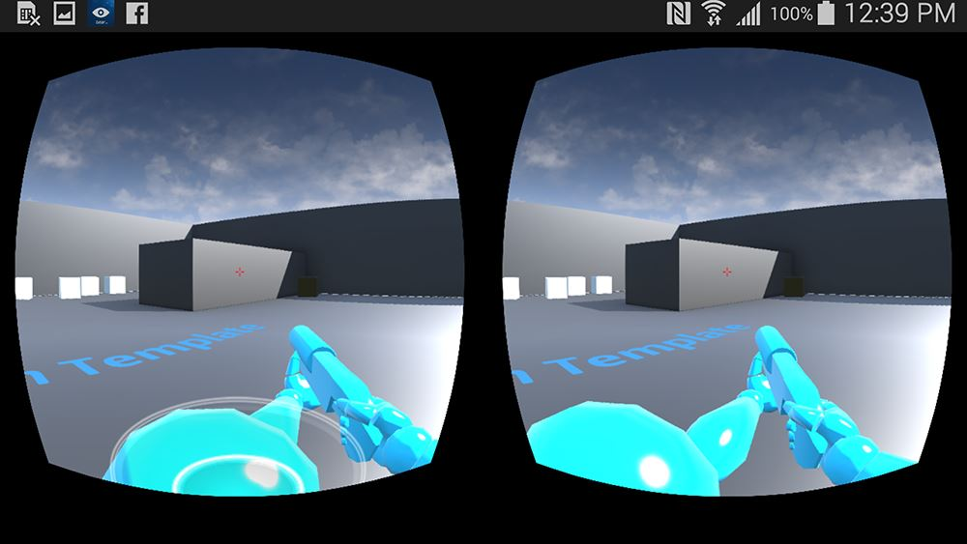

# Using Joystick with Gear VR

* Turn on controller

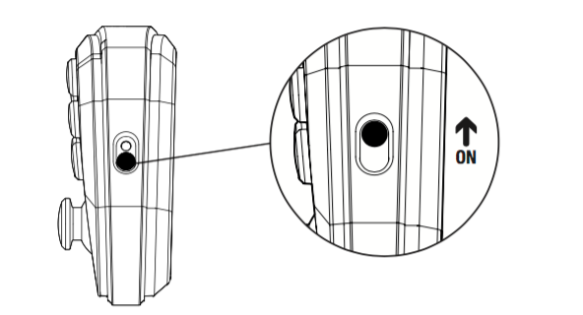

* All four LEDs will ash ON and OFF evenly when the Controller is not paired.
* To pair the Controller, go to your iOS device and follow the User Interface flow below: **Settings > Turn On Bluetooth > Search for new Devices  
  “SteelSeries Stratus”** will display on the screen. Click to Connect via Bluetooth
* If the Controller has paired successfully, the LEDs will ash ON and OFF unevenly (rapidly).
* If the Controller is paired and the user starts a game, one of the four LEDs will light up solid, depending on the player number (1-4) assigned.