Xenomai 3 Installation

Step 1 : Install Ubuntu 18.04 (20.04 also can be enough)

Step 2 : Search your computer for the ‘Software Updater’ and make sure that everything is up to date.

Step 3 : Open new terminal and run the command.
$sudo apt-get install devscripts debhelper dh-kpatches findutils kernel-package libncurses5-dev fakeroot zlib1g-dev dwarves flex bison libssl-dev

Step 4 : Open the ‘Ubuntu Software Center’ to install ‘Synaptic Package Manager’ then run the ‘Synaptic Package Manager’ to check off packages listed below. Then click ‘ Apply’
- libpopt-dev
- libglu1-mesa-dev
- libglade2-dev
- libelf-dev
You can easily find a specific library or package in ‘search’ and check off the box for the library or package as shown in Fig.
Step 5 : Download files listed below.
Linux kernel : linux 5.4.124 => www.kernel.org/pub/linux/kernel/v5.x/
Xenomai : xenomai 3.2.1 => https://source.denx.de/Xenomai/xenomai/-/tree/master
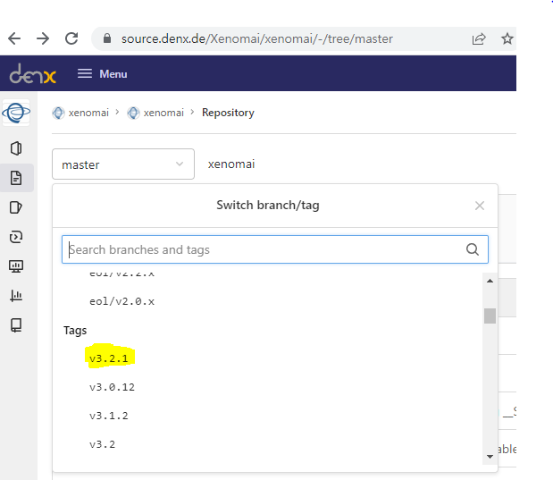
Ipipe patch : ipipe-5.4.124-x86-5 => xenomai.org/downloads/ipipe/v5.x
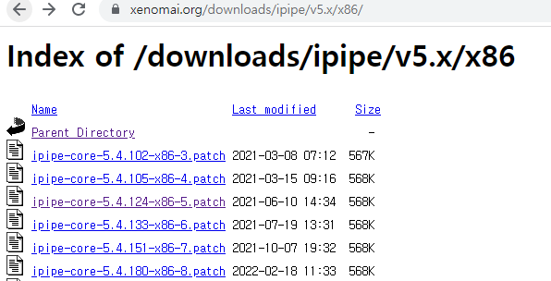

Step 6 : In a terminal,
$sudo nautilus
Then, move all files downloaded at step 5 to /usr/src/ to extract them.

Step 7 : Modify superuser password and get superuser permission
In a terminal run the command.
$sudo passwd root
Set the password as ‘control’, Then
$su

Step 8 : Apply xenomai patch to linux kernel.
In the terminal,
$cd /usr/src/xenomai-v3.2.1
Then,
$./scripts/prepare-kernel.sh --linux=/usr/src/linux-5.4.124 --ipipe=/usr/src/ipipe-5.4.124-x86-5.patch --arch=x86_64
Step 9 : Make configure file to build linux kernel
Move to ‘linux source directory’. Then,
$make gconfig
Then, Set the kernel option like this.
* General setup
--> Local version - append to kernel release : -xenomai-3.2.1
--> Timers subsystem
--> High Resolution Timer Support (Enable)

* Xenomai/cobalt
--> Sizes and static limits
--> Number of registry slots (512 --> 4096)
--> Size of system heap (Kb) (4096 --> 4096)
--> Size of private heap (Kb) (256 --> 256)
--> Size of shared heap (Kb) (256 --> 256)
--> Maximum number of POSIX timers per process (256 --> 512)
--> Drivers
--> RTnet
--> RTnet, TCP/IP socket interface (Enable)
--> Drivers
--> New intel(R) PRO/1000 PCIe (Enable)
--> Realtek 8169 (Enable)
--> Loopback (Enable)
--> Add-Ons
--> Real-Time Capturing Support (Enable)
​

* Process type and features
--> Transparent Hugepage Support (Disable)
--> Allow for memory compaction (Disable)
--> Contiguous Memory Allocator (Disable)
--> Allow for memory compaction
--> page migration (Disable)
--> Multi-core scheduler support (Disable)

* Device Drivers
--> Microsoft hyper-v guest support
--> Microsoft hyper-v client deivers (disable)
--> Staging drivers
--> Unisys SPAR driver support
--> Unisys visorbus driver (disable)
-->I2c Support
--> I2c Hardware Bus support
-->PC Speaker support (disable)
​
* Power management and ACPI options
--> CPU Frequency scaling
--> CPU Frequency scaling (Disable)
--> ACPI (Advanced Configuration and Power Interface) Support
--> processor (Disable)
--> CPU Idle
--> CPU idle PM support (Disable)
Then, save it.
You can easily find the options using ‘Ctrl + F’ and you can use wheel scroll to select next searching things.

Step 10 : Remove System trusted keys
In the terminal, type this command to open .config file
$gedit .config
Then, change
CONFIG_SYSTEM_TRUSTED_KEYS="debian/canonical-certs.pem"
to
CONFIG_SYSTEM_TRUSTED_KEYS=""
Then, save it.
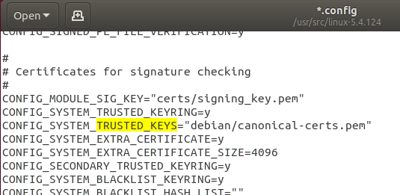-> 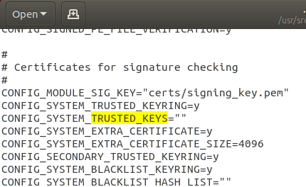

Step 11 : build kernel image
In the terminal,
$make bzImage modules -j4
$make modules_install
$make install

Step 12 : Allow non-root users
$sudo addgroup xenomai --gid 1234
$sudo addgroup root xenomai
$sudo usermod -a -G xenomai $USER

Step 13 : Configure GRUB and reboot
$sudo gedit /etc/default/grub
Then edit the grub config :
GRUB_DEFAULT="Advanced options for Ubuntu>Ubuntu, with Linux 5.4.124-xenomai-3.2.1"
#GRUB_DEFAULT=saved
#GRUB_SAVEDEFAULT=true
# Comment the following lines
#GRUB_HIDDEN_TIMEOUT=0
#GRUB_HIDDEN_TIMEOUT_QUIET=true
GRUB_TIMEOUT=5
GRUB_CMDLINE_LINUX_DEFAULT="quiet splash xenomai.allowed_group=1234"
GRUB_CMDLINE_LINUX=""

$sudo update-grub
$sudo reboot

Step 14 : Make sure that you are running the cobalt kernel :
In the terminal
$uname -a
# Should return Linux 5.4.124-xenomai-3.2.1 #1 SMP Wed Sep 20 16:00:12 CEST 2017 x86_64 x86_64 x86_64 GNU/Linux
$dmesg | grep Xenomai
# [ 1.417024] [Xenomai] scheduling class idle registered.
# [ 1.417025] [Xenomai] scheduling class rt registered.
# [ 1.417088] I-pipe: head domain Xenomai registered.
# [ 1.417704] [Xenomai] allowing access to group 1234
# [ 1.417726] [Xenomai] Cobalt v3.2.1
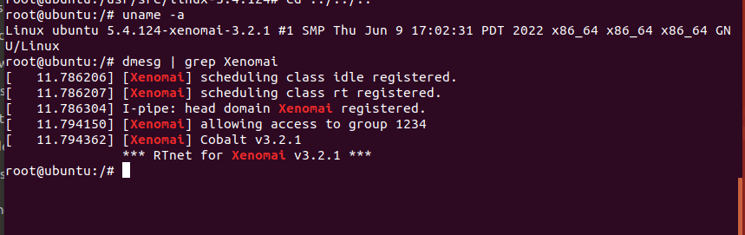

Step 15 : build Xenomai Library
Go to Xenomai directory
$cd /usr/src/xenomai-3.2.1
Then,
$./script/bootstrap
$./configure --with-core=cobalt --enable-smp --enable--pshared --includedir=/usr/include/xenomai --libdir=/usr/lib
$make install
$sudo chmod 77 /dev/rtdm/*
$reboot

- Install xenomai kernel and xenomai library complete.

PODO setup

Step 1 : PCAN driver installation
Go to this link,
http://www.peak-system.com/fileadmin/media/linux/index.htm
Download PCAN Driver Package and extract it.

Step 2 :
$make clean
$make NET=NO_NETDEV_SUPPORT
$sudo make install
$sudo modprobe pcan
You can use “lsmod” command to check pcan installed.
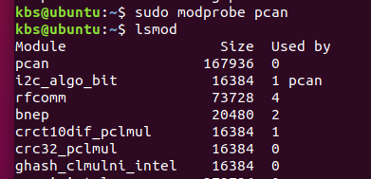

Step 3 : Qt installation
Ubuntu 18.04 can not support Qt creator version upper than 5
- Install Qt version 5.12.x
Download link : https://download.qt.io/archive/qt/5.12/5.12.12/
Download qt-opensource-linux-x64-5.12.12.run and running this file to install Qt and Qt creator

Step 4 : Modify xenomai3 debug.h

There is some error caused by xenomai debug.h
So you can modify /usr/include/xenomai/copperplate/debug.h like this.
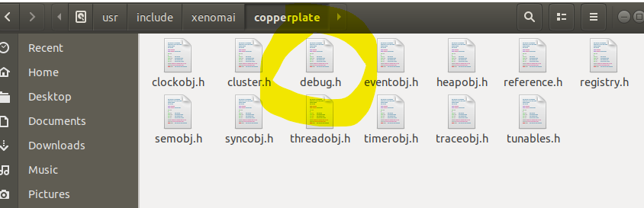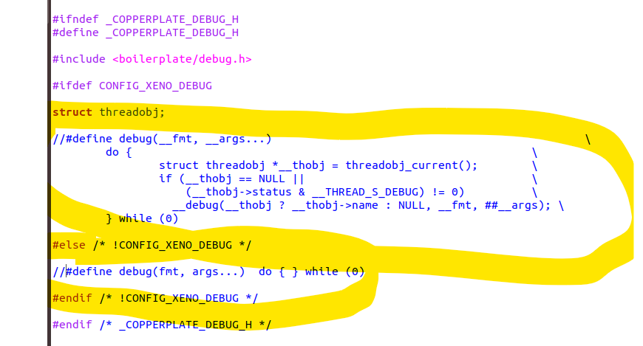

Step 5 : Install spdlog
In PODO_VR use spdlog library to log message.
Move to Download folder or Desktop folder or whatever you want.
Download spdlog and build it.
$ git clone https://github.com/gabime/spdlog.git
$ cd spdlog && mkdir build && cd build
$ cmake .. && make -j

You have to move spdlog’s include folder to /usr/include and dynamic library file to /usr/lib
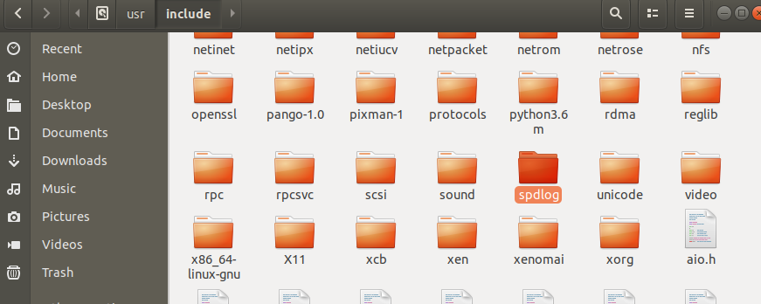
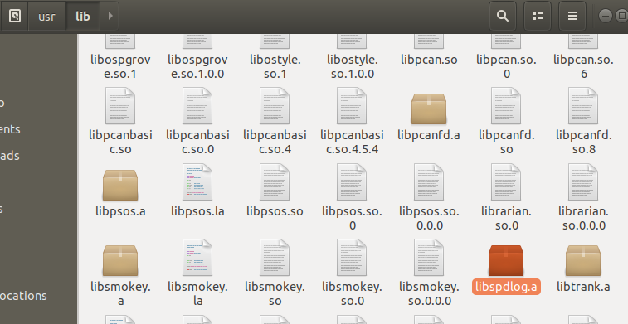

Step 6 : Setup PODO build environment.
Once you have your personal copy open qt. Once in qt go to File→Session Manager. Once inside Session Manager create a new session, name it what ever you want. Then double click it inside the Session Manager to edit the session.
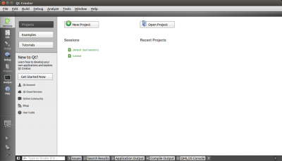 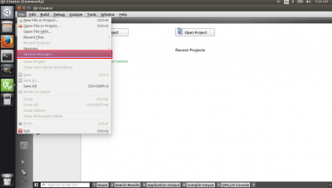 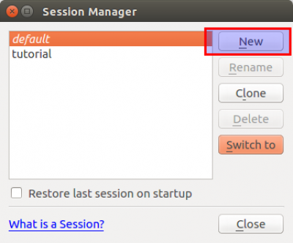 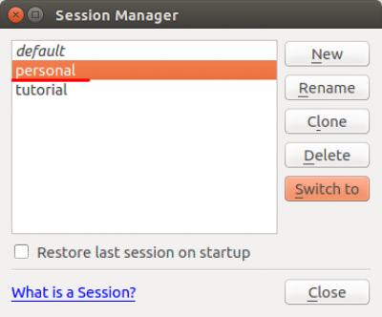 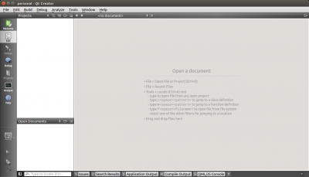
Now go to File→Open File or Project. Find your personal copy and go to [your personal copy]→podp_nrl→src→ALPrograms. Once in find the .pro file and open it. If a pop up comes up click yes and then configure project in the next screen.
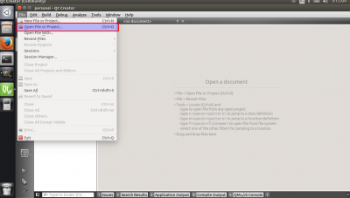 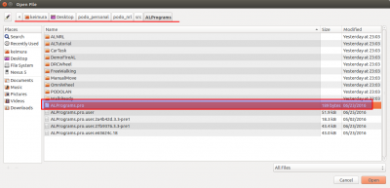 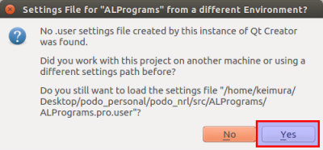 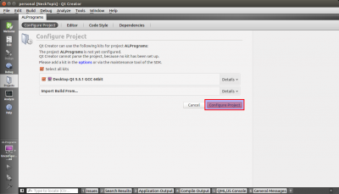
Do this for Daemon, PODOGUI, and PODOLauncher as well.
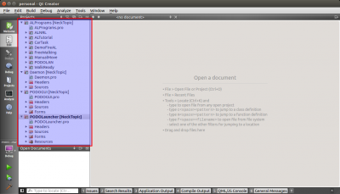
Once you have all of the projects open in your session go to the projects tab and change the build directory path. Click on the browse button in General and find your folder→podo_nrl→build. Then find the appropriate folder for the project (ex for ALPrograms go into ALBuild) and click open.
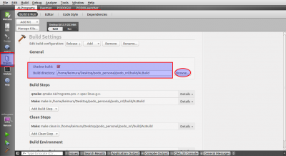 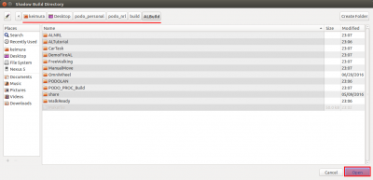
Note: If you don't have the build folder in your file run the build.sh file inside your podo file from a terminal:
sudo chmod +x build.sh
./build.sh
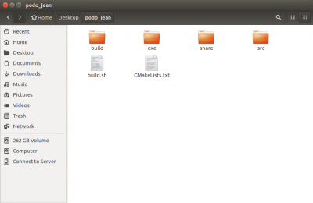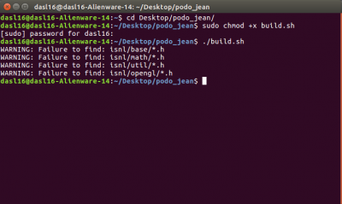
Make sure that both Release and Debug have the same path. Repeat this for all the other projects, making sure that both Release and Debug have the same build directory. As shown in the second picture you may see a warning, you can ignore it.
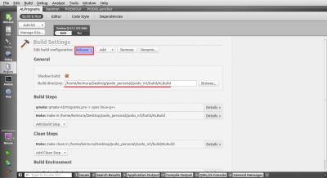 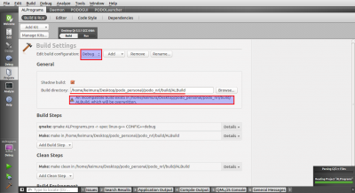
In the bottom left-hand corner of the QT window there is a computer icon, click it and make sure that all the projects are in release mode instead of Debug mode.
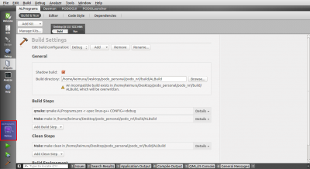 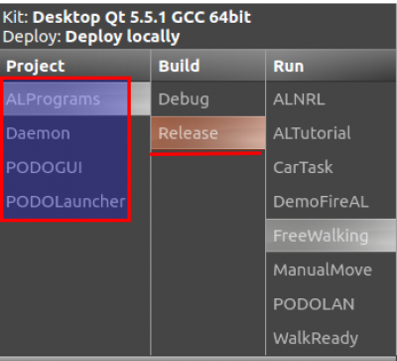
Step 7 : Modify AL program make file(.pro file)
You have to add “-lmodechk” to “QMAKE_LFLAGS” and “LIBS” every AL program’s pro file and Demon.pro file.

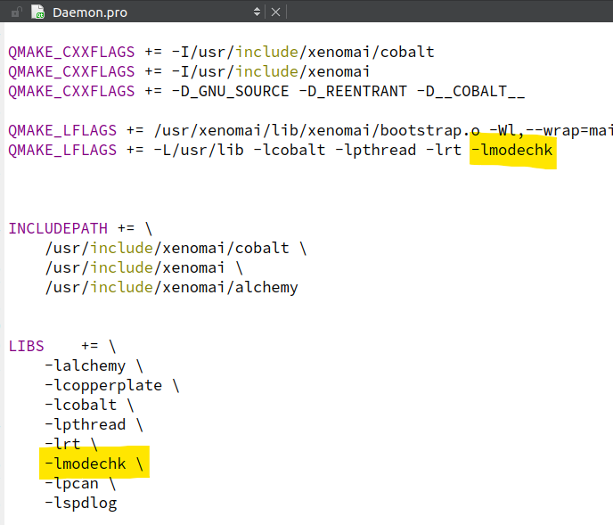
Once you have all of them in your session go to Build→Rebuild All.
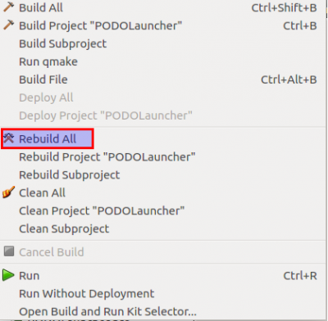
Note: If you get an error about being unable to locate -lrbmodel just add the RBModel project and rebuild it byitself before rebuilding the others. This will create the rbmodel library the code is looking for. Don't forget to change the build location like the other projects for RBModel.
Now right click PODOLauncher in qt and run it.
