**Hands-on Lab:**

**LabVIEW – PID**

In previous labs, the step response and the PID simulation of the LEGO DCP were performed. The former provides a Labview framework to use the gains discovered from latter to achieved PID closed-loop control.

**Concept 1:** Experimental PID control

**Step 1:** Create Front Panel and Initial Block Diagram

From your System Identification lab open the file nxtLabviewLegoDcpSystemId1_0.vi. Save this program as nxtLabviewLegoDcpPid1_0.vi. This program provided the framework to acquire, graphically display, and save to file the DCP’s angle. This program also allowed one to command the motor-prop. Since Step Input is no longer needed, eliminate the toggle switch. Add numeric controls to the Front Panel. These controls will allow one to set PID gains, the desired angle. Also, add a numeric indicator to display the power going into the motor-prop (**Figure 1-1A left**).

For the Block Diagram, delete the Case Structure that was associated with the toggle switch (but keep the NXT motor Block). Blocks will be added, so re-arrange the Block Diagram to provide suitable space (**Figure 1-1A right**).

**Figure 1-1A**: Red ellipses show the numeric controls and indicators added to the Front Panel (left). Red arrow gathers these blocks, to be used in next steps. NB: wires and blocks were slightly re-arranged, and the loop box was widened in anticipation of the need to accommodate more blocks.

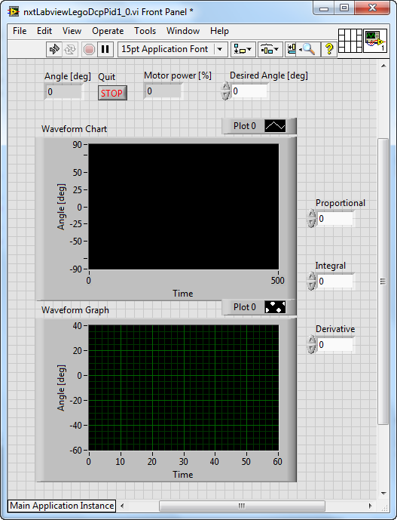

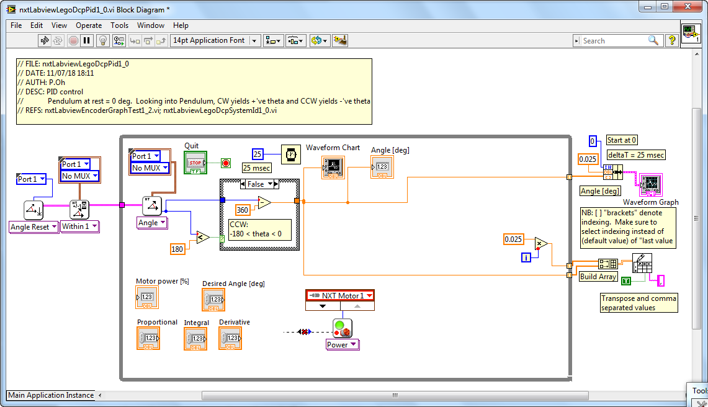

**Step 2:** Create the error signal and proportional control

PID control works on the error signal. The error is the difference between the desired and actual angle (in degrees). The proportional component of PID control scales this error. As such, add Subtraction and Multiplication blocks (**Figure 1-2A**).

**Figure 1-2A:** The Subtraction block (left Red Arrow) forms the error. The Multiplication block (right Red Arrow) proportionally scales this error.

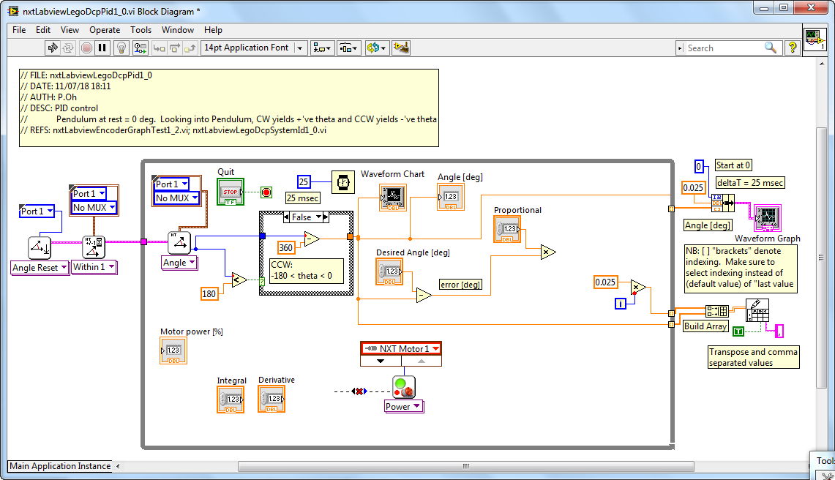

**Step 3:** Differentiate the error and derivative control

The derivative component of PID control scales the rate change of error. Mathematically, this is $\frac{∆e[k]}{T}=\frac{e\left[k\right]-e\left[k-1\right]}{T}$ for discrete-time systems where $T$ is the sample time is, $e\left[k\right]$ is the current error and $e\left[k-1\right]$ is the previous error. In Labview, shift registers were used to store the previous value in a loop. As such, add a shift register (**Figure 1-3A**) for the error signal.

**Figure 1-3A:** Red circle shows the resulting shift register that was added

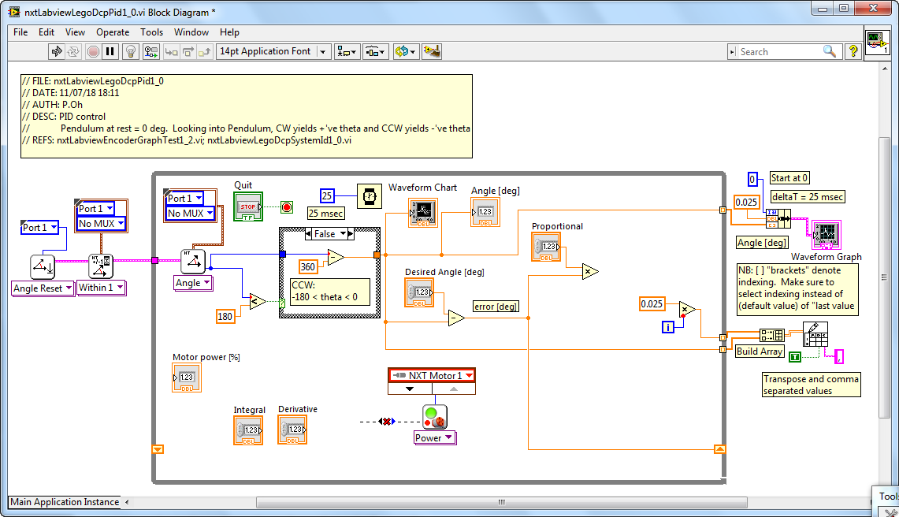

In the Block Diagram, the loop uses a 25 millisecond Wait block. Thus, for this program $T=0.025 \text{seconds}$. Add a Division block to perform the differentiation (**Figure 1-3B**). Lastly, add a Multiplication block; it multiplies the error derivative with a derivative gain value.

**Figure 1-3B:** Red arrow indicates Division and Multiplication blocks used to respectively differentiate and scale it.

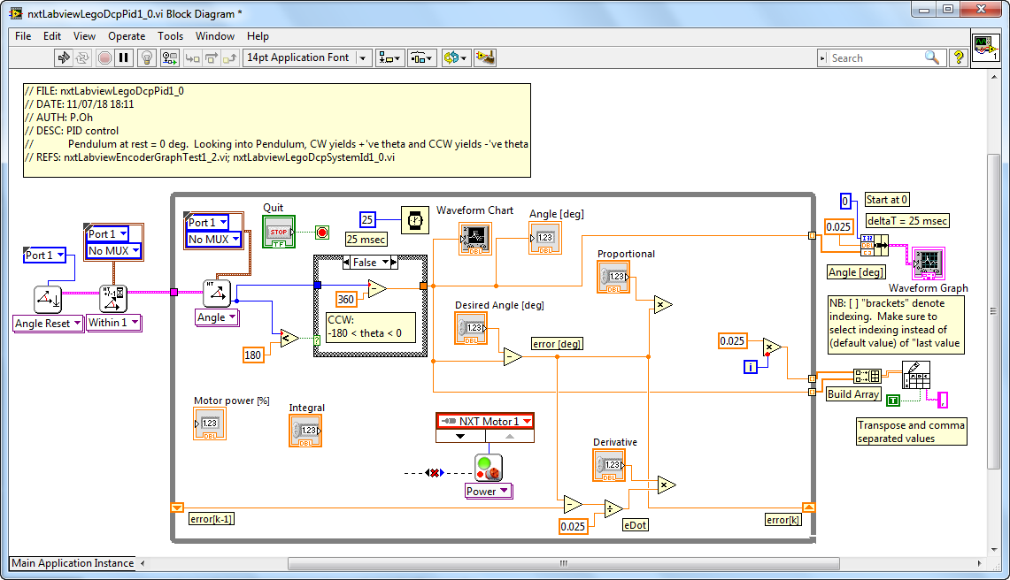

**Step 4:** Integrate the error and Integration control

The integration component of PID control, integrates the error. Mathematically, this is $\sum{e\left[k\right]=e\left[k\right]T+e\left[k-1\right]}$ for discrete-time systems. Thus, add a Multiplication block to take the product of the current error $e[k]$ and sample time $T=0.025$ seconds (**Figure 1-4A**).

**Figure 1-4A:** Red arrow points to the Multiplication block which multiplies the current error with sampling time

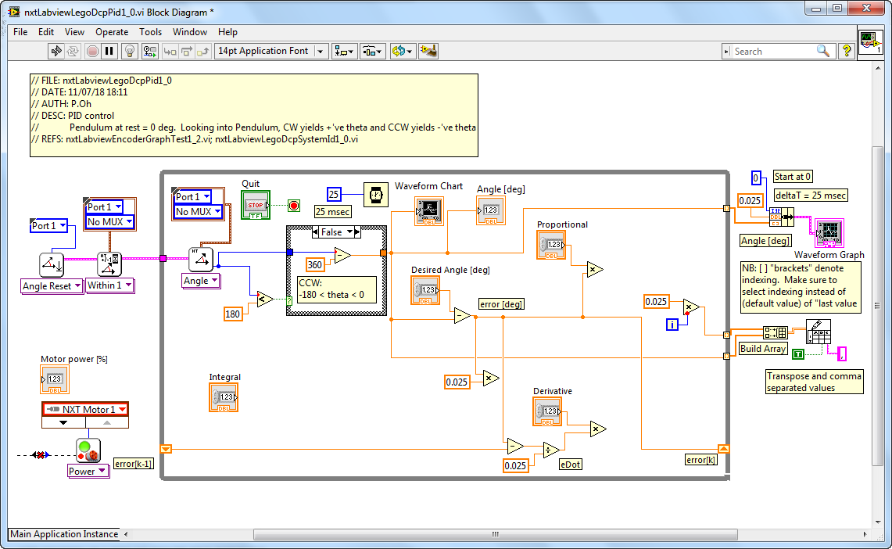

Drag an Addition block into the loop. Feed one input of the Addition block with the $e\left[k\right]T$. Next, wire the output of the Addition block as shift register (**Figure 1-4B**).

**Figure 1-4B:** Red circle shows the Addition block used to sum the error signal. Red arrow shows the added shift register. NB: Text boxes at the shift register caption their value e.g. $e\left[k\right]T$ and $e\left[k-1\right]T$.

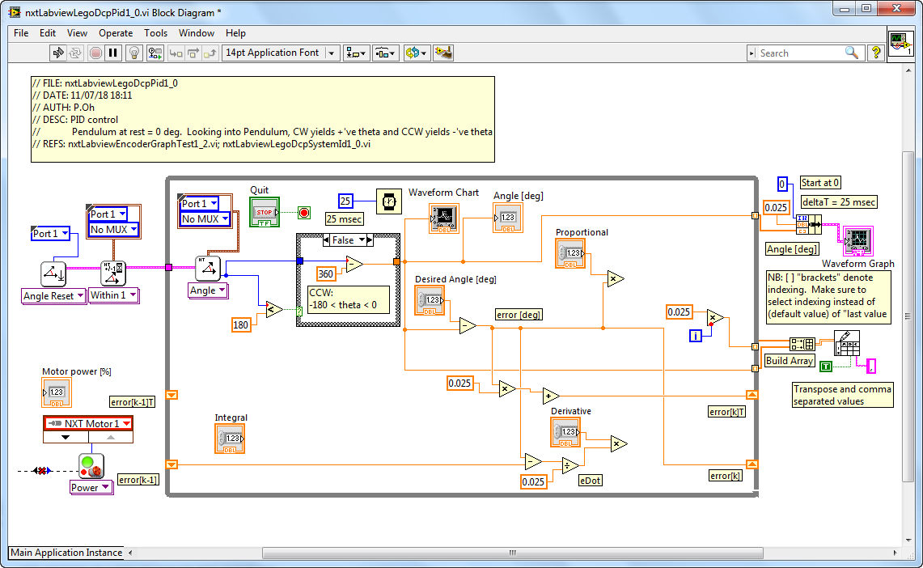

Lastly, drag a Multiplication block to form the product of the error sum and the integration gain (**Figure 1-4C**).

**Figure 1-4C**: Red circle shows the Multiplication block for the Integration gain. Red arrow shows the shift register going into the Additional block

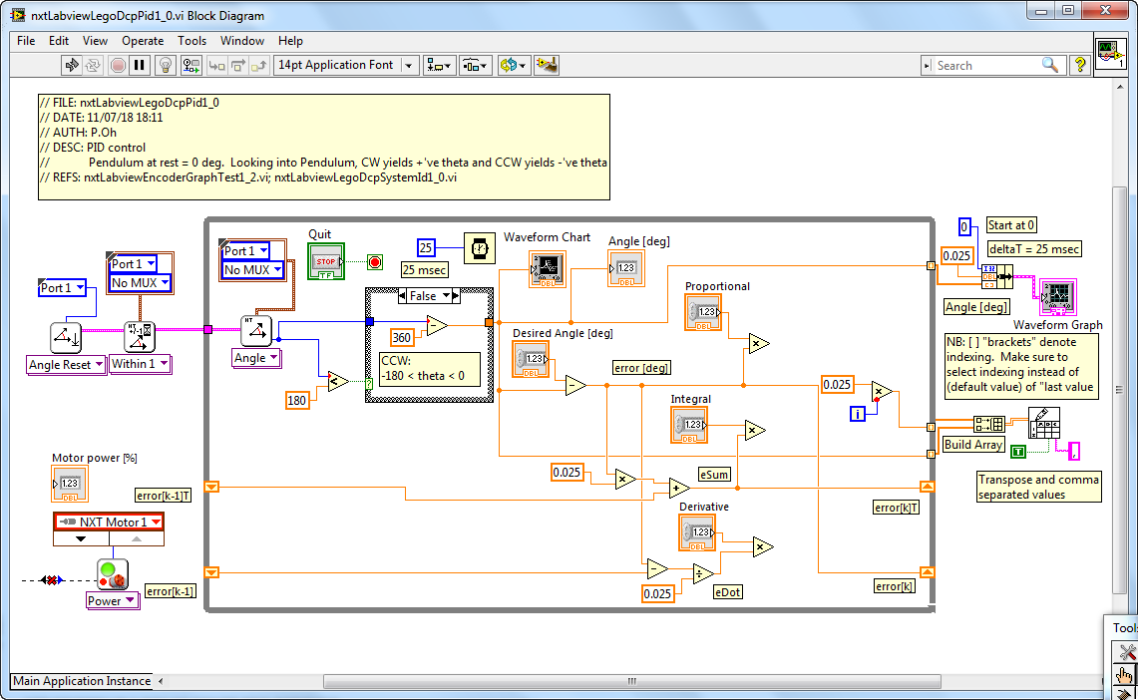

**Step 5:** Form the control signal and dead-zoning

Drag 2 Addition Blocks and wire the summation of the proportional, integral, and derivative commands (**Figure 1-5A**).

**Figure 1-5A:** Red arrow shows location of the 2 Addition blocks that add up the P, I, and D components

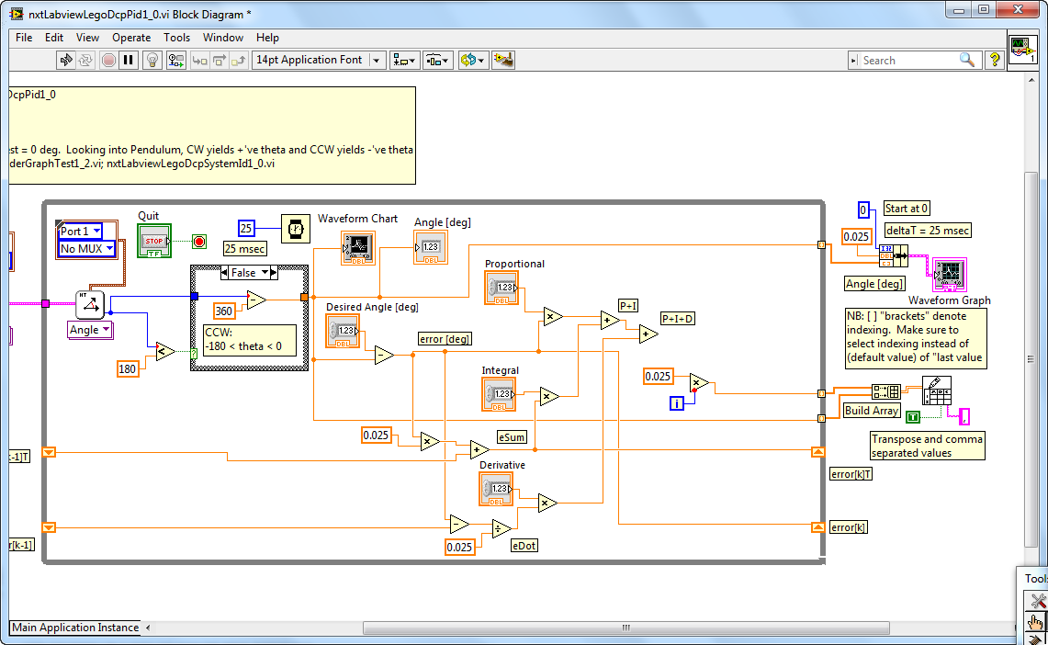

Motor power is limited from 0% (stop) to 100% (full power). *Dead-zoning* is used to limit signals to within this range. Add the In Range and Coerce block (Programming – Comparison – In Range and Coerce)[1]. Right-click this block and make sure both Include upper limit and Include lower limit are checked (**Figure 1-5B**). Add and wire constants 0 and 100 to the lower and upper limits respectively, wire the PID command signal to the input of the In Range and Coerce Block (**Figure 1-5C**). The numeric indicator (Motor Power [%]) has been moved to this region of the loop as well.

Wire the PID command signal to Motor Power numeric indicator. This will allow one to monitor this value when tuning gains. From the In Range and Coerce block, wire the coerced(x) output in the input of the Motor Power block. Save your program (e.g. nxtLabviewLegoDcpPid1_0.vi)

**Figure 1-5B:** Right-clicking the In Range and Coerce block allows on to include both upper and lower limits

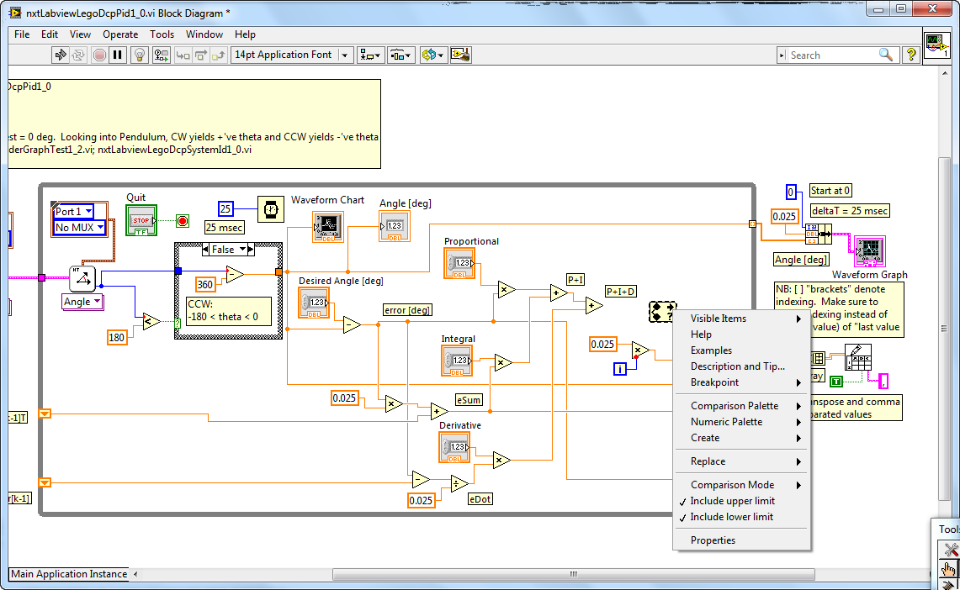

**Figure 1-5C:** Red ellipse shows the In Range and Coerce block configured with lower (0) and upper (100) constants. Right red arrow shows output of this block feeding into the Motor Power block. Left red arrow shows PID output feeding into a numeric indicator (Motor Power [%]).

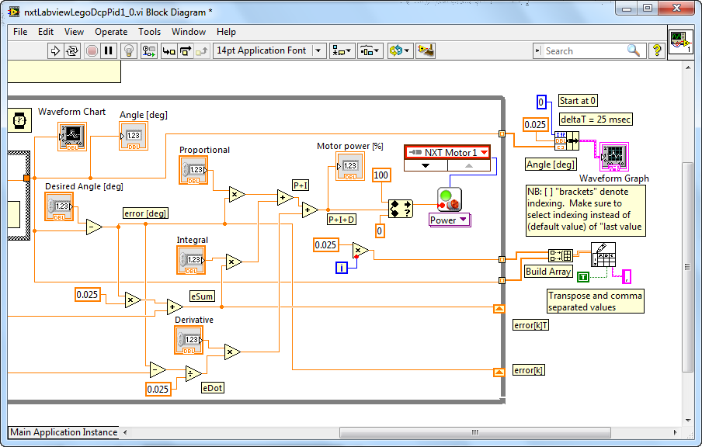

**Step 6:** Execution

From the Simulink PID lab, one simulated that $\left[P, I, D\right]=\left[0.3, 3.0, 0.5\right]$. Before executing the program, set these values in the appropriate numeric controls and set the desired angle to 35 degrees (**Figure 1-6A**). One can make these values default as well (Front Panel – Edit – Make Current Values Default). One can now run the program.

**Figure 1-6A:** Before executing the program, front panel shows desired angle set to 35 (red arrow) and P, I, D gains set (red ellipse)

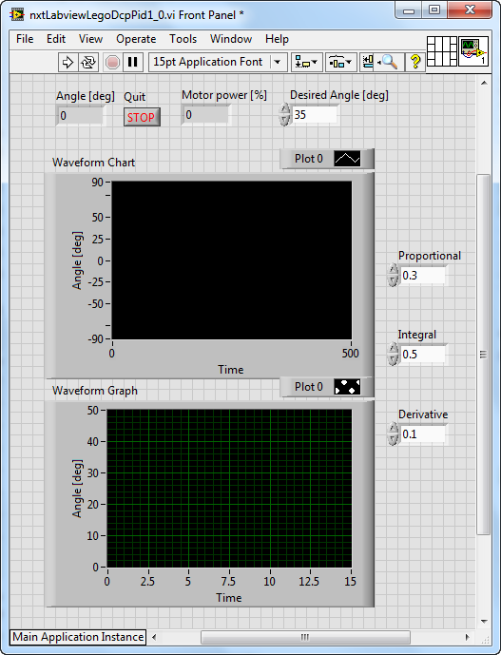

From simulation, one expects that with such gains, the DCP should slowly rise to the desired angle. Thus, the LEGO DCP should also slowly rise to 35 degrees if the Labview program is correct (**Figure 1-6B left**). Data was saved to a file (e.g. labviewPidOutput-111518-12H34M.csv) and plotted in Excel (**Figure 1-6B right**). One observes from the data plot, that slow increase in the pendulum’s angle which converges to 35 degrees.

**Figure 1-6B:** On execution, Front panel shows DCP converging to 35 degrees (left). Excel data plot of acquired angles reveals that for PID gains, steady-state is 35 degrees, with a rise time of about 3.1 seconds (right).

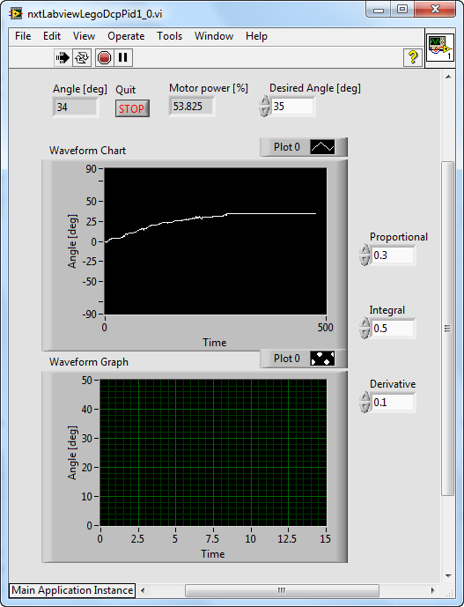

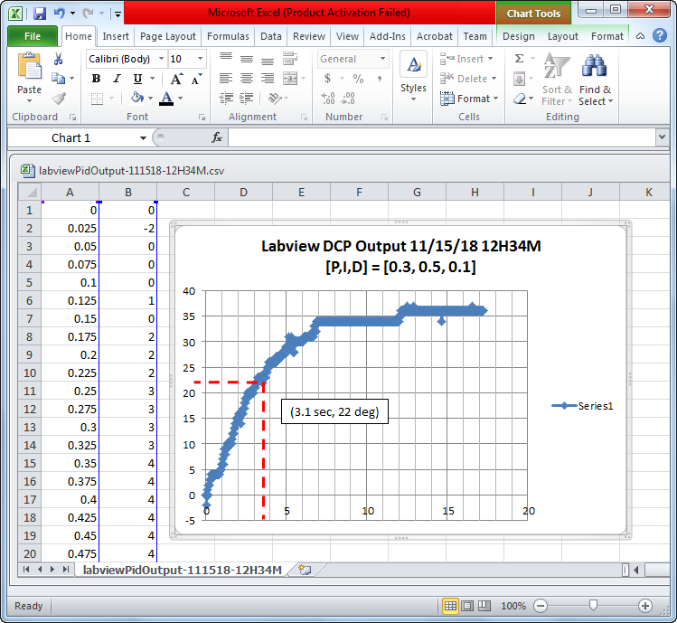

**Congratulations: LEGO DCP PID Control Completed**

**Exercise 1:**

* 1. Complete the following table

|  |  |  |  |
| --- | --- | --- | --- |
| Your Damping Ratio $ζ$ | | Your Natural Frequency $ω_{n}$ | |
| e.g. 0.033 |  | e.g. 7.320 |  |
|  |  |  |  |

* 1. Referring to the free body diagram, complete the following table
  2. Using $J=\frac{m_{L}gd}{{ω_{n}}^{2}}$ compute the Moment of Inertia (e.g. 0.00033 $kgm^{2}$)
  3. Using $c=2ζω_{n}J$ compute the coefficient of friction (e.g. 0.00016 )

thrustTesterFbd012905

|  |  |  |  |
| --- | --- | --- | --- |
|  | Pendulum Length [m] | e.g. 0.265 [m] | Your value |
| $$d$$ | Pivot to CG distance [m] | e.g. 0.1325 [m] |  |
| $$m_{L}$$ | Mass of Pendulum [kg] | e.g. 0.0137 [kg] |  |

1. The In Range and Coerce block is in the Labview Programmable Palette (not the Mindstorms Robotics palette). If needed, enable the Labview Program Palette (Function – Customize – Change Visible Palettes and check the Programming box).