Hands-on Lab 1:

LabVIEW – Basics 1

This lab reviews LabVIEW concepts needed to interface with the LEGO NXT. Specific LabVIEW concepts include: creating a VI (front panel and block diagram), case structures, while loops and shift registers.

LabVIEW 2012 for LEGO Mindstorms provides (1) many of the common controls found in standard LabVIEW; and (2) controls specific to the NXT like motors and sensors. The net effect is a rapid-development software platform to create NXT-based programs – especially those involving a PC-based GUI (Graphical User Interface). GUIs enable one to create dials (e.g. to adjust motor power), switches (e.g. to turn on a motor), and charts (to display sensor data).

Preamble: These steps will be common to all future NXT Lego LabVIEW programs. All programs begin by double-clicking the LabVIEW 2012 for LEGO Mindstorms icon. The following splash screen appears (Figure A1). To create a new program, click File-New (Figure A2)

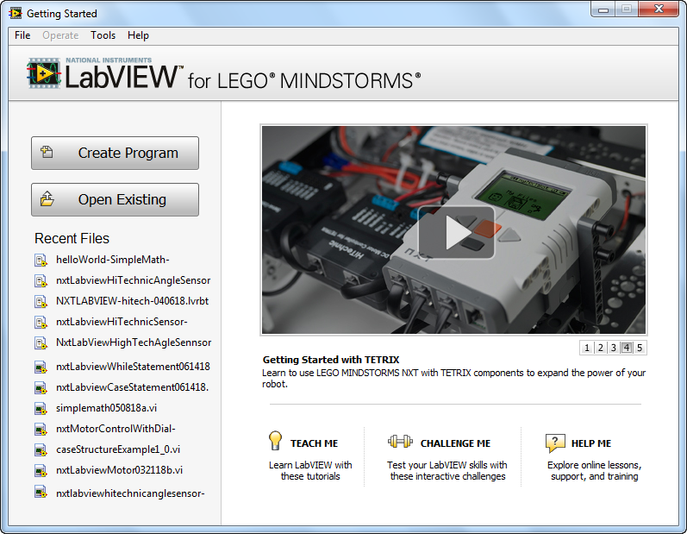
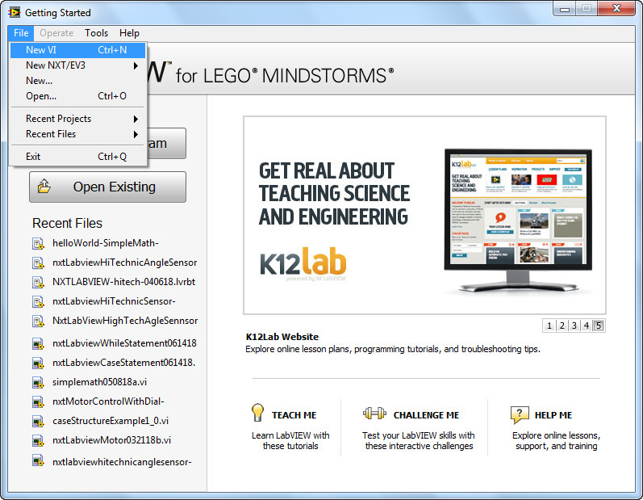

Figure A1: Splash Screen
Figure A2: Click File-New to create new program

A front panel and block diagram will pop up. Depending on your monitor’s size, you may wish to resize them with your mouse as shown in Figure B1. The front panel will be your GUI and serves as your canvas to add virtual controls like knobs, indicators, and charts. Programming occurs in the block diagram by wiring up virtual controls.

Now is the time to name your program. Refer to Figure B2 (File – Save All) to choose and create a suitable folder where you’ll keep all your future VI files (e.g. a USB thumb drive). Now you’re ready to create new NXT LabVIEW programs.

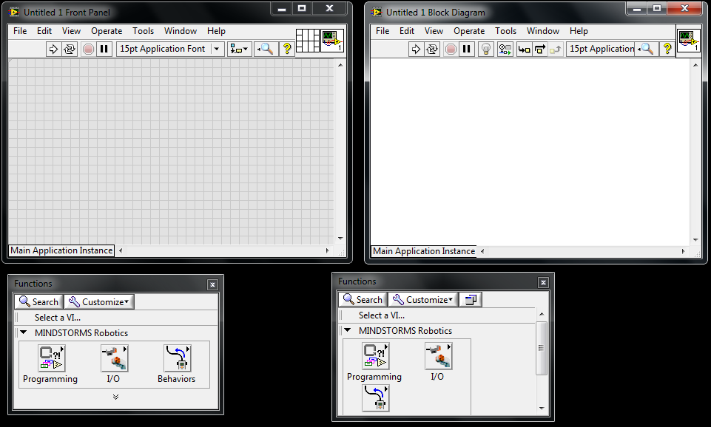

Figure B1: Front panel and Block Diagram

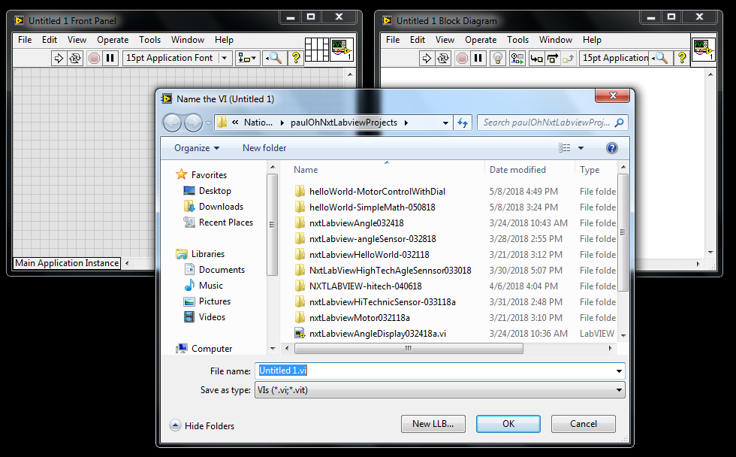

Figure B2: Chose File – Save All to store your VI programs e.g. to a USB thumb drive

You’ll be repeating these Preamble steps for all your future VI programs.

Concept 1: Creating your first VI: Front Panels and Block Diagrams

LabVIEW stands for Laboratory Virtual Instrument Engineering Workbench. In LabVIEW, a virtual instrument has two parts, namely a front panel (the visual front-end) and a block diagram (underlying high-level graphics-based code). One creates the front panel and block diagram by clicking and dragging icons (called controls). The objective in this exercise is to create a simple program that adds displays the sum and product of two numbers. The LED glows when the two numbers are equal.

Step 1: Launch LabVIEW to create the following front panel (Figure 1A below). Save your VI as nxtLabview-HelloWorld-SimpleMath.vi.

On your front panel, click View – Controls Palette as seen in Figure 1A below. This pops up a Controls palette. This palette categorizes GUI components like readout displays (numeric and alphanumeric), knobs and graph charts. Clicking Numeric reveals specific components (Figure 1B).

Figure 1B: In the Control Palette, clicking Numeric reveals specific components’

Figure 1A: On your Front Panel, click View-Controls Palette

Step 2: Create your Front Panel

Figure 1B shows a numeric indicator that has already been dragged to the Front Panel. This numeric indicator was renamed “A”. Create a second one. From the Control Palette, click-and-drag a numeric indicator into the grey area of your front panel as shown in Figure 1C. Double-click the “Numeric” and rename it as “B”
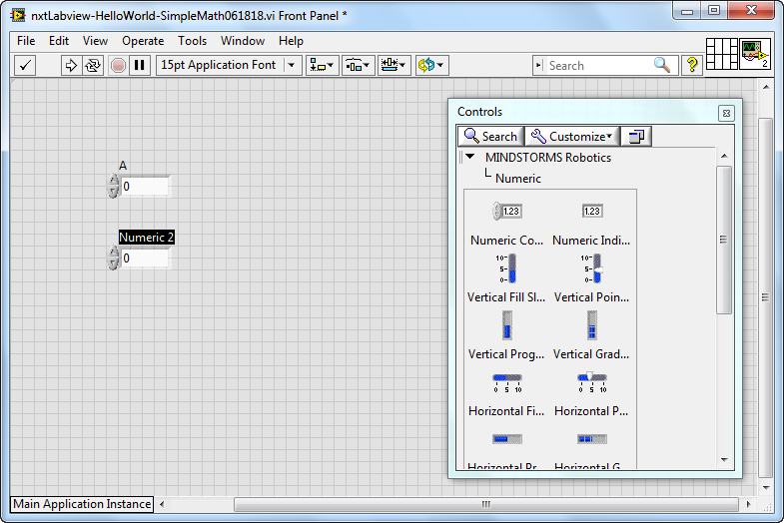

Figure 1C: Two numeric indicators (labeled as A and B) were created by clicking-and-dragging “numeric indicator” from the Controls palette

Figure 1A: Front Panel

Figure 1B: Block Diagram

Step 2: Create the block diagram. The block diagram (Figure 1B above) is invoked by clicking Window – Show Block Diagram from the panel’s menu bar. Again, one right clicks the mouse to bring up a menu of block element functions.

Step 3: Click the play button (arrow icon) on the front panel’s menu bar. Contrast this with clicking the Continuous Play button (arrows in a circle icon) Experiment by clicking on the rocker switches or typing numbers (e.g. integers and reals) in the text box.

Exercise 1: In LabVIEW create programs for the following:

  - Accepts temperatures in Celsius and displays its Fahrenheit equivalent (try pointer slides)
  - Accepts 3 numbers and displays the average
  - Accepts 2 numbers and displays which is the maximum

Concept 2: Case Structures (reference: Bishop p. 204)

Branch statements are those that test a condition (true or false) and execute commands based on those conditions. LabVIEW has several controls for branching. In the block diagram programming, the Case Structure control is invoked under the Executive Control category.

Step 1: Create the following LabVIEW front end – Note that toggle switch by default is FALSE by with a “Switch When Pressed” mechanical action.

Step 2: Create the Block Diagram (True Case: adds the two numbers). Note: clicking the down arrow in the Condition Terminal sets the True condition.

Step 3: Create the False Case condition (False case: subtracts the two numbers)
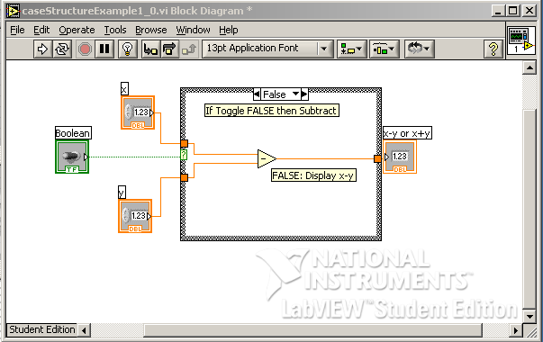

Exercise 2: In LabVIEW create programs for the following:

  - Given an input in inches, the equivalent in centimeters is displayed (by default) and the equivalent in feet is displayed (if the switch is toggled)
  - The maximum or minimum of two numbers is displayed based on toggle position

Concept 3: While Loops (reference: Bishop p. 185)

Loops that repeat until a condition is met are found in every programming language and LabVIEW is no exception. The While-loop repeats commands in its block control while the condition is TRUE. The While-loop control also has an iteration terminal that increases each time the block is executed.

Step 1: This LabVIEW VI counts the number of times the switch is toggled. Create the following front panel. Note: the toggle switch should have its mechanical action set to “Latch when released”.
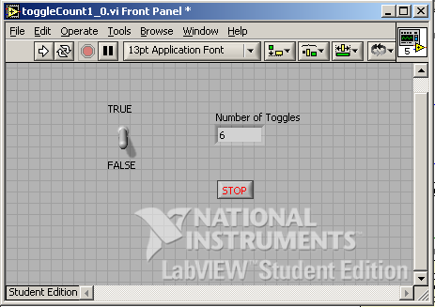

Step 2: Create the following block diagram. A case structure control is inside a while-loop control. When the case is TRUE, a variable (shift register) increases, thereby displaying the number of toggles. The while-loop control stops when the user hits the Stop button.

Step 3: Add the False condition in the conditional terminal. Note that there are no contents (i.e. do nothing) in the case structure
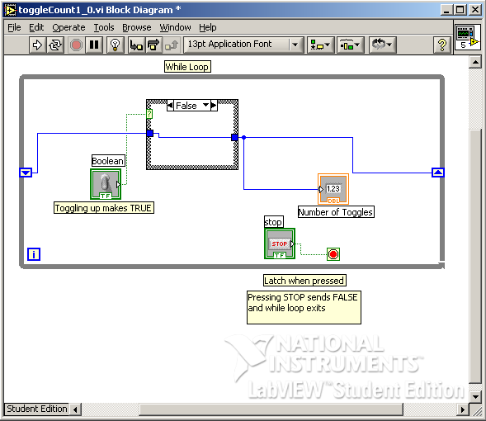

Step 4: Run your program and toggle the switch. Also, try clicking on the Highlight Execution (light bulb icon) button from the Block Diagram menu bar and notice what happens when you execute your program.

Exercise 3: In LabVIEW create programs for the following:

  - The display increases by 2 each time the switch is toggled
  - Increments or decrements depending on the users choice (i.e. using a 2nd toggle switch)
  - Create a for-loop example (Bishop p. 179).

