**Homework – Poles and Zeros**

1. The differential equation for a 2nd order system is expressed as. Here, $ω_{n}\text{ and ζ }$ are the natural frequency and damping ratio respectively.
2. Derive the roots of this equation **(5-points)**
3. Derive the solution  where $A_{1}\text{and }A_{2}$ are some constants **(10-points)**
4. Below is a free-body diagram (left) of the damped compound pendulum. Dimensions and experimental data plotting the time response from a free-fall experiment is also shown (right)

|  |  |  |  |
| --- | --- | --- | --- |
|  | Bar length | 0.495 |  |
|  | Pivot to CG distance | 0.023 |  |
|  | Mass of pendulum | 0.43 |  |

..\..\figures\simplePlankFbd010905.wmf

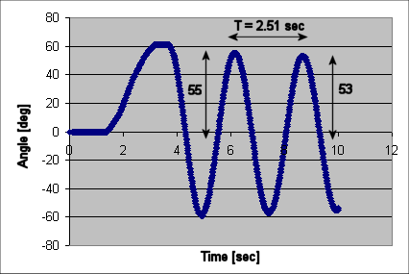

The logarithmic decrement equation states that where $a\text{ and }b$ are the magnitudes of the $N$ and $N+1$ peaks. These peaks are related by the relationship where $T$ is the time in seconds between these peaks

1. Show that $[\text{rad/sec]}$ and **(5-points)**.
2. Show that with these values that the roots are **(5-points)**
3. Sketch these roots on the imaginary plane. Show that and that $θ={\text{tan}}^{-1}(\frac{x}{y}$) and that $ζ=\sin{θ}$**(10-points)**
4. Given the following block diagram and values, show that the open-loop transfer function is given by **(5 points)**



|  |  |  |
| --- | --- | --- |
|  | = 0.0090 |  |
|  | = 0.00035 |  |
|  | = 0.43 |  |
|  | = 0.023 |  |
|  | = 9.81 |  |
|  | = 0.017 |  |

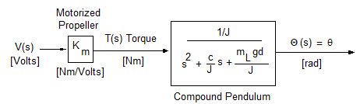

1. Show that the time constant and settling time for the damped compound pendulum given that and natural frequency **(5 points)**
2. Show that the complex poles will yield and phase angle **(5 points)**