**Homework – Free Body and 2nd Order Systems**

..\..\figures\simplePlankFbd010905.wmf

Figure 1: Free-body Diagram of Damped Compound Pendulum (DCP)

1. Given the DCP in Figure 1, derive that $\ddot{θ}= \frac{c}{J}\dot{θ}+\frac{m_{L}gd}{J}θ=0$ where $J$ is the moment of inertia in $[kg∙m^{2}]$, $c$ is the viscous damping coefficient in $[\frac{Nms}{\text{rad}}]$, $m_{L}$ is the pendulum mass in $[kg]$, $d$ is the pivot distance to the center of gravity in $\left[m\right]$ and $L$ is the pendulum length in $[m]$. What assumption(s) are you making to derive this equation? **(10-points)**
2. Show that the natural frequency $ω_{n}=\sqrt{\frac{m_{L}gd}{J}}$. What are the units? **(10-points)**
3. Show that the viscous damping coefficient $c=2ζω_{n}J$ where $ζ$ is the damping ratio. What are the units? **(10-points)**

Below is a free-body diagram of the damped compound pendulum, dimensions and experimental data plotting the time response from free fall.

|  |  |  |  |
| --- | --- | --- | --- |
|  | Bar length | 0.495 |  |
|  | Pivot to CG distance | 0.023 |  |
|  | Mass of pendulum | 0.43 |  |

..\..\figures\simplePlankFbd010905.wmf

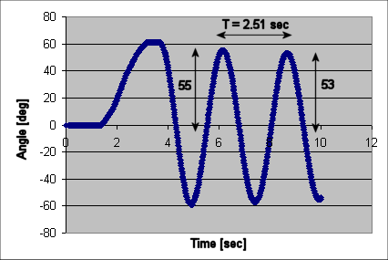

1. If is the viscous damping coefficient, show that the equation of motion for the damped compound pendulum sketch above is given the equation below **(10 points)**



1. Given the following block diagram and values, show that the open-loop transfer function is given by **(5 points)**



|  |  |  |
| --- | --- | --- |
|  | = 0.0090 |  |
|  | = 0.00035 |  |
|  | = 0.43 |  |
|  | = 0.023 |  |
|  | = 9.81 |  |
|  | = 0.017 |  |

figures\openLoopBlockDiagram1_2.wmf

1. Show that the time constant and settling time for the damped compound pendulum given that and natural frequency **(5 points)**
2. Show that the complex poles will yield and phase angle **(5 points)**