Hands-on Lab

XL-320 NXC Programming – “Hello World (LED)” Example

This lab introduces NXC Programming of the Robotis XL-320 Dynamixel servo. The Lego NXT Brick’s Port 4 features a serial interface (RS-485 protocol). This allows the Brick to communicate to the TTL-level serial port on the XL-320. Changing the XL-320’s LED color is a “Hello World” example to introduce RS-485 programming and writing instructions to the XL-320.

Preliminary: Hardware connections and explanation

Hardware Connections

Figure A: NXT-to-XL320 connections (left). NPN Transistor for half-duplex (top right) and NXT cable wire description (bottom right)

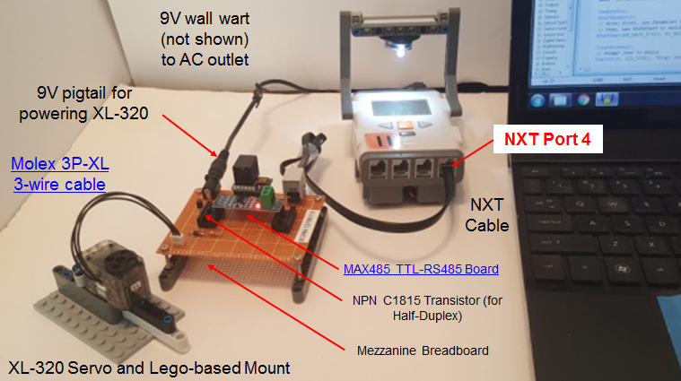

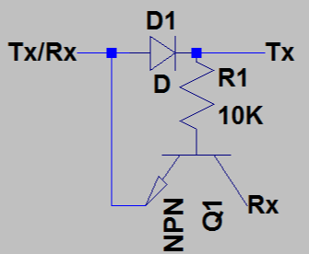

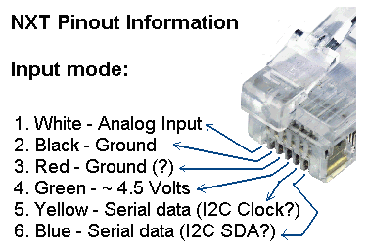

Figure A shows the hardware connections. RS-485 protocol digitizes at -7 to +12 Volts. However, the XL-320 uses transistor-to-transistor logic (TTL) to convert bytes digitally (+5V and Ground). As such, a converter is needed. The Maxim MAX485 is a popular chip for such conversion. Its popularity is underscored by $2 boards complete with supporting passive components. One caveat of the XL-320 is that it uses half-duplex RS-485 interfacing. The Molex connector has wires for power, ground, and data. Thus only 1-wire is used to read and/or write bytes (i.e. half-duplex). As such, a NPN transistor is used to implement half-duplexing (Figure A top right). Lastly, the NXT cable’s Yellow (YLW) and Blue (BLU) wires (Figure A bottom right) serve serial purposes when RS485 is invoked.

Dynamixel Protocol 2.0 and XL-320 EEPROM

As introduced earlier, the XL-320 is a smart servo. Embedded in this servo is random access memory (RAM) to hold temporary information like encoder positions and LED states. Also this servo has electronically erasable programmable read-only memory (EEPROM) to hold the XL-320’s firmware. Firmware is used to permanently hold device information like identifiers (e.g. model or ID number, communication settings like baud rate, and firmware version).

Robotis’ information on the XL-320 is comprehensive, albeit cryptic:

- XL-320 specifications http://emanual.robotis.com/docs/en/dxl/x/xl320/
- EEPROM and RAM Control Table http://emanual.robotis.com/docs/en/dxl/x/xl320/#control-table
- Robotis Protocol 2.0 Instruction and Status packets and Packet Processing http://emanual.robotis.com/docs/en/dxl/protocol2/

The XL-320 has powerful features and the above links are needed to exploit them.

Step 1: Create Definition Header File (H-File)

Blah: see my definitions H-file and provide filename and code here.

mponents: a 9V wall wart is used to power the XL-320 servo. The pigtail allows the 9V and GND lines to connect to the Robotis U2D2 servo controller using a spring connector. The U2D2 is essentially a microprocessor that allows a computer (USB) to communicate to the XL-320.

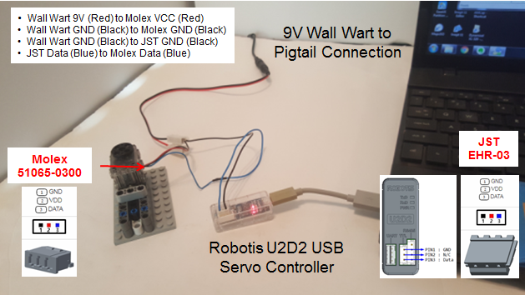

Figure B: Cable connections.

Figure B depicts the cable connections. First, tie the GND lines of the XL-320 (Molex connector), the U2D2 (JST connector) and the pigtail using a spring connector. Second, tie the pigtail’s 9V line to the XL-320 VCC line via the spring connector. Lastly, make sure the data lines from the U2D2 and XL-320 are connected (blue wire).

Concept 1 – Setting Servo ID and Baudrate

Step 1: Launch the Dynamixel Wizard

Figure 1-1 Dynamixel opening screen (left). Clicking Open Port (red circle) and pushing the Start Searching button requests a Dynamixel servo search (right).

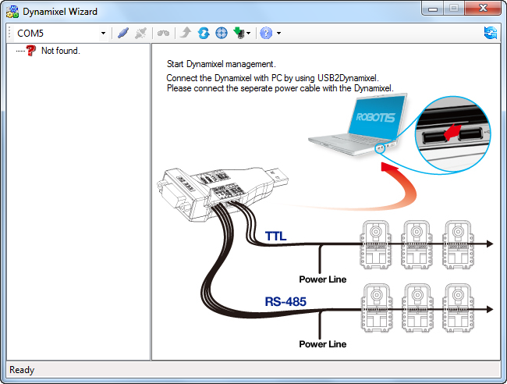

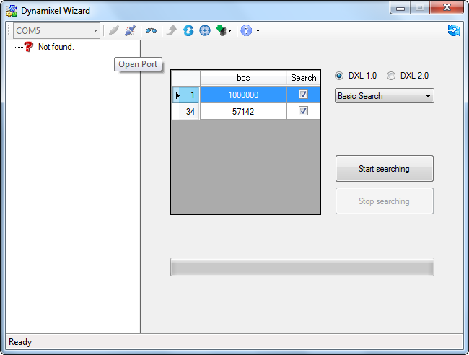

The Dynamixel Wizard is used to setup Robotis servos. Figure 1-1 (right) allows one to see what Dynamixel servos are connected to the PC’s serial port.

Figure 1-2: Results of the search reveals an XL-320 connected to the COM port (left). Clicking on the motor (red circle) reveals its current settings (right).
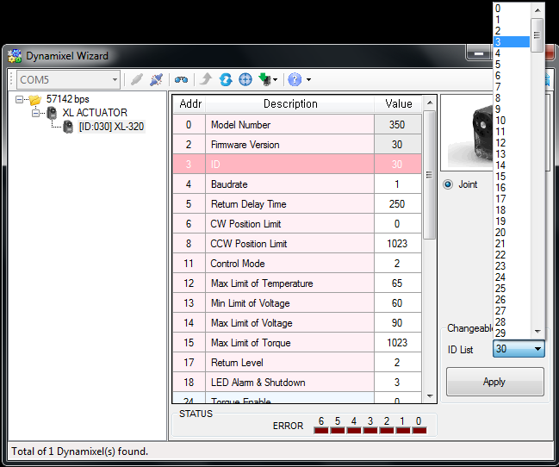

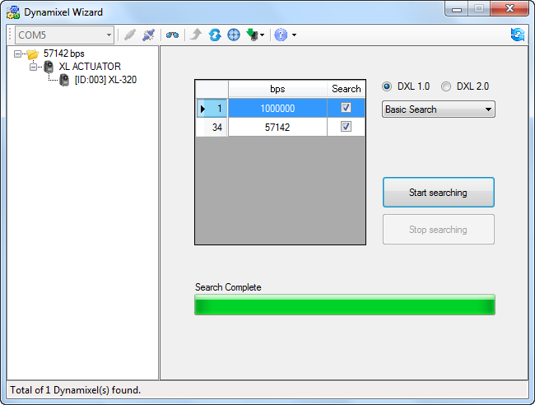

Step 2: Change XL-320 Servo ID

Figure 1-2 shows the properties of the XL-320 servo. Up to 253 different XL-320 servos can be daisy-chained; the servo ID allows one to uniquely identify each one. By default, the servo ID is the set to the label affixed to the XL-320.

For our future Lego NXC programming purposes, let us assign the XL-320 an ID of 1. Select ID and change to 1 and then press the Apply Button. This assigns the connected XL-320 with the ID of 1 (or 0x01 in Hexadecimal).

Step 3: Change Baudrate to 57600 bps

By default, factory XL-320 servos are set at a 1 Mbps baud rate. For our future Lego NXC programming purposes, change the baud to 57600.
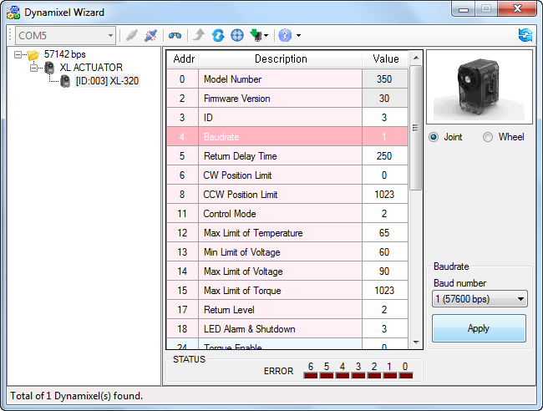

Figure 1-3: Clicking Baudrate allows one to change settings

Click the pull-down menu (Figure 1-3 red circle), choose 57600 bps, and push Apply.
Congratulations! You’ve set the XL-320 servo’s ID and baudrate
Concept 2 – Command Angular Position (Joint Mode)

Dynamixel Wizard offers different modes to command the XL-320. In Joint Mode, one can command the XL-320 to desired angular positions.

Step 1: Enable Torque and Set Velocity

Figure 2-1: Selecting Torque Enable (left) shows options to turn torque detection ON or OFF. By default, torque is enabled and the motor is in Joint mode (red arrow). Goal Velocity sets the XL-320’s rotational speed using the slider bar or typing values, and hitting the Apply button.
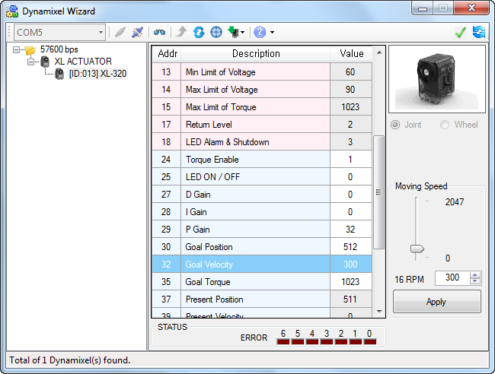

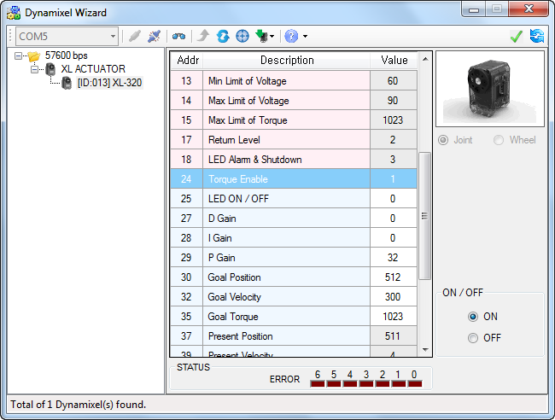

The XL-320 features over-torque protection. This is good to prevent damaging the servo. Figure 2-1 (left) shows that by default, Torque Enable is ON. The XL-320 can rotate very quickly and trigger over-torque protection. Thus, one can slow the servo’s velocity; Figure 2-1 (right) shows Goal Velocity set to 300 once the Apply button is clicked.

Step 2: Command Angular Position

Figure 2-2: Goal Position (left) and corresponding degrees and direction (right)

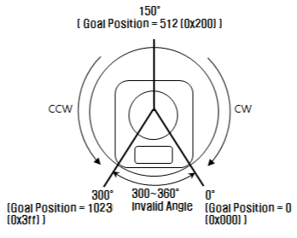
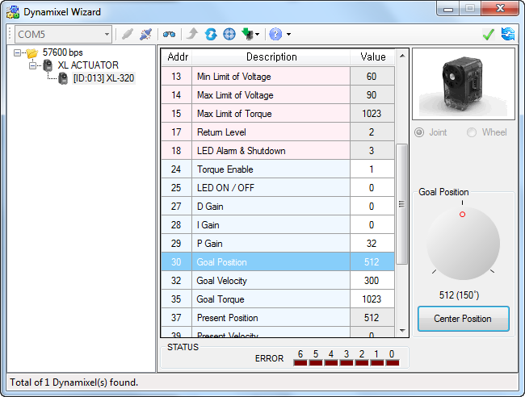

Figure 2-2 shows Goal Position. Clicking Center Position will command the XL-320 servo to be the middle of its range (0 to 1023). Clicking-and-dragging the dial rotates the XL-320’s horn.

Exercise 1:

  - What Goal Positions corresponds to the XL-320 being at its maximum clockwise and counter-clockwise positions?

  - What is resolution of the XL-320 servo in degrees? Hint: Maximum angular range is 300 degrees.

Concept 3 – Continuous Rotation (Wheel Mode)

In Wheel Mode, the XL-320’s horn will rotate continuously.

Step 1: Disable Torque

Figure 3-1: To rotate continuously, first set Torque Enable to OFF (left) and then choose Wheel (red circle). Clicking on Goal Velocity gives options for continuous rotation (right).
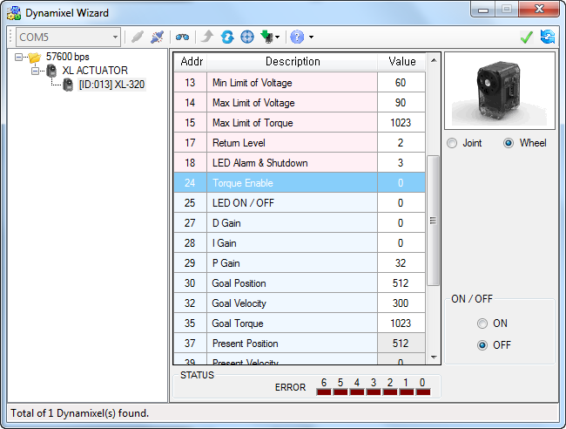

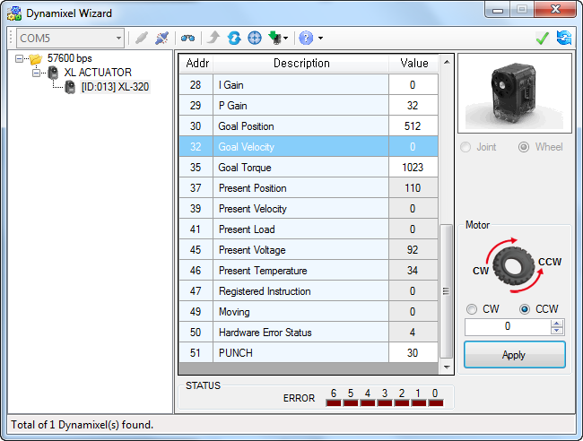

Step 2: Rotate continuously

Selecting Goal Velocity (Figure 3-1 right) one can choose to rotate the XL-320 servo horn clockwise or counter-clockwise. One can also type a numeric value (0 to 2047) and after hitting the Apply button, the XL-320 servo horn will rotate at the speed. Type in 0 and push Apply to stop the servo.

Exercise 2:

  - What is the maximum angular velocity in degrees/sec?

  - Set the angular velocity to 150. With a stopwatch, how many seconds does it take for the XL-320 servo horn to rotate once?

Congratulations! You can command XL-320 to desired angular positions and rotate continuously at desired angular velocities

