**Hands-on Lab**

**Scilab Installation**

Scilab is a free and open-source version of Matlab available for multiple operating systems (Windows, Mac and Linux). It also features Mathworks’ versions of Simulink and toolboxes like image processing and serial communications. Unlike Matlab, Scilab does not need any licensing and/or package updates. Another powerful feature of Scilab is it’s hooks to OpenCV. OpenCV is a popular computer vision package but difficult to install on non-Linux computers. The net effect is that Scilab reduces the learning curve to implement video and image processing in robotics.

**Step 1:** Download and install Version 6.1.0 suitable for your computer (e.g. Windows 64-bit) from <https://www.scilab.org/download/6.1.0>. Execute Scilab should show the workspace (**Figure A**)



**Figure A:** Scilab workspace opens when executed

**Step 2:** Install the plug-in “Image Processing and Computer Vision Toolbox 4.1.2

Click on the “Module Manager – ATOMS” shown by the red arrow in **Figure A**. This will launch the module manager (**Figure B left**). Click on “Image Processing” (see red arrow).

**Figure B:** ATOMS shows various modules (left). The image processing one provides two available ones (right).



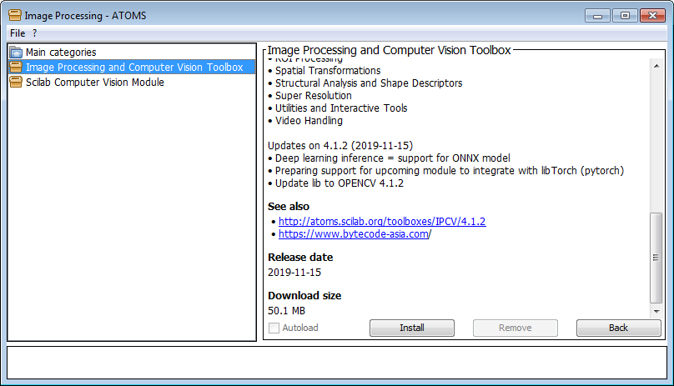

Highlighting “Image Processing and Computer Vision” (**Figure B right**) provides some background history. Click the Install button and then Back. Repeat this for the “Scilab Computer Vision Module”.

**Step 3:** Install the plug-in for Serial Communications

Returning back to the ATOM module manager, click “Signal Processing” category (show by red arrow in **Figure C**). This will show the Serial Communication module. Click the Install button and then Back.

**Figure C:** The Signal Processing category (left) shows a Serial Communication module (right)



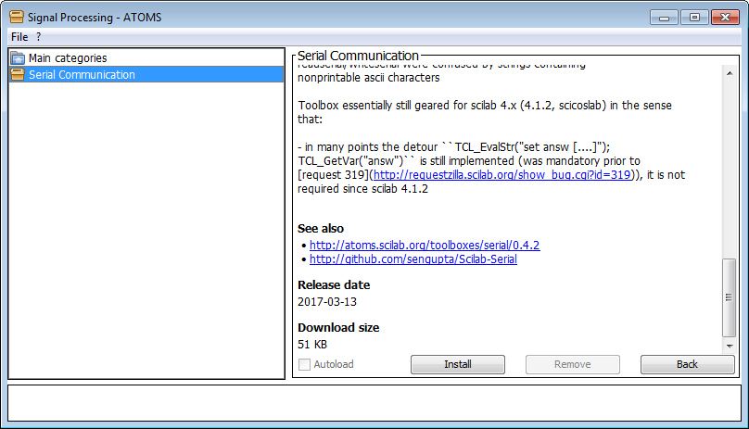

Finally, exit out of Scilab. Re-starting Scilab loads these modules as shown in **Figure D:**



**Figure D:** Re-starting Scilab shows the modules that are loaded automatically (red circle)

Congratulations! You’ve installed Scilab, 2 image processing and serial communication modules