**Hands-on Lab**

**Pixelformer Installation and Testing**

Pixelformer is a free bitmap editor. For image processing and computer vision algorithms, it is often useful to have an image file that one can define and control. Pixelformer allows one to create an image file with specified rows and columns, and to specify pixels with a desired color.

**Step 1:** Download and install from <http://www.qualibyte.com/pixelformer/download.html>.

There are many “benchmark” image files on the web like cameraMan.raw or lena.raw. However, they are often 256-by-256 pixels and have many features. This can make verifying one’s image processing algorithm (e.g. calculating the centroid) difficult.

Pixelformer allows one to create their own “benchmark” file. Execute Pixelformer and select FILE – New and define a 16-by-16 pixel with 256-color palette (**Figure 1A left**).

**Figure 1A:** Download both IrfanView and the Plugins (left). After IrfanView installs, run the EXE file to install the Plugins (right).

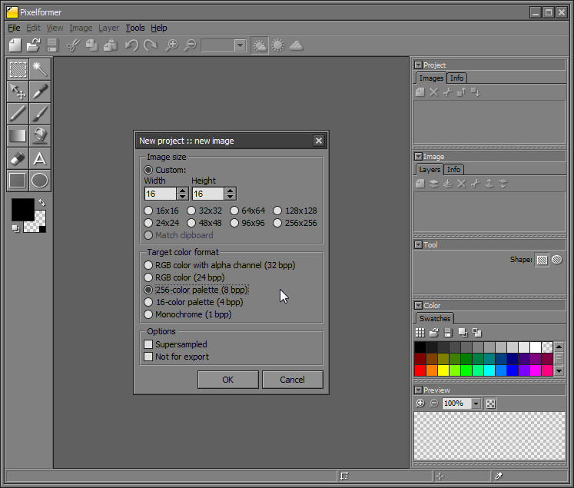

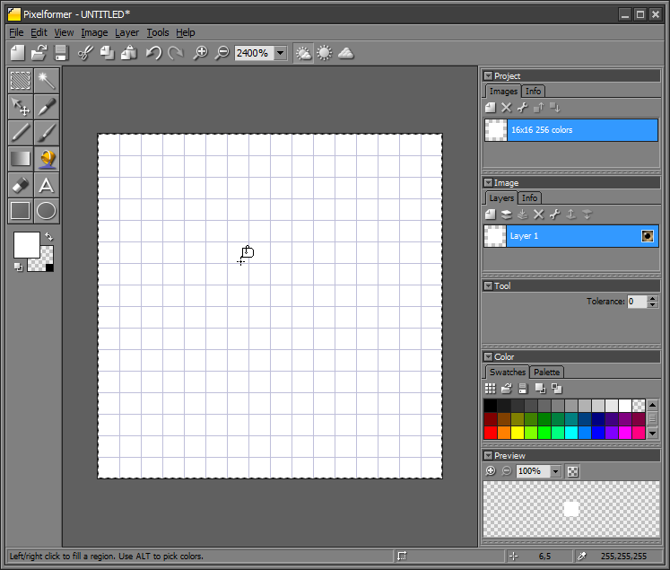

This will pop up a graphed canvas (**Figure 1A right**) where each square represents a pixel. The lower right corner displays the pixel’s row and column location of the mouse. Moving the mouse, one will observe there are rows (and columns) numbered 0 to 15.

**Step 2:** Hover the cursor at pixel location (8, 7). Use the Selection Tool and Fill to color the pixel Black (**Figure 2A left**). Continue filling boxes to form the letter X (**Figure 2A right**).

**Figure 2A**: The pixel (8, 7) is filled Black (left) as confirmed by mouse’s location (red circle). An X is drawn (right) by filling the appropriate pixels. The last one (lower right) has pixel location (10, 9) as shown by red circle.

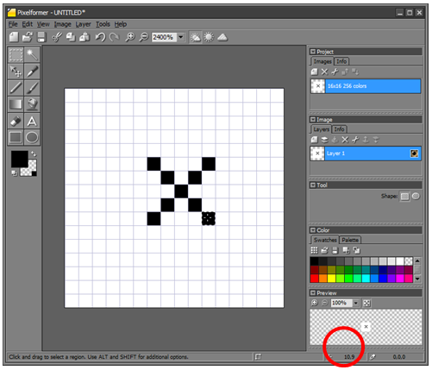

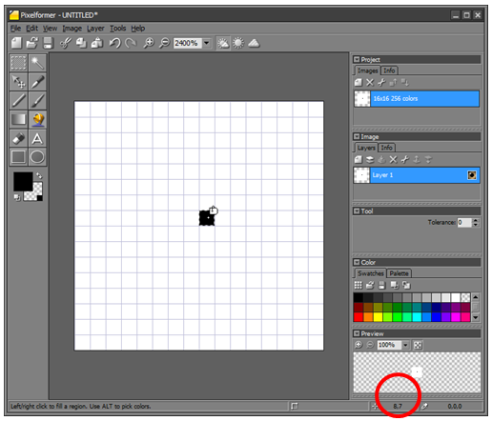

**Step 3:** Export bitmap to PNG

From the ribbon bar, select Image – Export and select Portable Network Graphics (*.png). Save your file as 16-by-16-x-Png.png.

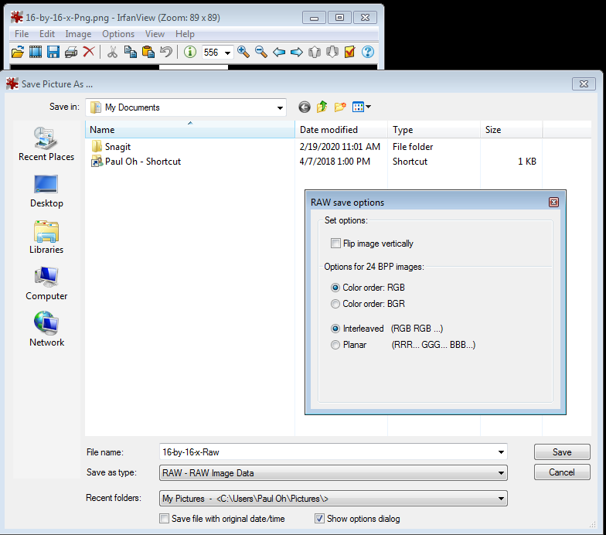

**Figure 3A:** IrfanView reads 16-by-16-x-Png.png and save as a RAW file called 16-by-16-x-Raw.raw (left). One can now view the 16-by-16 1 byte/pixel image (right).

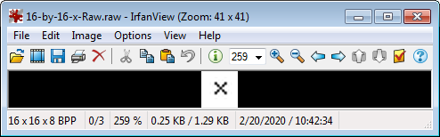

Pixelformer does not have the option to save as a RAW file. However, IrfanView can read the PNG file and save it as a RAW file. Launch IrfanView to view 16-by-16-x-Png.png and save as a RAW – RAW Image Data (see **Figure 3A left**) with the name 16-by-16-x-Raw.raw. Open this newly save RAW file with IrfanView (**Figure 3A right**).

Congratulations! You’ve Installed Pixelformer and can create RAW image files