**Hands-on Lab**

**IrfanView Installation**

IrfanView is freeware for viewing a wide range of graphic files. Moreover, it can both read and export RAW files. Many cameras have the option to save digital images in JPEG or RAW formats. Unlike JPEG, RAW files are uncompressed and the pixels are unaltered. Professional photographers typically save their shots in RAW format to more flexibly and creatively photo-shop their images. As their name suggests, RAW images are best used in image processing and computer vision algorithms. Hence IrfanView is a good tool for viewing the inputs and outputs of these algorithms.

**Step 1:** Download from <https://www.irfanview.com/>

The home page’s download section provides options for 32- or 64-bit computers. The figures reflect a 64-bit download. **Figure 1A-left** (red ellipses) shows the files to download.

**Figure 1A:** Download both IrfanView and the Plugins (left). After IrfanView installs, run the EXE file to install the Plugins (right).

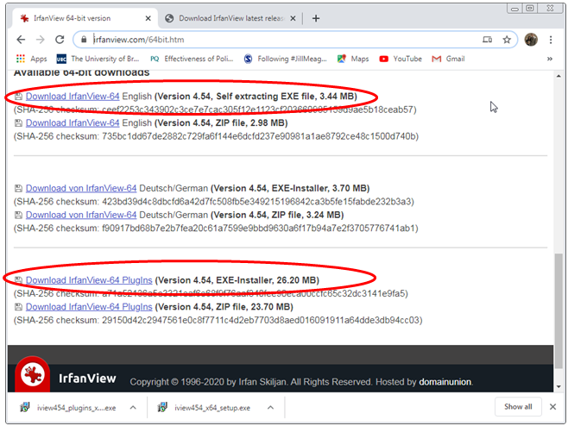

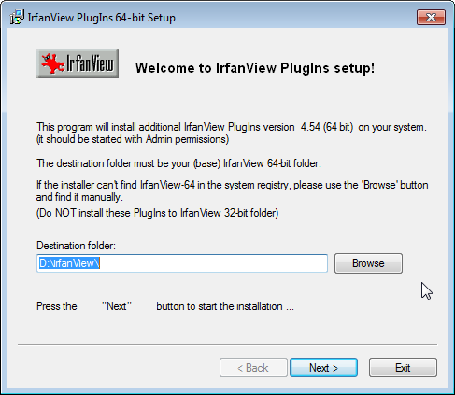

**Step 2:** Install IrfanView into your desired folder. The downloaded file is an EXE (executable) file, the install should be straight-forward. If IrfanView launches after the install, exit the program.

**Step 3:** Install the Plugin. This install will likely (and should be) in the same directory that IrfanView was installed in Step 2 (see **Figure 1A-right**).

**Step 4:** View a RAW file

Launch IrfanView and select File – Open and scroll to select RAW/YUV – RAW Files (Figure 4A).

**Figure 4A:** Selecting RAW files.

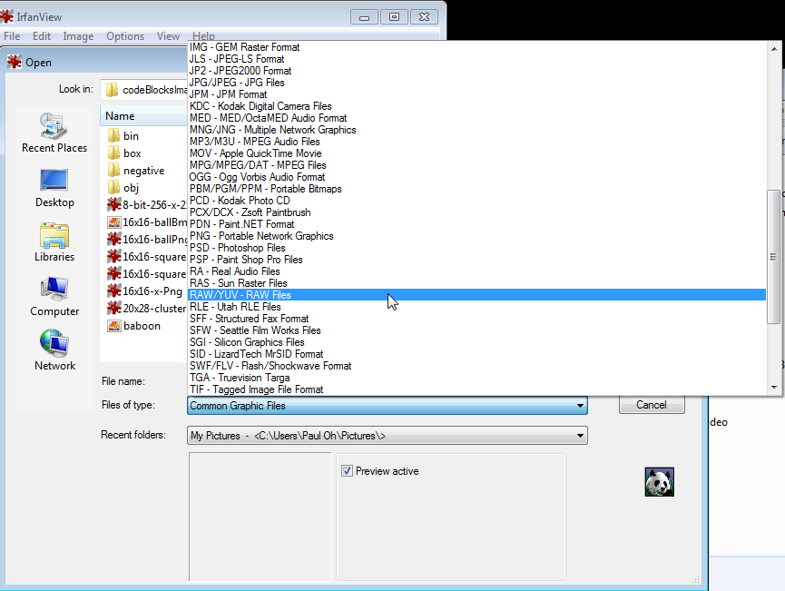

Select the RAW file cameraMan.raw. The pop-up box (**Figure 4B left**) will prompt one to enter information about the RAW file. RAW files need a priori information. cameraMan.raw is 256 by 256 pixels, grayscale with 1 byte per pixel. Once entered and hitting OK, the RAW file is displayed (**Figure 4B top right**). **Figure 4B bottom** right displays 16x16-ballRaw.raw which is 16 by 16 pixels, grayscale with 1 byte per pixel.

**Figure 4B**: Red ellipse sets the number of rows and columns of the RAW file (left). The red circle selects 8 BPP (8-bits or 1-byte per pixel). The resulting RAW file is then displayed (top and bottom right).

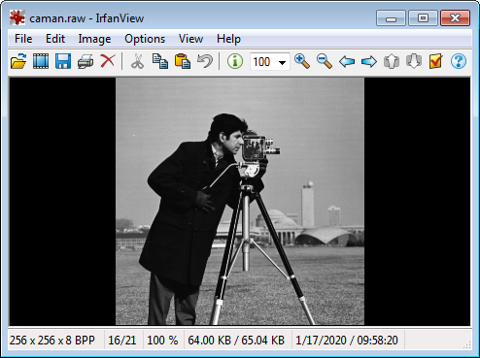

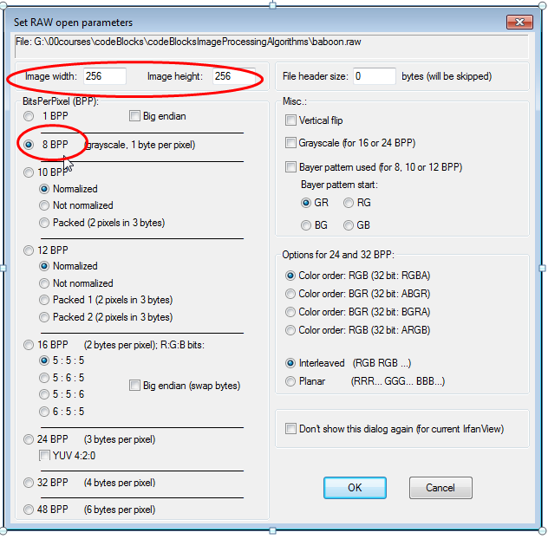

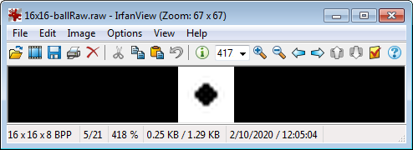

Congratulations! You’ve Installed and Tested IrfanView