**Hands-on Lab**

**Code::Blocks Installation and Testing**

Code::Blocks (or Code Blocks) is a free and open-source integrated development environment (IDE) available for Windows, Mac and Linux. It features GCC (GNU C Compiler) as well as a host of other C-compilers for target hardware like Android and ARM, AVR, 8051 processors. GCC follows the ANSI standard which leads to platform independent code. Code Blocks makes the installation straight-forward and reduces set up headaches. Screen shots and steps are for installation on a Windows-based computer. Installation on computers with other operating systems is assumed to be similar.

**Step 1:** Download from <http://codeblocks.org/downloads/26>

Select the version that includes the GNU C Compiler (GCC) option e.g. **codeblocks-17.12mingw-setup.exe**. MinGW (Minimalist GNU for Windows) is the Unix GCC compiler for Windows. It is also free, open-source but moreover, uses standard ANSI C. This maximizes the creation of portable code.

Check the default “Full: All plugins, all tools, just everything” is selected as seen in **Figure 1A left** and click Next. The following prompt will allow you to choose the directory to install Code::Blocks. After a few minutes of decompressing and install files, click OK when prompted to start Code::Blocks. This should yield the IDE shown in **Figure 1A right**.

**Figure 1A:** Select “Full: All plugins, all tools, just everything” as highlighted by red arrow (left). Once installed, select to run Code Blocks and the IDE will open (right).

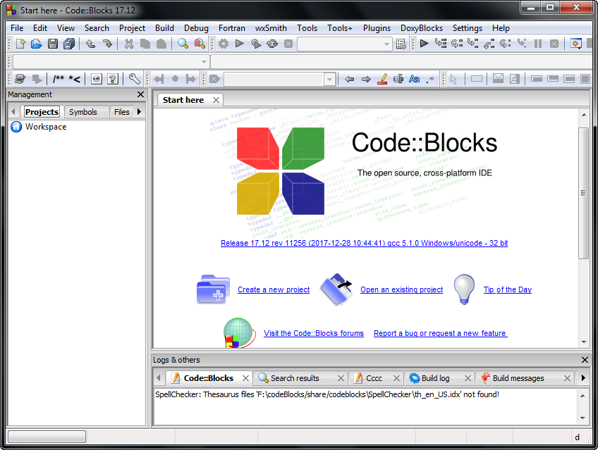

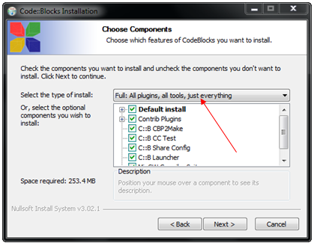

**Step 2:** Creating a Project

C is a compile programming language. Here, source and header (if any) files (.c and .h respectively) are compiled to created object files (.obj). The linker takes these object files to create an executable (.exe) file. The program or application launches when the executable is run. Like most IDEs, Code Blocks needs to know where all these files are. Thus, Code Blocks begins by creating a project.

Select File – New – Project and the pop-up will prompt choices. As seen in **Figure 2A left**, there are various templates for targets like Arduino, AVR and ARM processors. For our example, select “Empty Project”.

**Figure 2A:** Chose “Empty Project” (left) and create project. Enter desired project title, folder, and project filename as seen in example (right)

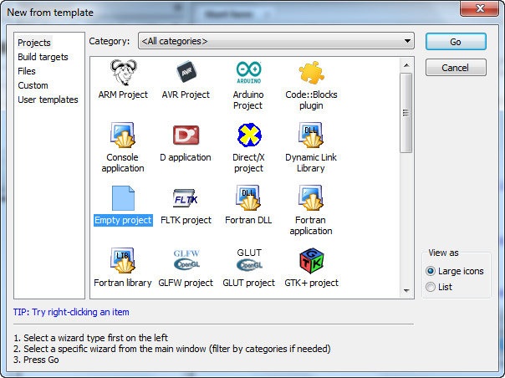

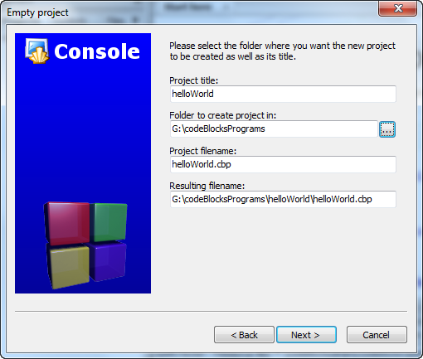

As seen in **Figure 2A right**, enter desired names and folder.

**Step 3:** Add files to project

Here is the opportunity to add source and header files that might already have been created or downloaded. In this “Hello World” example, the assumption is starting from scratch. Select File – New – Empty file and name as helloWorld1_0.c as seen in **Figure 3A left**. Hitting Save will pop us the prompt (**Figure 3A right**). Select OK.

**Figure 3A:** Add a new file to the project (left) and keep options (right).

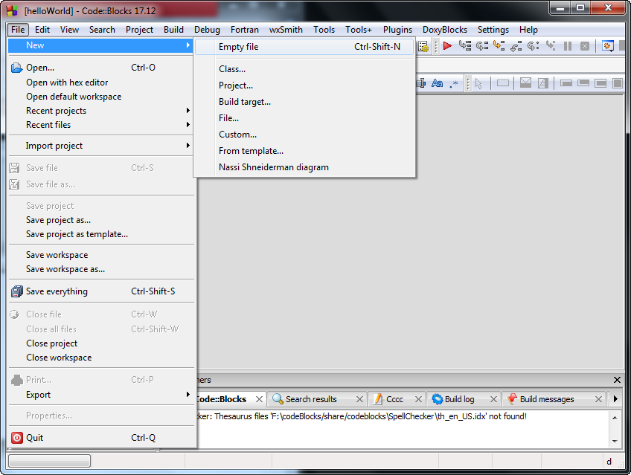

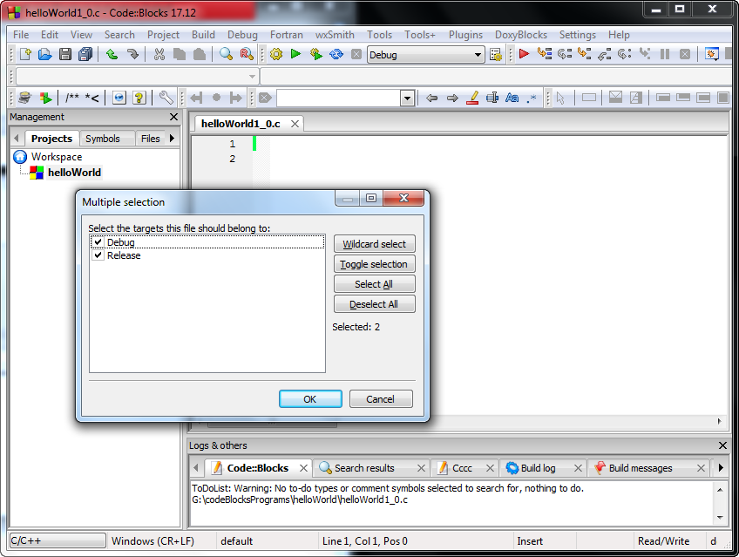

**Step 4:** Save, Compile and Execute

Write a simple “Hello World” program in the editor (**Figure 4A right**). The red arrows show the buttons to save all files, compile and run. Any compile errors are shown below the editor (red oval). If there are no errors, hitting Run will bring up a command window (**Figure 4A left**) showing the results of your executing your program.

**Figure 4A:** Red arrows show buttons for saving all files, compiling (called build) and running the executable (left). Results of running pop up in the command window (left).

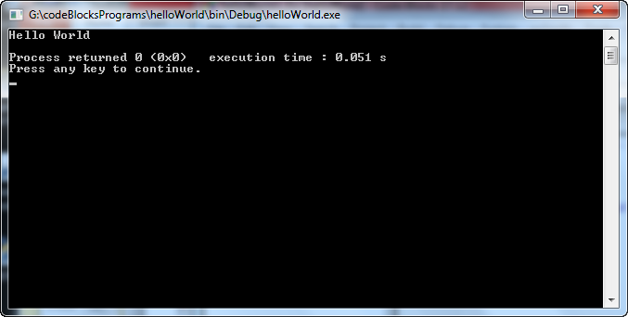

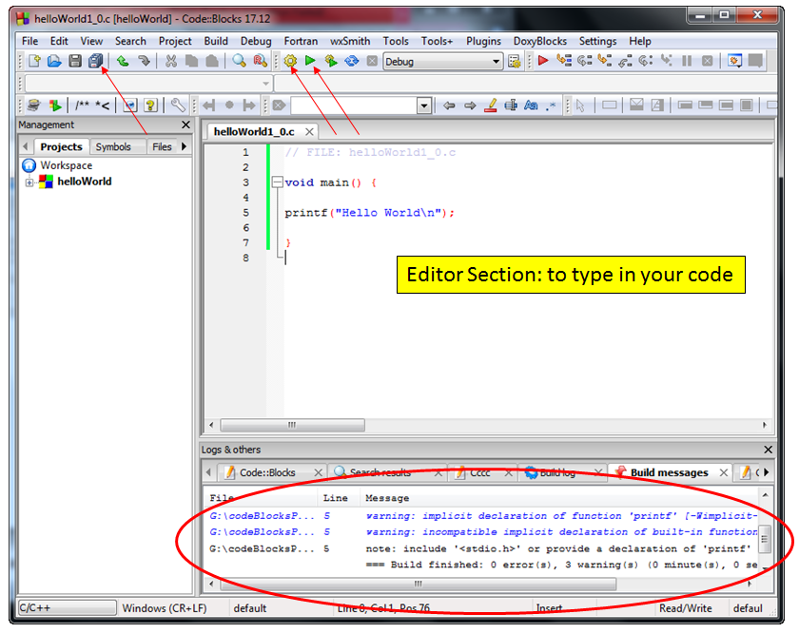

Congratulations! You’ve Installed, Setup and Tested Code::Blocks

**Addendum: Troubleshooting**

Developers may have other compilers on their computers. Or, there may be cases when failed to select a compiler. If when one attempts a compile, and Code Blocks yields messages of a missing compiler (Figure A), this addendum provides some suggestions.

**Figure A:** The red ellipse yields “No Compiler” message thus preventing the creation of the executable file

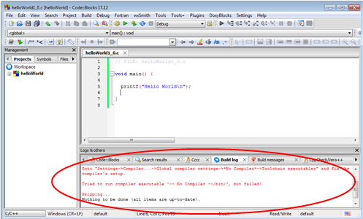

**Step 1:** Assign compiler

Check if the IDE knows the name and location of the compiler. From the ribbon bar, select Settings – Compiler as seen in **Figure B left**. From the resulting pop-up box, scroll to the top and select GNC GCC Compiler (**Figure B right**).

**Figure B:** The GCC C Compiler can be selected (right) after choosing Settings – Compiler (left).

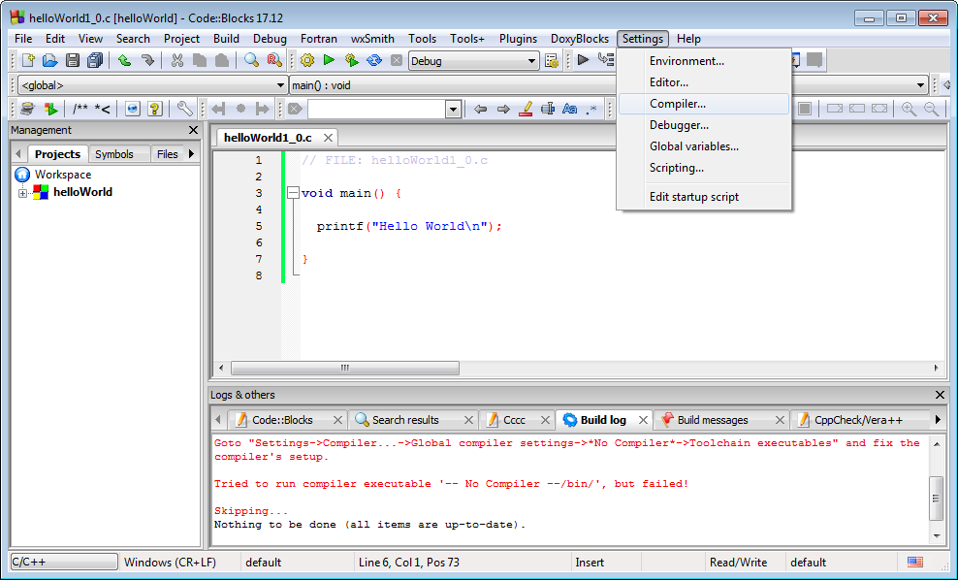

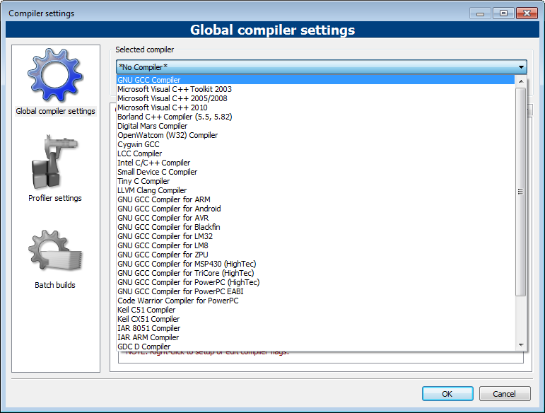

**Step 2:** Setup environment

To ensure the IDE knows the location of the compiler, select Toolchain executables (**Figure C left**) and select the folder where you installed Code Blocks (**Figure C right**).

**Figure C:** Assigning the location of the MinGW compiler (right) after setting the Toolchain executables (left).

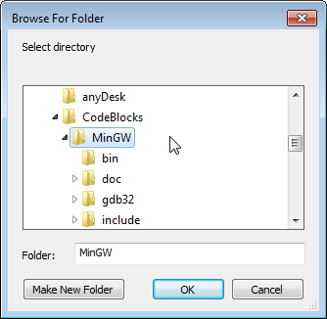

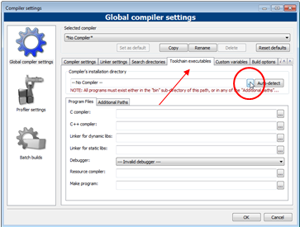

Before exiting the Global compiler settings pop up box, click “Set as default” to ensure Code Blocks uses this compiler (**Figure D**).

**Figure D:** Setting GNC GCC compiler as default

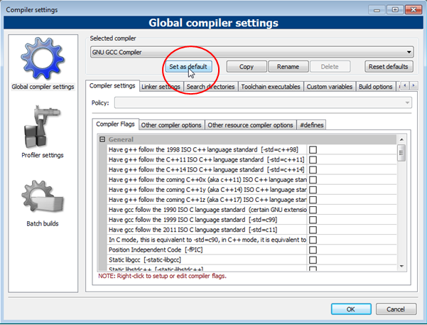

Another thing to check is that one’s Project is actually using the GCC. Right-clicking one’s project (**Figure E left**), select Build Options. From the resulting pop-up choose GNC GCC Compiler (**Figure E right**).

**Figure E:** Right-click over your project and select Build Options (left) and choose GNC GCC Compiler (right).

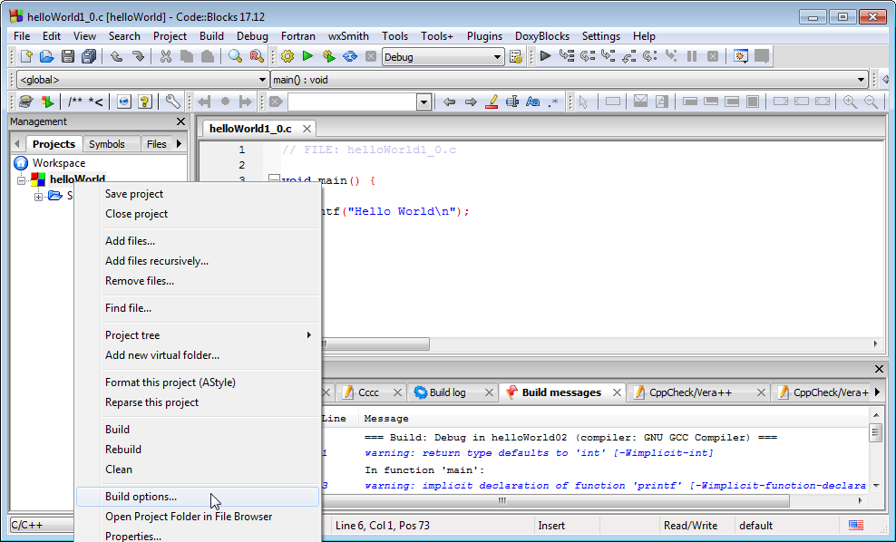

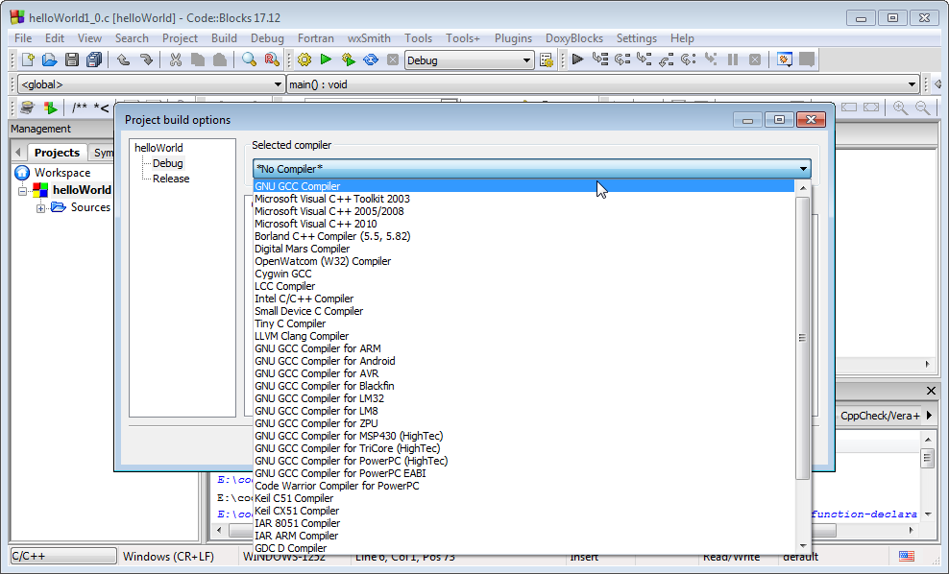

With these setting adjustments, one might have to exit the IDE program. Re-starting Code Blocks will then re-open with the adjusted settings.