**Homework – Inverse Kinematics**

In lab and lecture, the inverse kinematics of a 2-DOF planar manipulator were derived and demonstrated.

1. Reconfigure the original 2-DOF planar manipulator such that Link 1 is a Beam 7 and Link 2 is a Beam 9 and appropriately change in **xl320-ik-1_0.nxc**. Affix four green-colored 1-stud bricks at points that reflect $\left(θ_{1},θ_{2}\right)=\left(90, -90\right), \left(0, 90\right), \left(0, -90\right), \text{and (-90,-90}\text{)} \text{degrees}$, where $θ_{1}$ and $θ_{2}$ are angles of Link 1 and Link 2 respectively.
2. URL to your YouTube video demonstration (20-points)
3. All files (e.g. NXC and Headers). Comment and make readable i.e. make good use of white space (10-points)
4. Recall the DH parameters for the SCARA arm given below and you previously derived ${T_{4}}^{0}$.

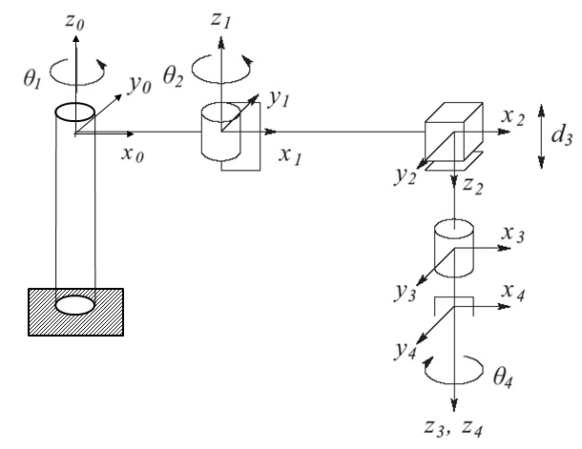

|  |  |  |  |  |
| --- | --- | --- | --- | --- |
| Link | $$a_{i}$$ | $$α_{i}$$ | $$d_{i}$$ | $$θ_{i}$$ |
| 1 | $$a_{1}$$ | 0 | 0 | $${θ^{*}}_{1}$$ |
| 2 | $$a_{2}$$ | 180 | 0 | $${θ^{*}}_{2}$$ |
| 3 | 0 | 0 | $${d^{*}}_{3}$$ | 0 |
| 4 | 0 | 0 | $$d_{4}$$ | $${θ^{*}}_{4}$$ |

* denotes variable

$${T_{4}}^{0}=\left[\begin{matrix}c_{12}c_{4}+s_{12}s_{4} & -c_{12}s_{4}+s_{12}c_{4} & 0 & a_{1}c_{1}+a_{2}c_{12} \\ s_{12}c_{4}-c_{12}s_{4} & -s_{12}s_{4}-c_{12}c_{4} & 0 & a_{1}s_{1}+a_{2}s_{12} \\ 0 & 0 & -1 & -d_{3}-d_{4} \\ 0 & 0 & 0 & 1\end{matrix}\right]$$

The general problem of inverse kinematics is given a homogeneous transformation $H=\left[\begin{matrix}R & o \\ 0 & 1\end{matrix}\right]$ find a solution (possibly non-unique) for $T_{n}^{0}\left(q_{1}⋯q_{n}\right)=H$ where $T_{n}^{0}\left(q_{1}⋯q_{n}\right)=A_{1}(q_{1})⋯A_{n}(q_{n})$. In other words, $H$ is the desired end-effector pose and one needs to find joint variables $q_{1}⋯q_{n}$ so that ${ T}_{n}^{0}\left(q_{1}⋯q_{n}\right)=H$. If say that ${T_{4}}^{0}=\left[\begin{matrix}R & o \\ 0 & 1\end{matrix}\right]$ where $o=\left[\begin{matrix}o_{x} \\ o_{y} \\ o_{z}\end{matrix}\right]=\left[\begin{matrix}a_{1}c_{1}+a_{2}c_{12} \\ a_{1}s_{1}+a_{2}s_{12} \\ -d_{3}-d_{4}\end{matrix}\right]$ is the end-effector position and $R=\left[\begin{matrix}r_{11} & r_{12} & r_{13} \\ r_{21} & r_{22} & r_{23} \\ r_{31} & r_{32} & r_{33}\end{matrix}\right]=$ $\left[\begin{matrix}c_{12}c_{4}+s_{12}s_{4} & -c_{12}s_{4}+s_{12}c_{4} & 0 \\ s_{12}c_{4}-c_{12}s_{4} & -s_{12}s_{4}-c_{12}c_{4} & 0 \\ 0 & 0 & -1\end{matrix}\right]$ is the end-effector orientation.

1. Use the figure below and the Law of Cosines to show that $θ_{2}=\tan^{-1}\left(c_{2},±\sqrt{1-c_{2}}\right)$ where $c_{2}=\frac{{o_{x}}^{2}+{o_{y}}^{2}-{a_{1}}^{2}-{a_{2}}^{2}}{2a_{1}a_{2}}$ (5-points)
2. Show that $θ_{1}=\tan^{-1}{(o_{x},o_{y})}-\tan^{-1}{(a_{1}+a_{2}c_{2}, a_{2}s_{2}}$) (5-points)
3. Given that $θ_{1}+θ_{2}-θ_{4}=α=\tan^{-1}\left(r_{11}, r_{12}\right)$ show that $θ_{4}=θ_{1}+θ_{2}-α$ (5-points)
4. Show that $d_{3}=o_{z}+d_{4}$ (5-points)

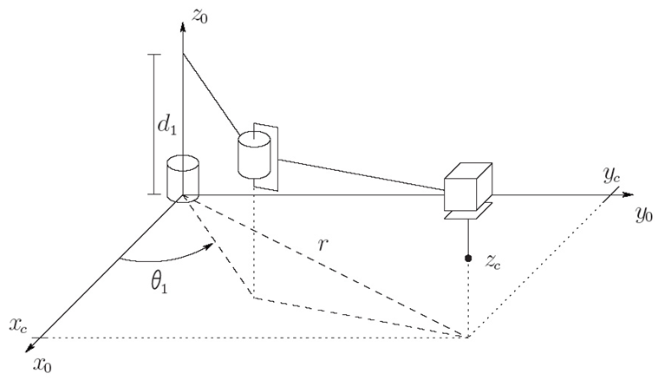

Figure: Configuring the SCARA as above, and projecting the manipulator onto the $x_{0}y_{0}$ plane shows that one can apply the Law of Cosines to show $c_{2}=\frac{{o_{x}}^{2}+{o_{y}}^{2}-{a_{1}}^{2}-{a_{2}}^{2}}{2a_{1}a_{2}}$