**Hands-on Lab**

**XL-320 NXC Programming – Forward Kinematics**

Reference frames determine the relationship of the end-effector’s position relative to the base. Denavit-Hartenberg (DH) notation prescribes the position and orientation of each joint’s frame. The resulting frames define the tool transformation matrix and hence the robot’s forward kinematics. This lab commands the 2-link planar manipulator’s joint angles to verify its end-effector reaches the theoretical position.

**Preliminary:** 2-link Planar Manipulator and Forward Kinematics

**Figure A:** XL-320 servos serve as Joints 1 and 2 of a LEGO-based 2-link planar manipulator (left). The colored circular 1-stud bricks on the base plate are various $\left(x, y\right)$ goals positions for the end-effector. XL-320 manual shows the servo is centered at position 512 [counts] (right).

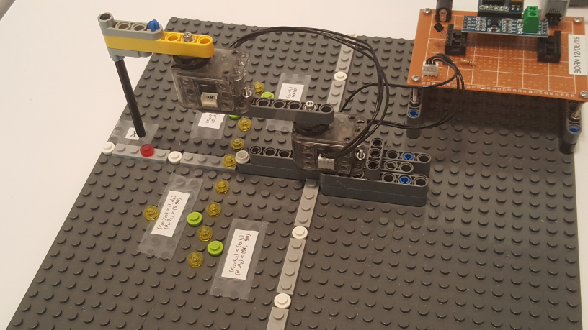

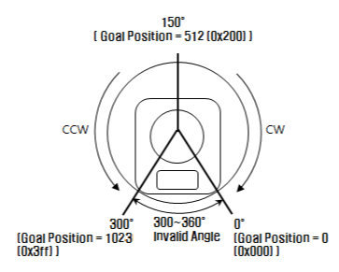

**Figure B** shows a 2-link planar manipulator with link lengths $l_{1}\text{ and}{ l}_{2}$.

**Figure B:** 2-link planar manipulator (left) and with reference frames and rotations $θ_{1}\text{and}θ_{2}$ (right)

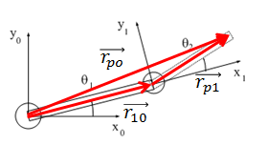

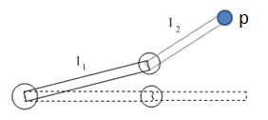

In lecture, the end-effector (EE) $p$ has the position $\left(x_{p0}, y_{p0}\right)$ given by:

$$x_{p0}=l_{1}\cos{θ_{1}}+l_{2}\cos\left(θ_{1}+θ_{2}\right)$$

$$y_{p0}=l_{1}\sin{θ_{1}}+l_{2}\sin\left(θ_{1}+θ_{2}\right)$$

(1)

**Concept 1 Implement Forward Kinematics Equations xl320-2dof-fk-1_0.nxc**

Figure 1A is the NXC code for implementing (1) for the 2-link planar manipulator. The code uses the previously created H-files xl320-defines1_0a.h and xl320-functions1_0d.h which define the constants and functions for using the XL-320 servo.

// FILE: xl320-2dof-fk-1_0.nxc - Works!

// DATE: 01/11/20 19:20

// AUTH: P.Oh

// DESC: Forward kinematics for 2-DOF planar manipulator using Dynamixel XL-320

#include "xl320-defines1_0a.h" // XL-320 defines from Control Table

#include "xl320-functions1_0d.h" // P.Oh functions written for XL-320

#define ID_ALL_MOTORS 0XFE // 0XFE commands all XL-320 motors

#define ID_MOTOR01 0X03 // Assumes Motor 1 configured with ID = 3

#define ID_MOTOR02 0X07 // Assumes Motor 2 configured with ID = 7

#define mmPerStud 8 // 8 millimeters per LEGO stud

// Global variables

bool orangeButtonPushed; // Detect Brick Center button state

bool rightArrowButtonPushed; // Detect Brick right arrow button state

bool leftArrowButtonPushed; // Detect Brick left arrow button state

bool greyButtonPushed; // Detect Brick Grey/Abort button state

void rotateMotorAbsolutely(float angle01, float angle02) { //------------------

// Rotates desired the two Dynamixel XL-320 motors to their desired angles

// Assumes motor count of 512 denotes 0 degrees. Uses right-hand rule for

// rotational direction

float desiredAngle01InDegrees; // Angle Motor 1 to move to [deg]

float desiredAngle02InDegrees; // Angle Motor 2 to move to [deg]

float degreesPerCount; // Conversion 0.29 [degrees/count]

float calculatedCount; // Count equivalent of desired angle [count]

int motor01Offset; // Motor 1's offset [count]

float theta01InDegrees; // Motor 1 angle [counts]

int theta01InCounts; // Motor 1 angle [deg]

int motor02Offset; // Motor 2's offset [count]

float theta02InDegrees; // Motor 2 angle [counts]

int theta02InCounts; // Motor 2 angle [deg]

string msg01, msg02; // dummy strings to print values to screen

motor01Offset = 512; // Set Link 1 at 0 deg (i.e. 512 counts)

motor02Offset = 512; // Set Link 2 at 0 deg (i.e. 512 counts)

// Note 1: Looking into horn from Top, count > 512 is CCW (i.e. +Z axis)

// and count < 512 is CW (i.e. -Z axis)

degreesPerCount = 0.29; // [deg/count] found from XL-320 data sheet

ClearScreen();

desiredAngle01InDegrees = angle01;

theta01InCounts = motor01Offset + desiredAngle01InDegrees/degreesPerCount;

desiredAngle02InDegrees = angle02;

theta02InCounts = motor02Offset + desiredAngle02InDegrees/degreesPerCount;

// Format string so displays nicely on Brick screen

sprintf(msg01, "Goto [%3.1f, " ,desiredAngle01InDegrees);

sprintf(msg02, "%3.1f]" , desiredAngle02InDegrees);

TextOut(0, LCD_LINE2, strcat(msg01, msg02));

XL320_servo(ID_MOTOR01, theta01InCounts, 200); // motor position at speed 200

Wait(2000); // wait about 2 seconds before issuing another command

XL320_servo(ID_MOTOR02, theta02InCounts, 200); // motor position at speed 200

Wait(2000); // wait about 2 seconds before issuing another command

PlayTone(TONE_B3,50);

}; // end rotateMotorAbsolutely function ---------------------------------

**Figure 1A:** Forward kinematics program **xl320-2dof-fk-1_0.nxc**

task main() {

// planar manipulator variables

float l1, l2; // length of link 1 and link 2 [mm]

float theta1, theta2; // angle of joint 1 and joint 2 [rad]

float theta1InDegrees, theta2InDegrees; // angle of joint 1 and 2 [deg]

float xP0, yP0; // end-effector absolute position i.e. wrt x0y0 frame [mm]

int xP0InStuds, yP0InStuds; // [studs]

// calculation and dummy variables

float C, k1, k2, num, den;

int i;

// initializations

l1 = 7 * mmPerStud; // [mm] link 1 is 7 studs long

l2 = 5 * mmPerStud; // [mm] link 2 is 5 studs long

UseRS485();

RS485Enable();

RS485Uart(HS_BAUD_57600, HS_MODE_8N1); //57600 baud, 8bit, 1stop, no parity

ClearScreen();

// Prompt user to begin

TextOut(0, LCD_LINE1, "Start: hit ->");

do {

rightArrowButtonPushed = ButtonPressed(BTNRIGHT, FALSE);

} while(!rightArrowButtonPushed);

ClearScreen();

// First go to home position

ClearScreen();

TextOut(0, LCD_LINE2, "Homing..." );

Wait(2000);

theta1InDegrees = theta2InDegrees = 0.0;

rotateMotorAbsolutely(theta1InDegrees, theta2InDegrees);

Wait(2000);

PlayTone(TONE_E4, 500);

// Second, user sets desired theta 1 and theta 2 here

theta1InDegrees = 0.0; // [deg]

theta2InDegrees = 90.0; // [deg]

theta1 = theta1InDegrees * PI/180; // [rad]

theta2 = theta2InDegrees * PI/180; // [rad]

// Forward Kinematics equations yield end-effector position (xP0, yP0)

xP0 = l1*cos(theta1) + l2*cos(theta1 + theta2); // [mm]

yP0 = l1*sin(theta1) + l2*sin(theta1 + theta2); // [mm]

// End-effector position in LEGO studs

xP0InStuds = ceil(xP0 / mmPerStud); // round up [stud]

yP0InStuds = ceil(yP0 / mmPerStud); // round up [stud]

ClearScreen();

TextOut(0, LCD_LINE1, "Will go to:" );

TextOut(0, LCD_LINE3, FormatNum("xP0 = %3d studs" , xP0InStuds) );

TextOut(0, LCD_LINE5, FormatNum("yP0 = %3d studs" , yP0InStuds) );

// Prompt user to begin motion

TextOut(0, LCD_LINE8, "Yes: hit ->");

do {

rightArrowButtonPushed = ButtonPressed(BTNRIGHT, FALSE);

} while(!rightArrowButtonPushed);

ClearScreen();

rotateMotorAbsolutely(theta1InDegrees, theta2InDegrees);

// Last, go back to home position and quit

ClearScreen();

TextOut(0, LCD_LINE2, "Back to Home" );

Wait(2000);

theta1InDegrees = theta2InDegrees = 0.0;

rotateMotorAbsolutely(theta1InDegrees, theta2InDegrees);

Wait(2000);

PlaySound(SOUND_DOUBLE_BEEP);

} // end main

**Figure 1A continued:** **xl320-2dof-fk-1_0.nxc**

This particular 2-link planar manipulator uses two XL-320 servos; joints 1 and 2 have IDs 0x03 and 0x07 respectively and hence defined accordingly. Recall, the motivation to use LEGO stems from its standard 8 $mm$ stud spacing. This spacing is universally used in all LEGO parts and hence provides a standard basis to calibrate lengths and assess positioning accuracies. As such the mmPerStud is also defined.

The links are affixed to the XL-320’s horns with M2.5 screws. Before screwing these LEGO beams, they are oriented to align with the +X-axis. This means each XL-320 is centered (i.e. 512 [count]) as shown in Figure A (right). This orientation is defined to be zero degrees. The function rotateMotorAbsolutely is written to account for this 512 [count] offset as seen by the yellow-highlighted lines for motor01Offset and motor01Offset.

The main function defines the link lengths. This particular 2-link planar manipulator uses Technic Beams 7 and 5 for link lengths $l_{1}\text{ and }l_{2}$ respectively.

The Brick sets Port 4 for RS485 communications at 57,800 baud (8N1) and upon execution, prompts the user to push the right arrow button to commence. Once pushed, the XL-320 servos are commanded to their home position. For this example, home position is defined by having the two links aligned with the +X axis.

For this example, joint angles are set at $θ_{1}=0.0\text{ [deg] and }θ_{2}\text{[deg]}$ respectively. One can envision the result as shown in **Figure 1B**.

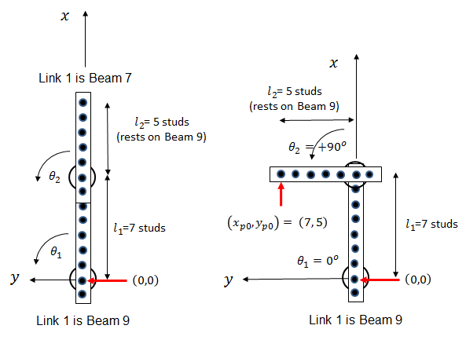

**Figure 1B:** 2-link planar manipulator in home position (left). Configuration after execution (right)

The lines below are the forward kinematics for the 2-link planar manipulator as given in (1). Note that NXC says cos and sin take radians as arguments.

xP0 = l1*cos(theta1) + l2*cos(theta1 + theta2); // [mm]

yP0 = l1*sin(theta1) + l2*sin(theta1 + theta2); // [mm]

The program displays the calculated EE position in stud values. Since these calculations are in float, the NXC ceil function rounds up to the nearest integer of studs. After reaching the EE position, the program then returns to the home position.

Congratulations! You implemented Forward Kinematics for the 2-link planar manipulator

Exercises

* 1. Edit **xl320-2dof-fk-1_0.nxc** to also display the EE’s position in millimeters on the Brick
  2. Calculate (1) by hand, execute program with the commanded angles and verify stud values to complete the table below

|  |  |  |  |
| --- | --- | --- | --- |
| $$θ_{1}$$ [deg] | $$θ_{2}$$ [deg] | Equation (1)  [studs] | Observed value  [studs] |
| 0 | +90 | (7, 5) | (7, 5) |
| 0 | -90 |  |  |
| +90 | -90 |  |  |
| -90 | -90 |  |  |
| +45 | +45 |  |  |

* 1. Unscrew and reverse the beams such that Link 1 is a Beam 7 and Link 2 is a Beam 9. Repeat 1.2 to complete a new table
  2. Introduce an offset by add a L-shape 3 x 5 Liftarm (Part# 32526) between Links 1 and 2 (see figure below). Link 1 will still remain aligned with the +X axis but this Beam 5 causes Link 2 to be offset (but parallel) to the +X axis. Use DH notation to derive the resulting tool transformation matrix and complete a new table like in 1.2

