**Homework – Forward Kinematics**

Recall that for a 2-link planar manipulator the end-effector (EE) $p$ has the position $\left(x_{p0}, y_{p0}\right):$

$$x_{p0}=l_{1}\cos{θ_{1}}+l_{2}\cos\left(θ_{1}+θ_{2}\right)$$

$$y_{p0}=l_{1}\sin{θ_{1}}+l_{2}\sin\left(θ_{1}+θ_{2}\right)$$

(1)

For both 1 and 2 provide the following

1. All files (e.g. NXC and Headers). Comment and make readable (e.g. good use of white space)
2. URL to your YouTube video demonstrating this program
3. Show hand calculations given (1) and the values in Columns 1 and 2 to complete Column 3. Execute program with those values to complete Column 4 below (20-points).

|  |  |  |  |
| --- | --- | --- | --- |
| $$θ_{1}$$ [deg] | $$θ_{2}$$ [deg] | Equation (1)  [studs] | Observed value  [studs] |
| 0 | +90 | (7, 5) | (7, 5) |
| 0 | -90 |  |  |
| +90 | -90 |  |  |
| -90 | -90 |  |  |
| +45 | +45 |  |  |

1. Unscrew and reverse the beams such that Link 1 is a Beam 7 and Link 2 is a Beam 9. Repeat Question 1 to complete a new table (20-points).
2. The DH parameters for the two-link planar arm are given below (above left). Confirm by hand calculations and derivations the given ${T_{2}}^{0}$ (15-points).
3. The DH parameters for the SCARA arm are given below (above right). Confirm by hand calculations and derivations the given ${T_{4}}^{0}$ (15-points).

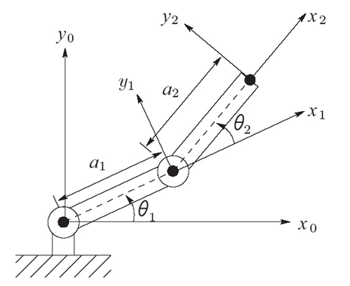

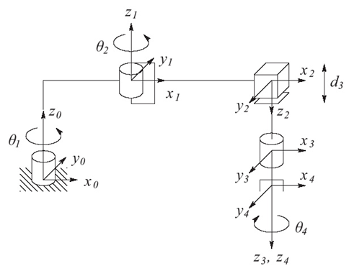

|  |  |  |  |  |
| --- | --- | --- | --- | --- |
| Link | $$a_{i}$$ | $$α_{i}$$ | $$d_{i}$$ | $$θ_{i}$$ |
| 1 | $$a_{1}$$ | 180 | 0 | $${θ^{*}}_{1}$$ |
| 2 | $$a_{2}$$ | 0 | 0 | $${θ^{*}}_{2}$$ |
| 3 | 0 | 0 | $${d^{*}}_{3}$$ | 0 |
| 4 | 0 | 0 | $$d_{4}$$ | $${θ^{*}}_{4}$$ |

* denotes variable

$${T_{4}}^{0}=\left[\begin{matrix}c_{12}c_{4}+s_{12}s_{4} & -c_{12}s_{4}+s_{12}c_{4} & 0 & a_{1}c_{1}+a_{2}c_{12} \\ s_{12}c_{4}-c_{12}s_{4} & -s_{12}s_{4}-c_{12}c_{4} & 0 & a_{1}s_{1}+a_{2}s_{12} \\ 0 & 0 & -1 & -d_{3}-d_{4} \\ 0 & 0 & 0 & 1\end{matrix}\right]$$

|  |  |  |  |  |
| --- | --- | --- | --- | --- |
| Link | $$a_{i}$$ | $$α_{i}$$ | $$d_{i}$$ | $$θ_{i}$$ |
| 1 | $$a_{1}$$ | $$α_{1}$$ | $$d_{1}$$ | $$θ_{1}$$ |
| 2 | $$a_{2}$$ | $$α_{2}$$ | $$d_{2}$$ | $$θ_{2}$$ |

$${T_{2}}^{0}=\left[\begin{matrix}c_{12} & -s_{12} & 0 & a_{1}c_{1}+a_{2}c_{12} \\ s_{12} & c_{12} & 0 & a_{1}s_{1}+a_{2}s_{12} \\ 0 & 0 & 1 & 0 \\ 0 & 0 & 0 & 1\end{matrix}\right]$$