**Homework –Denavit-Hartenberg and XL-320 Joint/Wheel Modes**

Commanding the XL-320 Dynamixel in Joint and Wheel modes was introduced in lab. The H-files and example NXC code to program the XL-320 to move to desired angles and/or angular speeds were covered in Lab. Denavit-Hartenberg notation was covered in lecture.

1. Write an NXC program that reads the NXT Brick’s left and right buttons. When the right button is pushed, the XL-320 velocity increases by 100. When the left button is pressed, the velocity decreases by 100. Hitting the Orange button stops rotation. (20-points). Provide the following
2. All files (e.g. NXC and Headers). Comment and make readable (e.g. good use of white space)
3. URL to your YouTube video demonstrating this program
4. Write a NXC program to home the 1-DOF planar manipulator at position 512. This puts the 1-DOF planar manipulator in the 12:00 position. Then command the servo to rotate 45-degrees clockwise. What the XY stud position of the manipulator’s end-effector? (20-points). Provide the following
5. All files (e.g. NXC and Headers). Comment and make readable (e.g. good use of white space)
6. URL to your YouTube video demonstrating this program

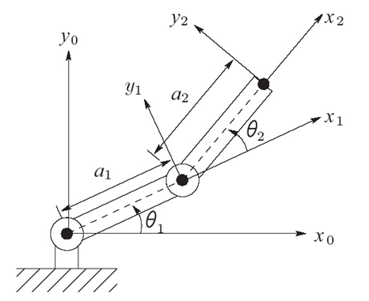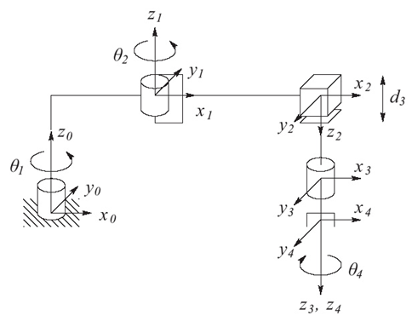

|  |  |  |  |  |
| --- | --- | --- | --- | --- |
| Link |  |  |  |  |
|  |  |  |  |  |
|  |  |  |  |  |

1. For the two-link planar arm shown above, show that the DH parameters are