Project: XL-320 based SCARA Robot

Preamble: SCARA (Selective Compliance Articulated Robot Arm) is commonly used for pick-and-place tasks in assembly lines. This 4 degree-of-freedom robot consists of 2 revolute joints (like the 2-link planar manipulator), a prismatic vertical joint, and a revolute wrist (gripper). Figure A shows a sketch with reference frames and a real-world SCARA. The prismatic joint is selectively made *compliant* (by adding or using springs, pneumatics, and/or dampers) to facilitate insertion tasks (peg-in-hole problem). *Articulation* refers to the fact that the 2-links mimics the human upper-and-lower arm movement.

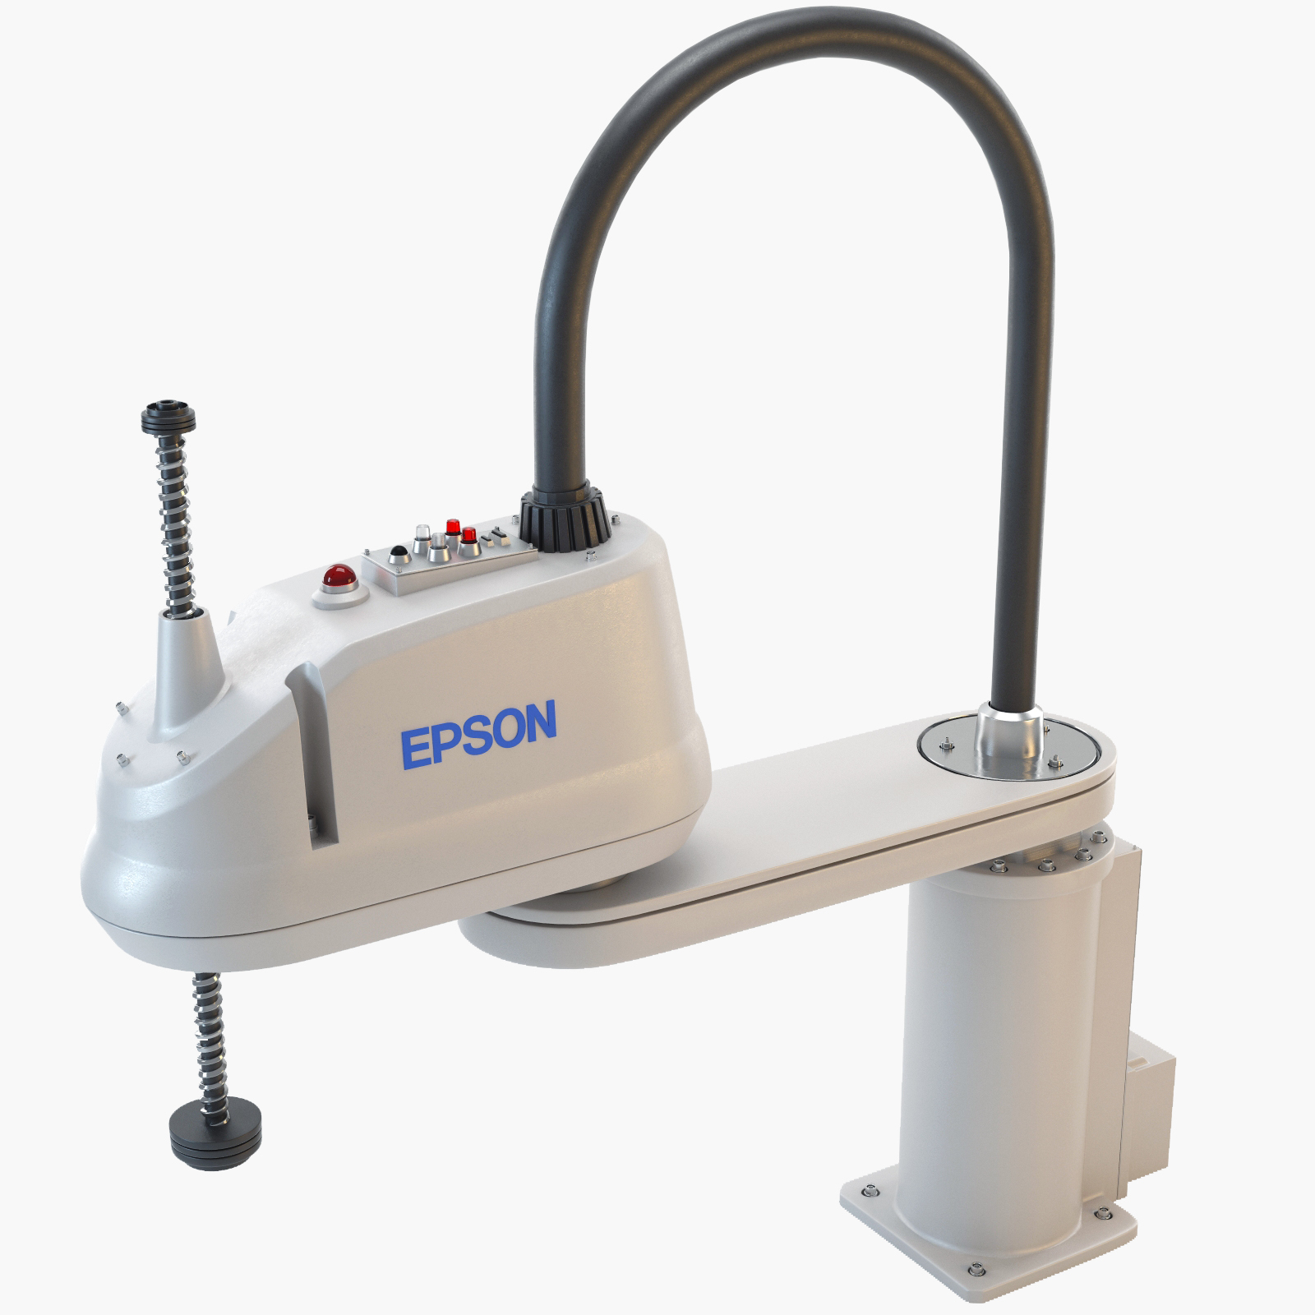

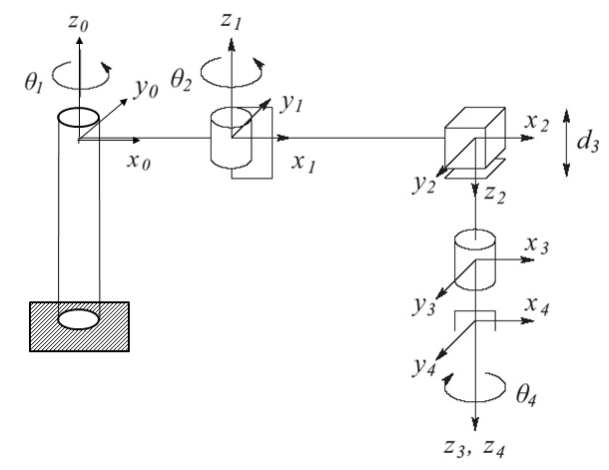

**Figure A:** Reference frames using Denavit-Hartenberg convention (left). Many manufacturing robot companies like Epson (right) offer SCARA products. Video of operation: <https://www.youtube.com/watch?v=nSDM3eqcwuY>

Project Goal: Synthesize and demonstrate a SCARA robot using three XL-320 servos and Lego parts. The prismatic joint adds a 3rd DOF to the 2-link planar manipulator. Thus, the SCARA’s end-effector should be able to hover over any $(x, y, z)$ point in the robot’s workspace. To verify this, a smaller base plate or a stack of LEGO bricks and plates can be affixed to the 32x32 baseplate. The Lego spacing standard (i.e. 8 mm per stud) can be used to visually confirm this.

Methodology: The mounting and mixed-use of XL-320 servos with Legos, the forward kinematics, tool transformation matrix, and inverse kinematics were all studied in class; the analysis of the 2-link planar manipulator was analyzed and experimentally confirmed. This project serves to reinforce these principles. One is given freedom to mechanically design the prismatic joint (e.g. rack-and-pinion, slider-crank, worm gear, etc) but it must use an XL-320 servo, Lego parts and screws, washers, and nuts are allowed. Lego parts cannot be irreversible altered (e.g. drilling additional holes or glued). Lego part connections can only be reinforced with fasteners (like M2.5 hardware) and not with glue or tape. The guiding principle is to demonstrate a Lego-based SCARA robot, understanding that the XL-320 servo substitutes for the ill-suited Lego motors.

Deliverables: Complete the given template to document and demonstrate the following:

1. Derivations of the Denavit-Hartenberg parameter table (using Figure A), the tool transformation matrix ${T_{4}}^{0}$, and inverse kinematics (15-points).
2. Photo build plan annotated with part name, number, and quantity, and captioned with 1-2 sentence instruction. Refer to build plans given in class labs as examples (15-points).
3. Provide 3 case study forward kinematics examples with hand calculations. These examples show that commanding the joint values (e.g. $θ_{1}$, $θ_{2}$, and $d_{3})$ the SCARA robot’s end-effector hovers over the calculated $(x, y, z)$ stud location (15-points)
4. Demonstrate using videos (YouTube links) and sequence of image grabs from video the SCARA’s forward kinematics verify the case studies in 3 above (20-points)
5. Provide 3 case study inverse kinematics examples with hand calculations. These examples would predict the SCARA robot’s joint values for a given $(x, y, z)$ stud location (15-points).
6. Demonstrate using videos (YouTube links) and sequence of image grabs from video the SCARA’s forward kinematics verify the case studies in 5 above (20-points).

Tips:

1. Bricklink’s free Studio software (<https://www.bricklink.com/v2/build/studio.page>) was used in ME 425/625 to design Lego-like step-by-step build instructions. Studio features over 3000 Lego parts. This could help finding suitable parts to design the SCARA (e.g. prismatic joint).
2. The “Lego Mechanisms” link in <http://www.daslhub.org/unlv/wiki/doku.php> features 300 different Lego mechanisms with photos, videos, and Studio-based build plans. These could provide ideas for the prismatic joint (e.g. #154 to #161 #174 to #178, #235 to #236. These use the Lego Power Function (PF) motors. But these mechanisms reveal principles and could be adapted to use the XL-320 servo.
3. The lab has a wide inventory of Lego parts. Thus if one finds desired parts, please contact the lab so you can pick them up. Please note that 60% of the project grade revolves around demonstrations. Thus, it’s important to design your SCARA early.