**Supplemental Notes**

**Lego SCARA arm – Determining Vertical Resolution**

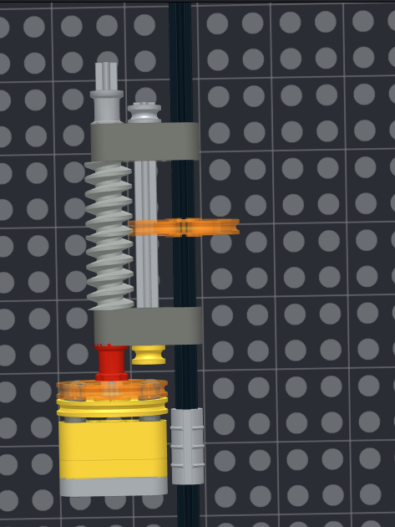

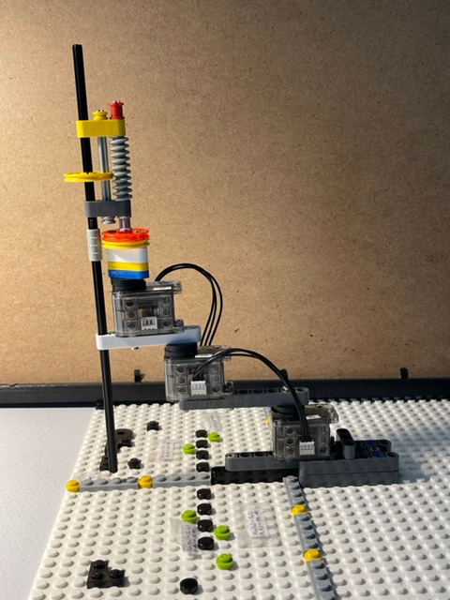

**Figure 1A**: A 3-DOF SCARA arm constructed from Lego and XL-320 Dynamixels (left). The vertical DOF (right) uses worm gears and a wedge belt pulley.

**Figure 1A**: Classic 3-DOF SCARA arm constructed with three XL-320 Dynamixels and Lego

**Vertical Resolution**

**Question 1**: How does the vertical DOF work?

Answer 1: First, observe in Figure 1A (right) that Lego part 4185 (wedge belt pulley) slides across Lego part 4716 (worm gear). In other words, this is mechanism isn’t a traditional worm-spur gear. Rather, the worm simply acts as a threaded “screw” and the wedge belt pulley acts as a “nut”. As the worm rotates, the wedge translates.

**Question 2**: If the worm acts as a screw, what are its dimensions?

**Figure 1B**: Worm gear has 5 peak-to-peak spacings (yellow braces) and spans 2 studs

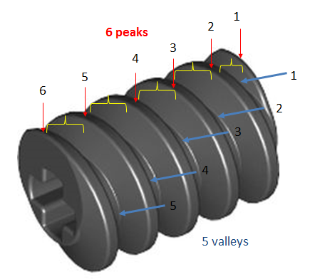

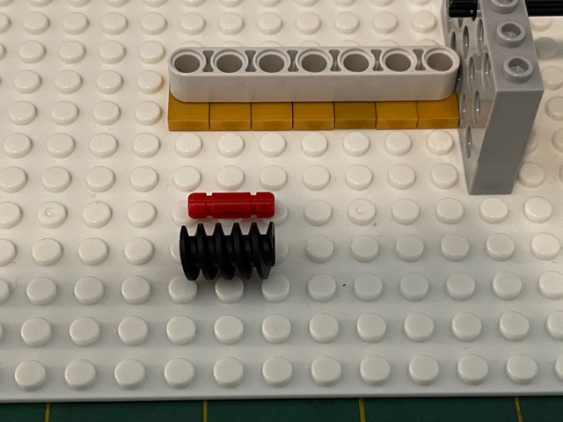

Answer 2: Observing the worm gear (**Figure 1B left**), one easily counts 5 peak-to-peak spacings. This means it takes 5 worm gear revolutions to go from end-to-end.

Also, one sees (**Figure 1B right**), the worm gear is the same size as an Axle 2. Thus the worm gear spans 2 studs. Recall a stud, which also known as a Fundamental Lego Unit (FLU) is 8 millimeters. Thus we can say the worm gear:

$$\frac{5 \text{revolutions}}{2 \text{studs}}=2.5 \frac{\text{revolutions}}{\text{stud}}$$

**Question 3**: How many revolutions does it take to span one Brick height?

**Figure 1C**: From <http://cs.wellesley.edu/~rds/handouts/LEGOStructures.pdf>, all Lego bricks are 6/5 FLU (or studs) tall (left). Since a FLU is 8 mm, this means the Brick is 9.6 mm tall (right). Note: height does not include the stud part.

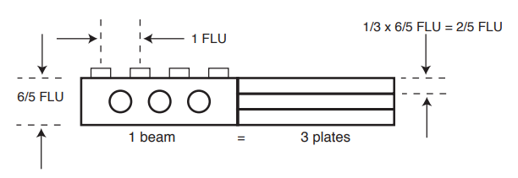

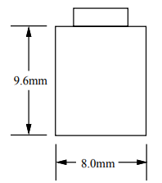

Vernier calipers indeed confirms 9.6 mm is the height of a Brick 1x1

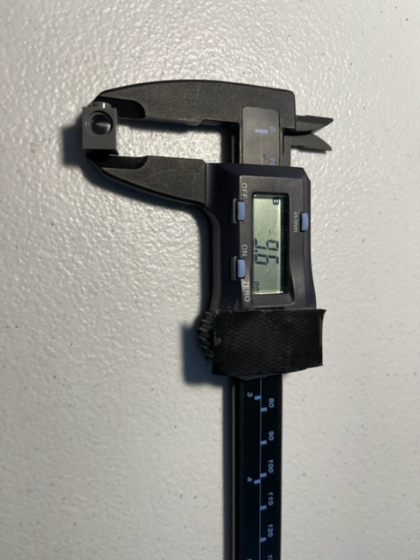

Answer 3: Referring to Figure 1C, one calculates the following:

$$2.5 \frac{\text{revolutions}}{\text{FLU}}×\frac{6}{5}\text{FLU}=3 \text{revolutions}$$

A YouTube video demonstrates 3 revolutions results in 9.6 mm translation <https://youtu.be/OvmJYHDu_bo> using the NXC program **xl320-scaraTest0_1b.nxc**.

**Question 4**: What’s the total vertical distance this arm can travel?

Answer 4: The mechanism employs two worm gears. This means 10 peak-to-peak spacings in total. Hence, it will take 10 revolutions for the wedge belt pulley to translate 4 FLU = 4*8 millimeters = 32 millimeters.

**Question 5**: What’s the vertical resolution? That is, how many millimeters of travel per degree?

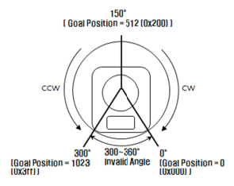

**Figure 1D**: Source <https://emanual.robotis.com/docs/en/dxl/x/xl320/> shows the XL-320 spans 0 to 300 degrees in servo mode. This means the XL-320 has a 0.29 degree/count resolution.

Answer 5: Recall that the XL-320’s encoder spans from 0 to 1023 counts for motion of 0 to 300 degrees. This results in 0.29 degrees/count.

One has:

$$1 \frac{\text{revolution}}{360 \text{degrees}}×\frac{\text{FLU}}{2.5\text{ revolutions}}×\frac{\text{8 mm}}{\text{FLU}}=8.89×{10}^{-3}\frac{\text{mm}}{\text{deg}}$$

Alternatively this means 112.5 degrees per millimeter of travel.

In terms of count:

$$8.89×{10}^{-3}\frac{\text{mm}}{\text{deg}}×0.29\frac{\text{deg}}{\text{count}}=2.31×{10}^{-3}\frac{\text{mm}}{\text{count}}$$

Alternatively this means 432 counts per millimeter.