**Mid-term – Part 2 Hands-on Section (Open Book) – 90 minutes time limit**

**Instructions:** Complete your answers in the space below (do not use back of paper).

**Student Name** _________________________ **Final Score** out of 50: ________

1. Write an NXT program that switches from Wheel Mode and Joint Mode. When the left arrow button is pushed, the XL-320 rotates continuously (say, at 200). When right arrow button is pushed, the XL-320 continuously rotates back and forth from -90 to +90 degrees (10-points)
2. Construct a 2-link planar manipulator using a Beam 7 (link 1) and Beam 5 (link 2) as sketched below.

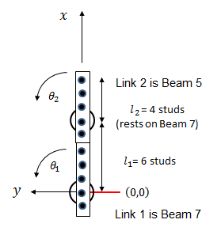

1. Using forward kinematics, write your calculations (showing equations used) to complete the following table’s 3rd column (10-points)

|  |  |  |  |
| --- | --- | --- | --- |
| $$θ_{1}$$ [deg] | $$θ_{2}$$ [deg] | [studs] | Observed value  [studs] |
| 0 | +90 | (7, 5) | (7, 5) |
| 0 | -90 |  |  |
| +90 | -90 |  |  |
| -90 | -90 |  |  |
| +45 | +45 |  |  |

1. Write, execute and demo an NXC program to complete the 4th column of the above table (10-points)
2. Using the above 2-link planar manipulator Affix four green-colored 1-stud bricks at points that reflect $\left(θ_{1},θ_{2}\right)=\left(90, -90\right), \left(0, 90\right), \left(0, -90\right), \text{and (-90,-90}\text{)} \text{degrees}$, where $θ_{1}$ and $θ_{2}$ are angles of Link 1 and Link 2 respectively. Write, execute and demo an NXC program that shows the manipulator’s end-effector hovers over each of the four 1-stud bricks (20-points)