**Homework – Lagrange**

Email PDF version no later than beginning of next class.

**Handwrite** your derivations (do not simply cut-and-paste from notes)

1. Use Lagrangian Method to derive the equations of motion for the pulley system given in Lecture *(5-points)*
2. Use Lagrangian Method to derive the equations of motion for the wagon problem given below. Use the notation and reference frame for your derivations *(10-points)*

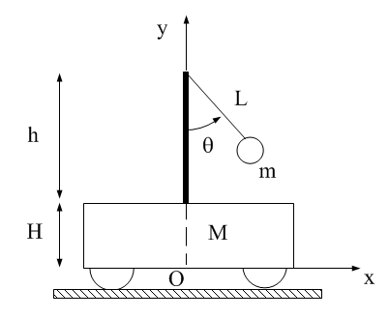

1. Use Euler-Newton method and derive the Equations of Motion for the ball-and-beam system (left figure below). Use the relative reference frame as shown in the right figure below *(10-points)*

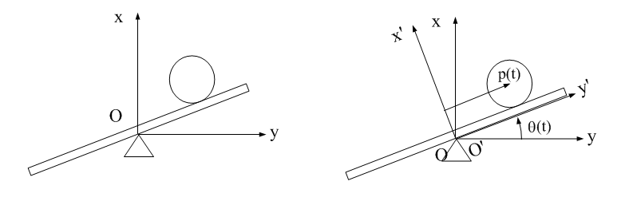

1. Use Lagrange Method to derive the Equations of Motion for the ball-and-beam system. Note, the answer should be the same as above using the Euler-Newton method *(15-points)*