**Hands-on Lab**

**Lego Interfacing**

Digital Input and Output (DIO) expanders, like the PCF8574, allow the NXT to interface to a wide range of devices. The DIO lines can be used to actuate binary devices like switches, relays and transistors and 8-bit peripherals like external LCD screens.

**Review – NXT and the PCF8574**

The PCF8574 is an I2C chip that when connected to an NXT, gives the Brick 8 digital lines. In previous concepts, these lines could turn on/off LEDs (output) or read a switch’s on/off position (input). These concepts are the “Hello World” version of embedded micros. The usefulness of such on/off output or input becomes clear when LEDs are replaced with relays or transistors.

**Concept 1 – NXT and Reed Relays**

A relay is an electromechanical switch. A reed relay has a small form factor and is capable of handling low voltage, low current devices. Energizing its coil (often labeled COM) will throw the relay’s switch from a normally open (often labeled N.O.) state to a closed one.

**Step 1:** With the PCF8574 circuit constructed from before, wire up the schematic (**Fig. 1A**). In this circuit, only one digital (output) line (D0) is needed. Typically, a SPST (single pole, single throw) relay has 4 pins. Two of them represent the coils’ ends. The remaining two refer to the ends of switch.

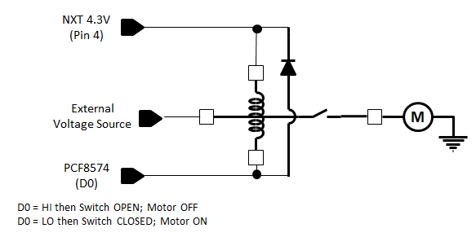

**Fig. 1A:** Interfacing a reed relay to the NXT using one PCF8574 digital output line.

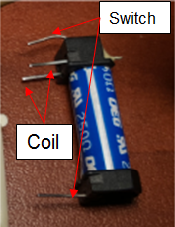

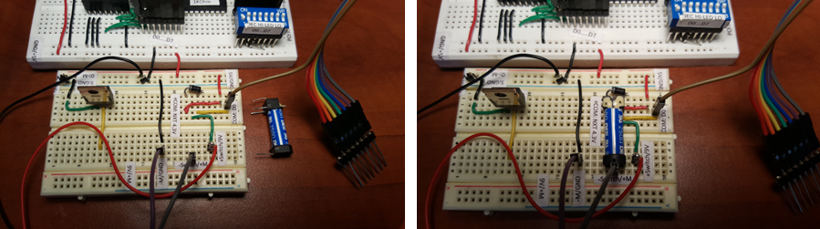

**Fig. 1B:** Part placement on a solderless breadboard (left). The reed relay inserted into place (right)

The toy DC motor used in **Fig. 1A** can easily draw over 1 A. Since the PCF8574 can only source about 20 mA, an external power supply is needed. A 9V battery’s +’ve terminal connected to one end of the relay’s switch, and the –‘ve one connects to NXT’s GND pin. This ties all ground lines together.

**Step 2:** Compose an NXC program called dioRelay1_0.nxc.

// FILE: dioRelay1_0.nxc - Works

// AUTH: P.Oh

// DATE: 09/19/16 11:26; 09/23/16 08:19

// VERS: 1.0 - PCF8574A digital output. Reed relay (+5V coil) connected to D0

// When D0 is LO, then relay COM should close

// NOTE: Uses PCF8574A chip (hence address A2-A1-A0 set to 0-0-0 hence 0x70

// 9V battery (or power supply) drives toy DC motor.

#define I2Cport S1 // Port number

#define I2CAddr8574 0x70 // I2C address x040 8574 or 0x70 for 8574A

task main() {

// array variables (since NXC's I2C functions take array variables

byte WriteBuf[2]; // data written to PCF8574A. Declares a two one-byte variables

byte ReadBuf[]; // data received from PCF8574A. We won't be reading any data but we need this for I2CBytes

int RdCnt = 1; // number of bytes to read

// button variables

bool orangeButtonPushed, rightArrowButtonPushed, leftArrowButtonPushed, greyButtonPushed, overflowFlag;

// Counting variables

int decimalNumber; // values from 0 to 255

SetSensorLowspeed (I2Cport); // PCF8574A connect to NXT on S1

// Prompt user to begin

// First, set address with first I2CWrite. Recall, WriteBuf[1] has address 0xF0 0x00

WriteBuf[1] = 0x00; // i.e. write zeros to port sets up PCF8574A for writing

WriteBuf[0] = I2CAddr8574; // i.e. address is 0x70

I2CBytes(S1, WriteBuf, RdCnt, ReadBuf);

// Lets start with D0...D7 set to HI

WriteBuf[1] = 0xFF; // Port lines are HI; so, reed relay should be open and Line_Out should be LO

WriteBuf[0] = I2CAddr8574; // i.e. address is 0x70

I2CBytes(S1, WriteBuf, RdCnt, ReadBuf);

TextOut (0, LCD_LINE1, "Orange Btn starts");

do {

orangeButtonPushed = ButtonPressed(BTNCENTER, FALSE);

} while(!orangeButtonPushed);

ClearScreen();

TextOut(0, LCD_LINE1, "Orange BTN quits");

TextOut(0, LCD_LINE3, "Reed Relay");

TextOut(0, LCD_LINE4, "<-OFF/ON->");

decimalNumber = 0;

do {

greyButtonPushed = ButtonPressed(BTNEXIT, FALSE);

// If pressed, then grey button becomes TRUE. If not pressed, then grey button is FALSE

rightArrowButtonPushed = ButtonPressed(BTNRIGHT, FALSE);

leftArrowButtonPushed = ButtonPressed(BTNLEFT, FALSE);

if(rightArrowButtonPushed) {

// right button pushed, so turn on relay's coils.

// set digital line D0 LO

decimalNumber = 0; // D0 is now LO; NXT's 5V can now flow thru coil, thus switch ON and motor ON

WriteBuf[1] = decimalNumber;

WriteBuf[0] = I2CAddr8574;

I2CBytes(S1, WriteBuf, RdCnt, ReadBuf);

TextOut (0, LCD_LINE6, FormatNum("%3d - Relay ON " , decimalNumber));

// now coils activated; switch is closed and resistance between COM and N.O. should be almost zero

};

if(leftArrowButtonPushed) {

// left button pushed, so turn off relay's coils

// set digital line D0 HI

decimalNumber = 1; // DO is now HI; NXT's 5V can't flow thru coil, thus switch remains closed and motor OFF

WriteBuf[1] = decimalNumber;

WriteBuf[0] = I2CAddr8574;

I2CBytes(S1, WriteBuf, RdCnt, ReadBuf);

TextOut (0, LCD_LINE6, FormatNum("%3d - Relay OFF" , decimalNumber));

// now coils are de-activated; switch is open and resistance between COM and N.O. should be infinite

};

Wait(250); // wait 250 millsec

} while(!greyButtonPushed && !overflowFlag);

TextOut(0, LCD_LINE5, "Finished!");

PlaySound(SOUND_DOUBLE_BEEP);

} // end main

Code Explanation: Much like dioOutput2_0.nxc from a previous lab, dioRelay1_0.nxc configures the PCF8574’s eight digital lines for output. A do-while loop continuous reads button presses. Pushing the right arrow button (rightArrowButtonPushed) closes the switch and turns the motor on and vice-versa with the left arrow button. The program aborts when the grey button is pressed.

**Exercise 1:** In NxC create programs for the following:

* 1. Replace the DC motor with a buzzer so that closing the relay’s switch results in a sound
  2. Modify your code and wiring to turn the motor on using digital line D1.

**Concept 2 – Concept 1 – NXT and Transistors**

Like a relay, a transistor is a switch. Unlike a relay, transistors do not have any mechanical parts. As such, they are capable of switching much quicker than relays, and have longer mean-time-between-failures (MTBF). Popular NPN transistors include the TIP31 and IRF510 which both come in TO-220 packages. The TIP31 is a current-driven transistor, whereas the IRF510 is a voltage-driven one. Since the PCF8574’s source current is low, turning on or off a current-hungry device like a motor is best done using the IRF510. The IRF510 is called a MOSFET and allows current to flow when its gate pin is above a certain voltage (about 5 Volts). One could employ a TIP31, but then a current-to-voltage converter would be needed.

Step 1: Breadboard the schematic in **Fig. 2A**, noting the IRF510’s pin labels (**Fig. 2B**)

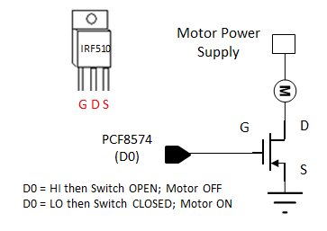

**Fig. 2A:** Interfacing a IRF510 MOSFET to NXT using one of the PCF8574’s digital output lines.



**Fig. 2B:** The IRF510 MOSFET can simply insert into the solderless breadboard.

**Fig. 2A** does not use any diodes (and capacitors) in contrast to **Fig. 1A**. While the circuit in **Fig. 2A** will work, the back-EMF from the motor could kick-back enough current to damage the digital line. The analogy is back-wash in hydraulics. A capacitor across the motor leads and a diode will prevent such back-wash to occur.

**Step 2:** Write and execute an NxC program called dioMosfet1_0.nxc

Much like dioOutput2_0.nxc and dioRelay1_0.nxc, one can set digital line D0 HI (+5V) or LO (GND) by setting decimalNumber to 1 or 0 respectively.

When the right arrow button is pressed, have the motor turn on and vice-versa with the left arrow button. Use the grey button to abort the program.

**Exercise 2:**

2-1: Refer to dioInput2_0.nxc and dioDipLed2_0.nxc from a previous lab. Write a program that reads DIP switch positions, and when the value is one, turn on the motor. For any other DIP switch value, the motor turns off. You can use either a reed relay or IRF510 circuit.