**Hands-on Lab**

**Lego Communications – I2C Basics**

The Lego NXT has 4 sensor ports. Each port is capable of I2C communications. The PCF8574 is an I2C chip that provides 8-bit digital lines. These lines can be configured to serve as outputs or inputs. The net effect is that I2C and the PCF8574 increase the NXT’s capabilities to interface and communicate with devices.

**Preamble – NXT and the PCF8574**

A high or low signal represents a binary system. Electronically, these signal states are represented by voltages. In TTL (transistor-to-transistor logic) chips, +5V is HI and GND is LO. The ability to control HI and LO states is important; when interfaced to devices, these states allow a computer to turn on/off actuators (like lights, relays and transistors) or read the closed/open state of sensors (like switches).

The wires that connect a computer to a device are called digital lines. These lines are often bundled together and called a port. Quite common is an 8-bit port where eight lines form a port. In part, this is historical because 8-bits (called a byte) yield $2^{8}-1=255$ unique states. In ASCII, which is the standard to represent alphanumeric characters, 255 states could capture all English letters, digits and symbols.

*PCF8574 Motivation:* Suppose one wants their NXT Brick to turn on an off-the-shelf relay or read a standard 12-key keypad. Since such devices are rarely I2C-compatiable, one has to resort to using digital lines. The PCF8574 provides such lines. It is I2C-compatiable and yields eight digital lines. Each line can be configured to be either an output or input one. Conceivably, the PCF8574 can control up to eight relays or other on/off actuator (like a DC motor or lamp). It can also read up to eight separate switches. The eight lines can be configured into a single 8-bit port which is useful if one wants to interface the Brick to a separate LCD display.

**Concept 1 – NXT and the PCF8574 Digital Outputs**

**Step 1:** Using the following schematic (**Fig. 1A**), construct the PCF8574 circuit on a solderless breadboard. Advice: Insert DIP devices (e.g. PCF8574, Resistor network and Bar Graph) into sockets. Then insert sockets into the breadboard. Use (rainbow ribbon) jumpers between PCF8574 and the Resistor network. Reduce wiring; take advantage of common lines e.g. GND on the breadboard.

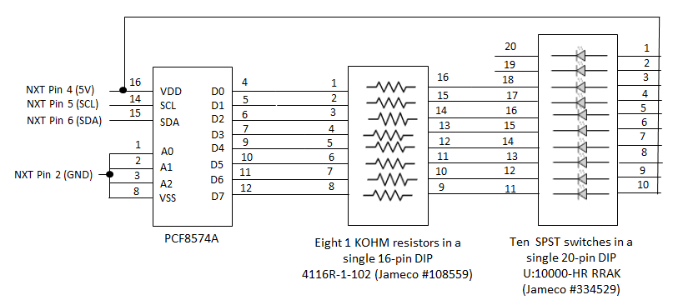

**Fig. 1A:** NXT-to-PCF8574 circuit diagram. Takes advantage of DIP resistor and LED DIP packages. PCF8574A’s digital lines (D0-D7) are configured for output and sink current.

**NB:** The pin labels and numbers in schematics often do not reflect their physical position in the real DIP device. Real DIP devices enumerate counter-clockwise. Pin 1 on the real DIP device is the first top left pin. Pin 2 is the next pin and so forth. A physical marking (e.g. notch) on the DIP device denotes which side is top.

**Step 2:** Compose, compile and run the following NXC program called dioOutput2_0.nxc.

// FILE: dioOutput2_0.nxc - Works!

// AUTH: P.Oh

// DATE: 07/20/16 10:32

// VERS: 2.0 Uses I2CBytes and my understanding of registers

// DESC: Connect to Port S1. LEDs configured to sink i.e. when bit is "O" then LED lights up

// NOTE: Uses PCF8574A chip (hence address A2-A1-A0 set to 0-0-0 hence 0x70

#define I2Cport S1 // Port number

#define I2CAddr8574 0x70 // I2C address x040 8574 or 0x70 for 8574A

task main() {

// array variables (since NXC's I2C functions take array variables)

byte WriteBuf[2]; // data written to PCF8574A. Declares a two one-byte variables

byte ReadBuf[]; // data received from PCF8574A. We won't be reading any data but we need this for I2CBytes

int RdCnt = 1; // number of bytes to read

// button and counting variables

bool orangeButtonPushed, rightArrowButtonPushed, overflowFlag;

int decimalNumber; // values from 0 to 255

SetSensorLowspeed (I2Cport); // PCF8574A connect to NXT on S1

// Prompt user to begin

// First, set address with first I2CWrite. Recall, WriteBuf[1] has address 0xF0 0x00

WriteBuf[1] = 0x00; // i.e. write zeros to port sets up PCF8574A for writing

WriteBuf[0] = I2CAddr8574; // i.e. address is 0x70

I2CBytes(S1, WriteBuf, RdCnt, ReadBuf);

// Lets start with all LEDs on. This means making the port LO

WriteBuf[1] = 0x00; // Port lines are LO; LEDs should be on

WriteBuf[0] = I2CAddr8574; // i.e. address is 0x70

I2CBytes(S1, WriteBuf, RdCnt, ReadBuf);

TextOut (0, LCD_LINE1, "Right Btn starts");

do {

rightArrowButtonPushed = ButtonPressed(BTNRIGHT, FALSE);

} while(!rightArrowButtonPushed);

TextOut(0, LCD_LINE1, "Orange BTN quits");

decimalNumber = 0;

do {

orangeButtonPushed = ButtonPressed(BTNCENTER, FALSE);

// If pressed, then orange button becomes TRUE. If not pressed, then orange button is FALSE

WriteBuf[1] = decimalNumber;

WriteBuf[0] = I2CAddr8574;

I2CBytes(S1, WriteBuf, RdCnt, ReadBuf);

TextOut (0, LCD_LINE3, FormatNum("Value Out: %3d" , decimalNumber));

// Play beep for major bits being lit up

if( (decimalNumber == 0) || (decimalNumber == 2) || (decimalNumber == 4) ||

(decimalNumber == 8) || (decimalNumber == 16) || (decimalNumber == 32) ||

(decimalNumber == 64) || (decimalNumber == 128) ){

PlaySound(SOUND_LOW_BEEP);

Wait(1000);

}; // end if

if(decimalNumber == 255) {

overflowFlag = TRUE;

} else {

overflowFlag = FALSE;

decimalNumber++;

WriteBuf[1] = decimalNumber;

}

Wait(250); // wait 250 millsec

} while(!orangeButtonPushed && !overflowFlag);

TextOut(0, LCD_LINE5, "Finished!");

PlaySound(SOUND_DOUBLE_BEEP);

} // end main

**Code Explanation:** The NxC statement SetSensorLowSpeed(I2Cport)sets Port S1 for I2C communications with an I2C device. The PCF8574 is the I2C device. The NXT needs to know the device’s address. **Fig.1A** ties the PCF8574’s address pins (A0, A1, and A2) to GND.

The circuit (and code) uses the *PCF8574A* specifically. The datasheet for this particular version of the PCF8574 states that A2-A1-A0 (i.e. 0-0-0) corresponds to address 0x70 (i.e. 70 hexadecimal). Hence, the statement WriteBuf[0] = I2CAddr8574.

The PCF8574A datasheet states that to set the digital lines as outputs, one must write 0x00 to the address. Hence, the statement WriteBuf[1] = 0x00.

Next, the statement I2CBytes(S1, WriteBuf, RdCnt, ReadBuf)is used to send the array (containing the address and setting) through the NXT Brick.

**Fig. 1A** also shows that +5V is being driven into the eight LEDs, through their corresponding resistors, and into the PCF8574A’s eight digital lines (D0-D7). In other words, the PCF8574A is *sinking* current. This means that when a digital line is LO (i.e. 0V), the LED lights up. This is because the current from the NXT Brick’s Pin 4 (+5V) can flow through the LED and its resistor. If the digital line is HI (i.e. 5V), then current cannot flow, and the LED remains dark. Sinking current is often preferred (albeit somewhat counter-intuitive). This is because devices can often sink more current than it can source. The PCF8574 datasheet says it can sink about 25 mA, but only source 20 mA.

Before the code enters a do-while loop, all LEDs are turned on by setting the eight digital lines (D0-D7) LO. The do-while loop then iterates decimalNumber from 0 to 255. The statements send the decimal number across the digital lines and lights up the corresponding LEDs. The pattern of LEDs reflects the binary equivalent of the decimal number:

WriteBuf[1] = decimalNumber;

WriteBuf[0] = I2CAddr8574;

I2CBytes(S1, WriteBuf, RdCnt, ReadBuf);

The if-statements just add some fun to the program. Major decimal numbers are just powers of two such as 0, 2, 4, 8…128. In these instances, only one of the LEDs in the bar-graph display will be dark while the remaining seven will be lit. The Brick beeps when this happens.

The NXT is quite fast, hence a Wait(250) statement is inserted in the do-while loop. This allows one to actually see the individual LEDs light up or go dark.

**Exercise 1:** In NxC create programs for the following:

* 1. Modify your circuit and modify dioOutput2_0.nxt (call the new program dioOutput2_1.nxc) so that the PCF8574A sources current. Here, when the digital lines D0-D7 are HI, then the corresponding LED should light.

**Concept 2 – NXT and the PCF8574 Digital Inputs**

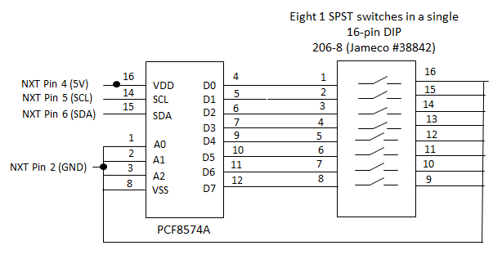

**Fig. 2A:** NXT-to-PCF8574 circuit diagram. Takes advantage of DIP switch package. PCF8574A’s digital lines (D0-D7) are configured for input.

**Step 1:** Add the DIP switch component to your original circuit (**Fig. 1A**). Use a socket for the DIP switch and take advantage of the GND line that runs along your solderless breadboard.

Blah: Add photos! Add code dioInput2_0.nxc

**Step 2:** Write and execute the following NxC program

// FILE: dioInput2_0.nxc - Works!

// AUTH: P.Oh

// DATE: 07/20/16 17:32

// VERS: 1.0 - PCF8574A digital input. Read DIP switch and display decimal value

// 1.1 - Same, but without using pcf8574llb.nxc library. Uses I2CBytes(S1, WriteBuf, RdCnt, ReadBuf)

// 2.0 - Same as 1.1 but using I2CBytes based on my understanding of PCF8574A

// DESC: DIP switch configured with pull-ups. Closed switch (i.e. ON) means 0 Volts going into bit

// NOTE: Uses PCF8574A chip (hence address A2-A1-A0 set to 0-0-0 hence 0x70

#define I2CAddr8574 0x70 // 0x40 8574 or 0x70 for 8574A. NB: 0x70 = 0111 0000

task main(){

// PCF8574 read/write variables

byte WriteBuf[2]; // set up two one-byte variables

byte ReadBuf[]; // Byte received from PCF8574

int RdCnt = 1; // number of bytes to read

// button variables

bool orangeButtonPushed, rightArrowButtonPushed;

// Counting variables

int decimalNumber; // values from 0 to 255

SetSensorLowspeed(S1); // PCF8574A connect to NXT on S1

// (1) First, set up PCF8574A for reading.

WriteBuf[0] = I2CAddr8574; // this is the address 0x70

WriteBuf[1] = 0xFF; // writing ones to the port sets up chip for reading

I2CBytes(S1, WriteBuf, RdCnt, ReadBuf); // OK, now port set up for reading

TextOut (0, LCD_LINE1, "Right Btn starts");

do {

rightArrowButtonPushed = ButtonPressed(BTNRIGHT, FALSE);

} while(!rightArrowButtonPushed);

TextOut(0, LCD_LINE1, "Orange BTN quits");

do {

orangeButtonPushed = ButtonPressed(BTNCENTER, FALSE);

// If pressed, then orange button becomes TRUE. If not pressed, then orange button is FALSE

// (2) Read the port

I2CBytes(S1, WriteBuf, RdCnt, ReadBuf);

decimalNumber = ReadBuf[0]; // value read from PCF8574

TextOut (0, LCD_LINE3, FormatNum("Value Read: %3d" , decimalNumber));

// Play beep for major switch being closed

if( (decimalNumber == 0) || (decimalNumber == 2) || (decimalNumber == 4) ||

(decimalNumber == 8) || (decimalNumber == 16) || (decimalNumber == 32) ||

(decimalNumber ==64) || (decimalNumber == 128) ){

PlaySound(SOUND_LOW_BEEP);

Wait(1000);

}; // end if

Wait(10);

} while(!orangeButtonPushed); // end do

TextOut(0, LCD_LINE5, "Finished!");

PlaySound(SOUND_DOUBLE_BEEP);

} // end main

**Code Explanation:** To read the actual ADC value (called $raw$), one uses the NxC statement touchSensorRawValue = SensorRaw(IN_1). Recall that we have a 10-bit ADC, so the raw value will range from 0 to $2^{10}-1=1023.$ Thus, we can calculate the unknown resistor that lies between Pins 1 and 2 with the formula

(2)

$$R=\frac{10000}{1023-raw}raw$$

So, this homemade ohmmeter can detect resistances between $≈9Ω$ and 10,220,000 $Ω$.

**Exercise 2:**

2-1: Derive the equation (2) above and calculate the min and max resistances that can detected

2-2: Replace a fixed resistor with a potentiometer and show with a real ohmmeter, that your NxC program works

**Concept 3 – ADC Voltages:** Build a voltmeter

Recall that a 10-bit ADC results in (raw) decimal values ranging from 0 to 1023. The ADC is connected to a +5V power supply inside the NXT Brick, Thus, the (raw) decimal values corresponding to 0 and 1023 for 0V and 5V respectively. Or, a formula:

(3)

$$V_{m}=\frac{raw}{1023}∙5 [Volts]$$

**Exercise 3:**

3-1. Write an NxC program that implements equation (3). Use the NxC statement SensorRaw(IN_1) for your program to report raw values that digitally represent a voltage across Pins 1 and 2. Call your program volt1_0.nxc – to represent your homemade voltmeter.

3-2: Connect a 1.5V battery or variable power supply to Port 1. The +’ve part of the battery or power supply connects to Pin 1 (AN). The –‘ve part goes into Pin 2 (i.e. GND). Run your volt1_0.nxc so that it displays the voltage of the battery or power supply. Compare the Brick’s value with a real voltmeter.

3-3. From equation (3), what is calculated resolution (in volts) of the Brick’s 10-bit ADC?