**Homework – Electronics and Numbering Systems**

Email PDF version no later than beginning of next class.

1. Convert the following numbers to binary. Show calculations i.e. don’t just use a calculator to write down the answer *(10 points)*
2. 64
3. 67
4. 99
5. 608
6. 2000
7. Convert the following binary numbers to decimal. Show calculations i.e. don’t just use a calculator to write down the answer *(10 points)*
8. 10101010
9. 1010101
10. 1111111100000000
11. 1100110011101001
12. 0000000011111111
13. Given the following eight LED circuit, what decimal number inputs are needed to light the appropriate LEDs? *(10 points)*

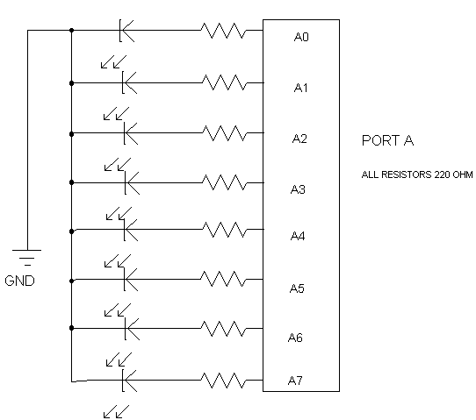

* 1. LEDs A0, A2, A4, A6 and A8 on and the rest are off?
  2. LEDs A1, A3, A5, and A7 on and the rest are off?
  3. LEDs A5 and A7 on and the rest off?
  4. LEDs A0, A1, A2, A3, A4, A6 on and the rest off?
  5. LEDs A0 and A7 on and the rest off?

1. Write an NXC program called binary1_0.nxc that iterates from 0 to 255 decimal and displays both the decimal and binary equivalent on the Brick. Include screen shots showing that your program is operating correctly. Point credit/deduction will look at variable type-casting (i.e. floats versus integers) and equations that involve the two, and code commenting (25 *points*).
2. Reference Class notes on file-writing and timing. Write an NXC program that extends Question 3 above, called binary 2_0.nxc. This program will print to file, every 0.25 seconds, the decimal number (0 to 255) and it’s binary equivalent. Shows screen shots of the XLS file and resulting plot. Point credit/deduction will look at variable type-casting (i.e. floats versus integers) and equations that involve the two, and code commenting (25 *points*).
3. Show all your mathematical work to find the equivalent capacitance of each circuit (10 points)

A.

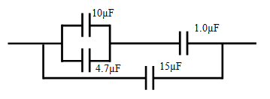

B.

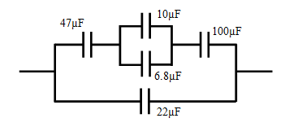

1. Show all your mathematical work to find the equivalent resistance of each circuit (10 points)

