**Hands-on Lab**

**NXT Motor Characteristics: Part 3 – Motor Characteristics**

Parts 1 and 2 respectively created the platform (motorized winch-and-chart) and the instrumentation (ammeter for measuring running current). This final part details the steps for capturing data to ultimately plot the NXT motor’s torque related curves: (1) velocity versus torque; (2) current versus torque; and (3) mechanical power versus torque. Examples of these curves are given in **Figure A** below

**Figure A:** Sample curves resulting from NXT motor measurements

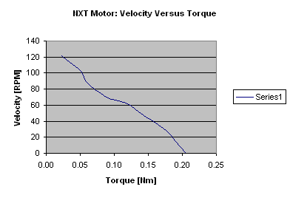

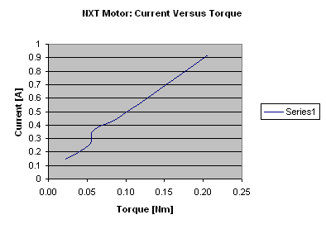

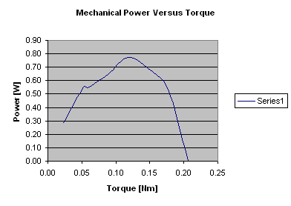

These curves should not be surprising. In lecture, the underlying DC motor equations were derived. The plots confirm the phenomena: motor velocity is inversely proportional to torque i.e. Equation (1); motor current is proportional to torque i.e. Equation (2); and the motor’s mechanical power is inversely parabolic to torque i.e. Equation (3):



(1)



(2)



(3)

One also observes that a motor has a maximum power value. **Figure A** (right) shows that this is at half the stall torque. The motor velocity at maximum motor power can be eye-balled by intersecting the left and middle plots in Figure A. Or, one can manipulate the above equations, and calculate the velocity when the derivative is set to zero. Exercises will follow to confirm this.

First, complete **Table 1**

|  |  |
| --- | --- |
| Parameter | Value |
| Lego wheel radius | [m] |
| Lego loading cart mass | [Kg] |
| NXT Brick Voltage | [V] |

**Table 1:** Preliminary values

**Step 1:** Identify the surface where you intend to clamp your motorized winch-and-cart. This could be desk, door or some overhang. The key is to have enough time to observe your ammeter’s reading while the motor winches the loading cart. Once identified, cut enough fishing line and tie it to the winch’s wheel and the cart’s crossbar. In **Figure 1** below, the platform was clamped to a door and 83 cm of fishing line was used.

**Figure 1:** Prepare fishing line length and tie to both winch’s wheel and loading cart’s crossbars

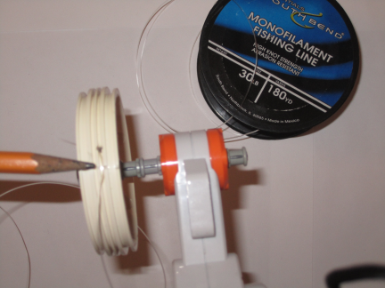

Tie fishing line through hole in wheel

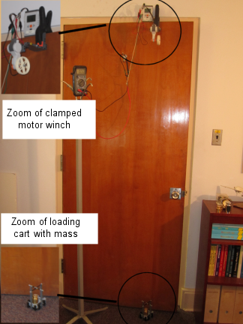

A door makes for a good clamping surface

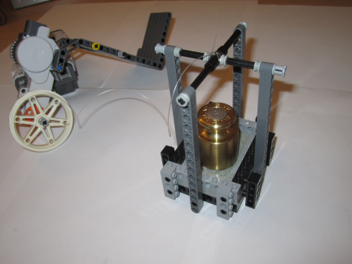

Tie other end of fishing line to cart’s crossbars

**Step 2:** Set up your ammeter in series (refer to Lab Part 2 – Electrical Connections if needed).

**Step 3**: From a previous lab entitled “NxC for Motor Speed and for Data Acquisition”, load the program helloWriteMotorSpeedToFile1_0. Recall, this file commands the NXT motor (attached to Port A) to rotate at the 100% level, and records the motor velocity every 25 milliseconds.

**Step 4:** With an empty cart, execute helloWriteMotorSpeedToFile1_0. Be prepared to catch the cart when you kill this program (the motor loses power when the program is aborted). Abort the program when the cart reaches near the top of the wheel. As the cart is winched up, observe the ammeter current. Record this current’s value in **Table 2** below. Open the captured motor velocity data files and plot in Excel to eye-ball the steady-state velocity. Sample currents and velocities are given in **Table 2**. Replace these with your own values.

|  |  |  |
| --- | --- | --- |
| Payload [Kg] | Current  [A] | Velocity  [RPM] |
| 0.00 | 0.15 | 122 |
| 0.10 | 0.25 | 101 |
| 0.20 |  | 89 |
| 0.30 | 0.45 |  |
| 0.40 |  |  |
| 0.50 |  |  |
| 0.60 |  |  |
| 0.70 | 0.92 | 0 |

**Table 2:** Observed current and captured velocity

**Step 5:** Repeat Step 4 by loading masses in the cart as per Table 2. Replace the example values with your own measurements and observed values.

**Step 6:** Use the completed Table 2 to calculate and create **Table 3** (perhaps with Excel). Replace the sample values with your own

|  |  |  |  |  |
| --- | --- | --- | --- | --- |
| Total Mass [Kg] | Current  [A] | Velocity  [RPM] | Torque  [Nm] | Power  [W] |
| 0.08 | 0.15 | 122 | 0.02 | 0.29 |
| 0.18 |  |  |  |  |
| 0.28 |  |  |  |  |
| 0.38 |  |  |  |  |
| 0.48 | 0.56 | 63 | 0.12 | 0.78 |
| 0.58 |  |  |  |  |
| 0.68 |  |  |  |  |
| 0.78 |  |  |  |  |

**Table 3:** Calculated Torque and Power values

For the 4th column in Table 3, the torque is

 [Nm]

(4)

For the 5th column in Table 3, the mechanical power is

 [W]

(5)

**Exercise:** Using Table 3 values

1. In Excel, recreate Figure A (left) by plotting velocity (y-axis) in RPM versus torque (x-axis) in Nm.
2. In Excel, recreate Figure A (middle) by plotting current (y-axis) in Amps versus torque (x-axis) in Nm.
3. In Excel, recreate Figure A (right) by plotting power (y-axis) in Watts versus torque (x-axis) in Nm.
4. What is your NXT motor’s stall current in Amps?
5. What is your NXT motor’s maximum power value in Watts?
6. At what torque and velocity does the maximum power value correspond to?

**Summary:** This 3-part lab details the creation of a Lego-based motorized winch-and-cart, the electrical connections for using an ammeter to measure motor current and tables to be completed by observing current and capturing motor velocities. The net effect is a methodology that can be applied to any DC motor; one loads the motor with known torques (fixed motor wheel radius and weights) to plot current, velocity and mechanical power. Such plots are important because one can then select the correct motor (and/or motor/gear combination) to meet load requirements of a mechatronic system or robot.