**Hands-on Lab**

**NXT Motor Characteristics: Part 2 – Electrical Connections**

This part details how to measure motor current. An NXT cable is spliced (Figure A) in order to place an ammeter in series with the NXT Brick and NXT motor (Figure B). The motor is commanded to move and the resulting motor current is displayed on the ammeter (Figure C).

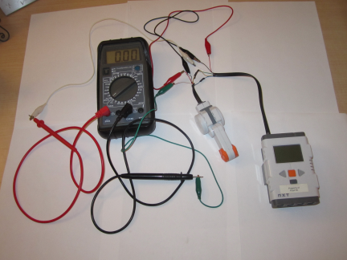

**Figure B:** Ammeter is clipped to spliced leads

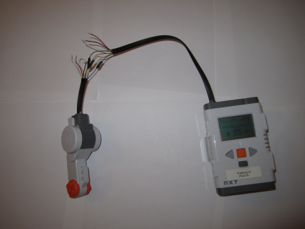

**Figure A:** NXT Cable is spliced

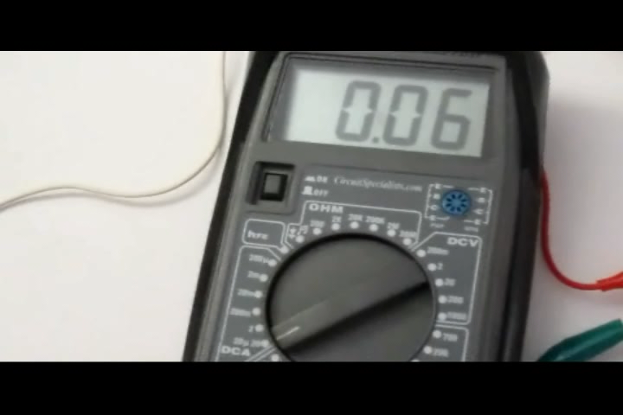

**Figure C:** Ammeter close up reveals 6 milliamp running current at no load and lithium NXT battery at 100% motor speed

**Step 1:** Referring to **Figure 1A**, splice an NXT cable. If possible, try to only splice the Black, Red and White wires (see **Figure 1B**)

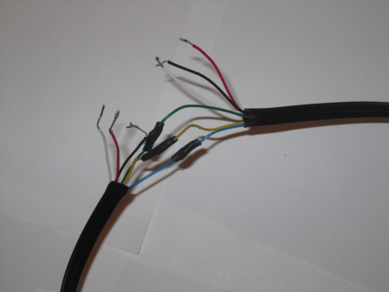

**Figure 1B:** only the Red, White and Black wires will be used

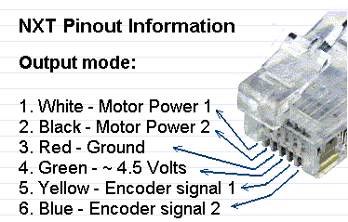

**Figure 1A:** NXT Cable wire diagram

**Step 2:** Set your multimeter to measure current (i.e. ammeter). Since motor currents can easily exceed 1 Amp, set your ammeter to its highest rating e.g. 10 or 20 A). Referring to **Figure 2A**, set connect your ammeter’s leads with the red one inserted into CURRENT and the black one to COM (i.e. ground)

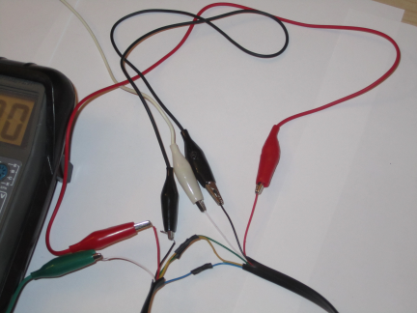

**Figure 2B:** Red alligator clips connect the NXT cable’s red wires. Black clips connect the cable’s black wires

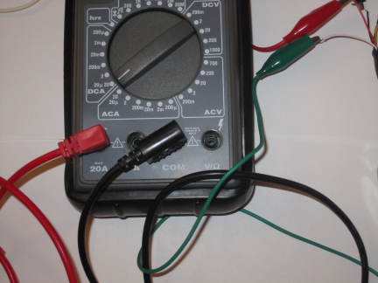

**Figure 2A:** This multimeter is set for a 20 Amp ammeter (see dial and red lead). The black lead is connected to COM

Because the ammeter will be placed in series, one only needs access to one power wire. The **white** one (i.e. Motor Power 1) will be used. As such, red and black alligator clips are used to respectively tie the NXT cable’s red and black wires (see **Figure 2B**).

**Step 3:** Plug one end of the spliced NXT cable to the Brick and the other to the motor. Next, connect a white alligator clip to the spliced white wire (the one closest to the Brick). Attach the other end of the white alligator clip to the ammeter’s red lead. Next, connect a green alligator clip to the ammeter’s black lead. Connect the remaining end of the green alligator clip to the spliced white wire (the one closet to the motor. See **Figure 3A**.

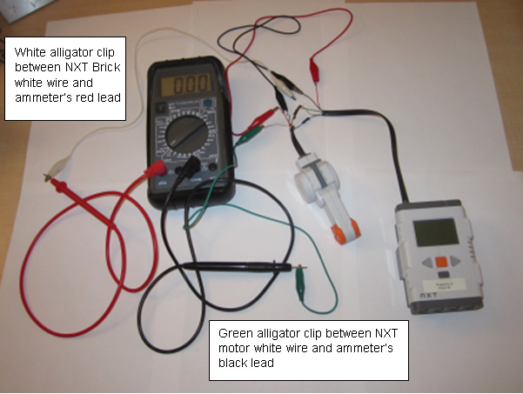

**Figure 3A:** Hooking up ammeter in series. Current flows from Brick’s white wire, into the ammeter’s positive lead (red), through the ammeter, exits through ammeter’s ground lead (black) and into the NXT motor’s white wire.

**Step 4:** Turn on your ammeter. Command your NXT motor to move at 100%. The motor should rotate and the resulting current should be displayed. For a fully charged NXT Brick battery, the running current should be about 0.06 Amps.

Grip the motor’s axis in an attempt to slow the rotational velocity. The running current should increase and will be indicted by the ammeter. Try stalling the motor by stopping rotation with your hands. The ammeter will report a stall current of about 0.9 Amps. Do not stall the motor for more than a few seconds, otherwise the motor coils will burn out and thus destroy the motor!

**Summary:** This Part 2 of the lab details how to connect an ammeter in series to measure motor current. The next step is to apply this series connection to the motorized winch-and-cart (from Part 1). Part 3 will detail this application. By winching known masses and observing running currents one can collect current versus torque data. This data will ultimately serve to capture motor characteristics.