**Hands-on Lab**

**NXT Motor Characteristics: Part 1 – Motorized Winch-and-Cart**

Previously, the underlying equations for a DC motor were derived. NxC code was also introduced to command NXT motor velocities and capture sampled data to file. The resulting motor velocity versus time plot showed a 1st order response. This lab serves to reinforce remaining DC motor theoretical concepts, namely: (1) motor velocity is inversely proportional to torque; (2) motor current is proportional to torque; and (3) motor mechanical power is inversely parabolic with torque. The net effect is a hands-on lab to appreciate DC motor performance. Many mechatronic systems are composed of DC motors. Consequently appreciating performance characteristics will aid one when design decisions involve DC motors.

**Preamble:** A DC motor’s torque can be measured in many ways. A common setup mimics a winch – a wheel of known radius is fixed to the motor’s shaft. A rope connects the wheel to known masses. The motor is commanded to winch the mass and the resulting current and velocities are then captured. **Figures A** and **B** are photos of a Lego-based realization.

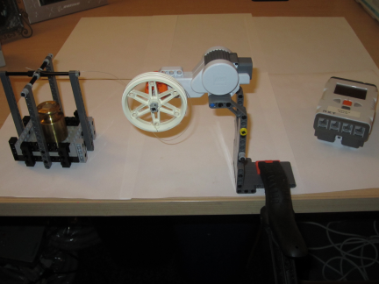

**Figure B:** The winch (motor and wheel) are clamped to overhang from a desk. The mass can then suspend from the desk.

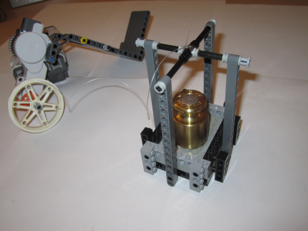

**Figure A:** Fishing string connects a 3-cm radius wheel to a known mass (cart and weight).

From physics, one knows that torque  is equal to the product of force and lever arm. Given a suspending mass, the force is the product of the known mass and gravitational constant. The lever arm is simply the wheel’s radius. Consequently:



One runs winch trails with various masses. A trial would involve capturing the resulting motor velocity and motor current. Trials would end when the mass is too great for the motor to winch. This state is called the stall torque and stall current. These are states at which the motor would burn out and catastrophically fail if prolonged too long. The following presents step-by-step build instructions for a Lego-based winch for future measurement trials.

**Motorized Winch-and-Cart Fabrication**

The NXT Educational Kit (9797) has all parts to create the motor winch. The only exception is the wheel (Part 2903) which was included in the original Mindstorms Invention Kit). There are 2 parts to the Motorized Winch-and-Cart: (1) the motor winch; and (2) the loading cart.

**Part 1:** The Motor Winch consists of 3 sub-assemblies: clamp arm, hinge and motor arm.

**Step 1:** Assemble the **clamp arm** as shown in **Figures 1A – 1D**. This sub-assembly is the part that clamps to a desk (or a door, as will be described later).

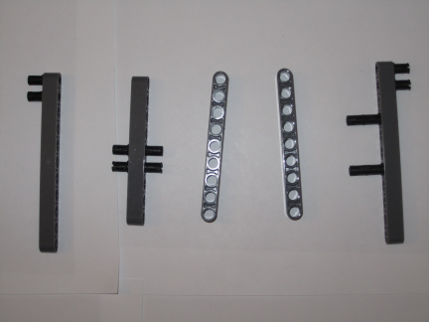

**Figure 1B:** Insert pins into beams as shown

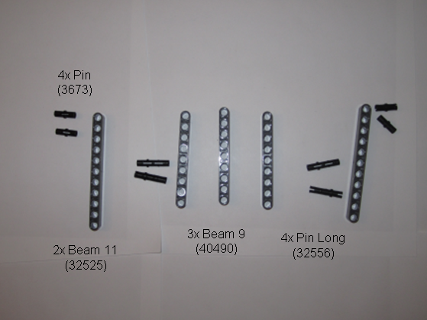

**Figure 1A:** Beams and pins for clamp arm

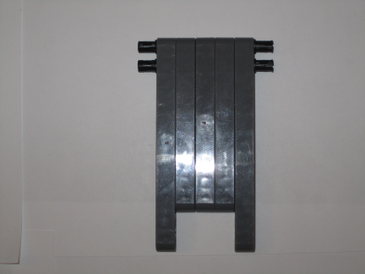

**Figure 1D:** Final realization. This part will clamp to a desk or door

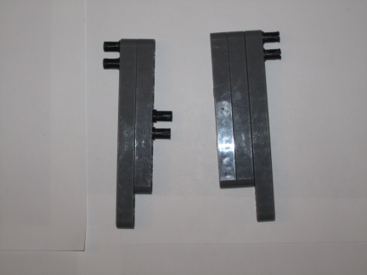

**Figure 1C:** Connect beams as shown

**Step 2:** Assemble the **hinge** as shown in **Figures 2A-2C**. This sub-assembly will connect the motor arm (Step 3) with the clamp arm (Step 1)

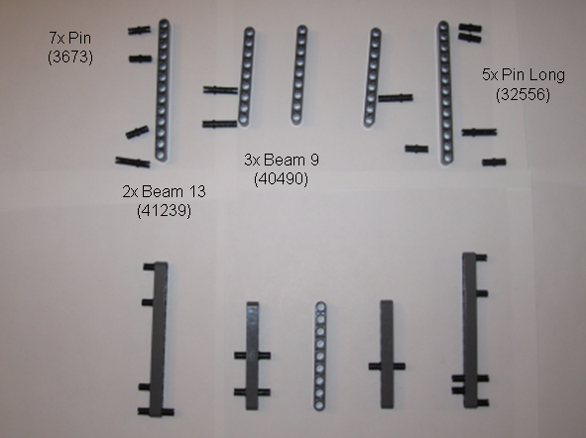

**Figure 2A:** Top shows parts for the hinge. Bottom shows pin insertions

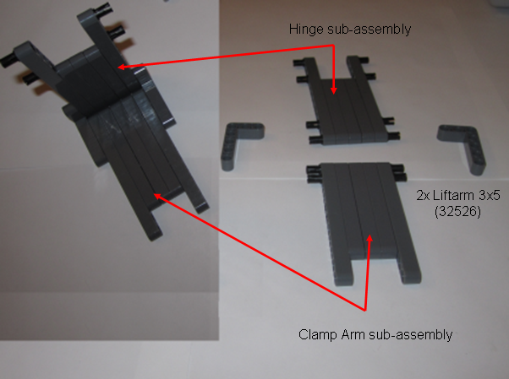

**Figure 2C:** Right shows constructed clamp arm (from Step 1) and hinge (from Step 2). Left shows how the two are connected with liftarms

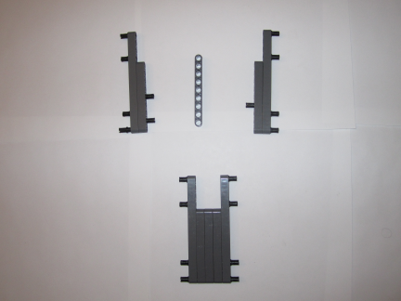

**Figure 2B:** Top shows beam connections. Bottom shows the completed hinge

**Step 3:** Assemble the **motor arm** as shown in **Figures 3A-3C**. This sub-assembly serves as the motor winch.

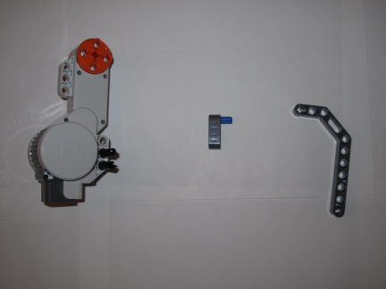

**Figure 3B:** Pin insertions

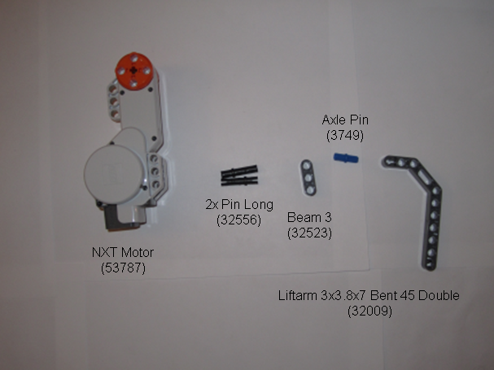

**Figure 3A:** Parts for one side of the motor arm

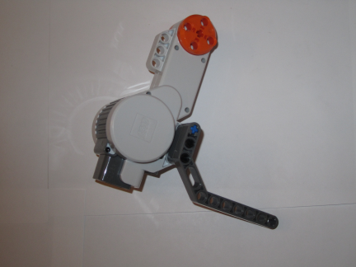

**Figure 3C:** Attach Beam 3 to motor and then liftarm

**Step 4:** Combine the 3 sub-assemblies to form **motor winch** (see **Figures 4A-4J**)

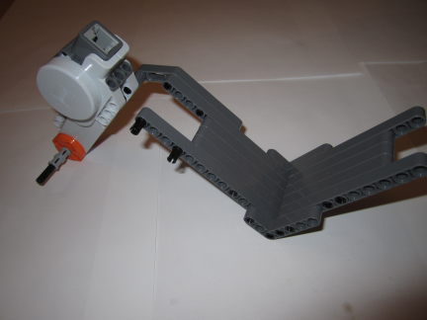

**Figure 4B:** Mount motor arm and thread motor axle

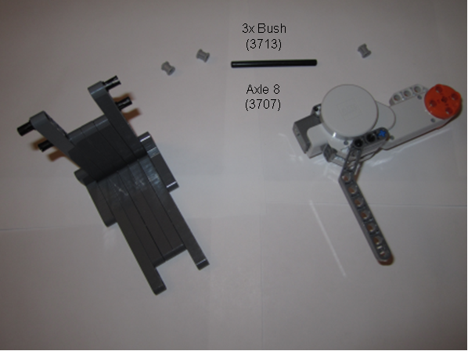

**Figure 4A:** Attach motor arm to hinge

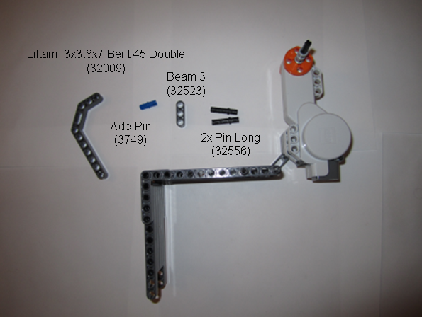

**Figure 4C:** Parts for opposite site

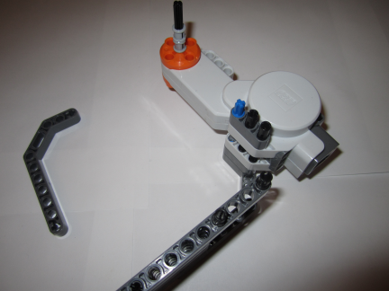

**Figure 4D:** Pin insertions

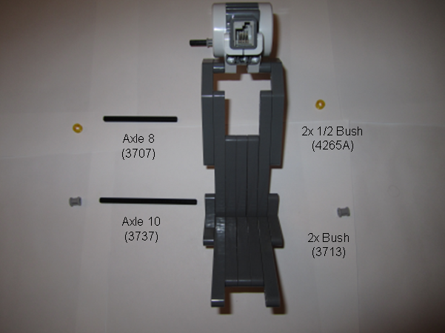

**Figure 4F:** Gather axles to secure hinge connection

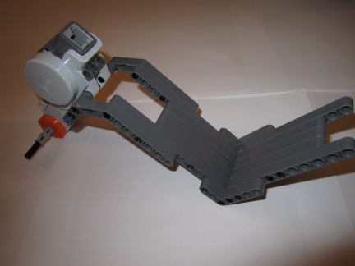

**Figure 4E:** Attach liftarm to hinge

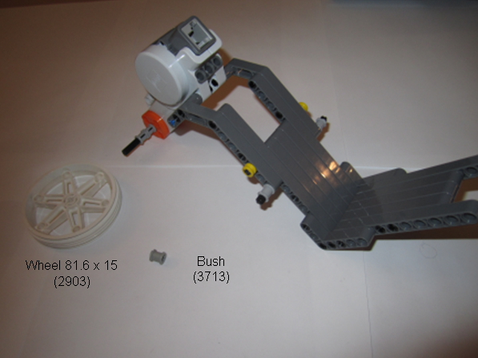

**Figure 4H:** Gather parts for wheel

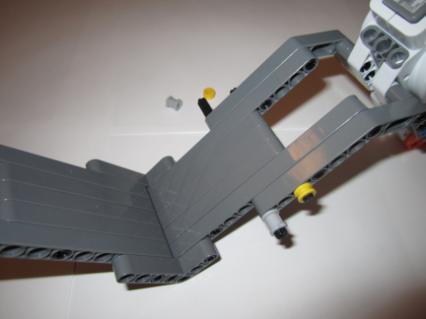

**Figure 4G:** Thread and bush the axles

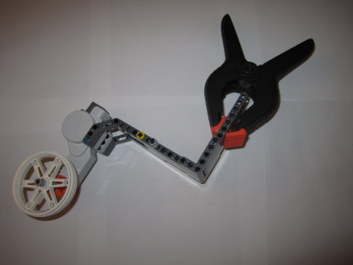

**Figure 4J:** Completed winch to be clamped

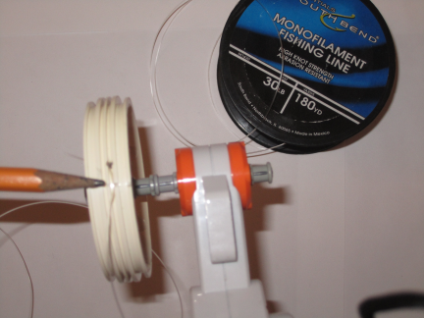

**Figure 4I:** Drill hole in wheel and mount on motor axle

**Part 2:** The Loading Cart is the platform where known masses are placed. The fishing string connects the motor winch’s wheel (**Figure 4I**) to the cart’s crossbars (**Figure 5K**).

**Step 5:** Assemble the loading cart referring to **Figures 5A-5K**

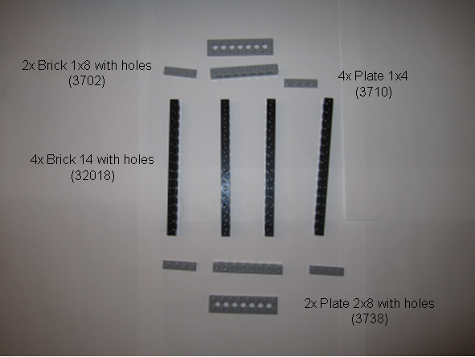

**Figure 5A:** Parts for cart’s base

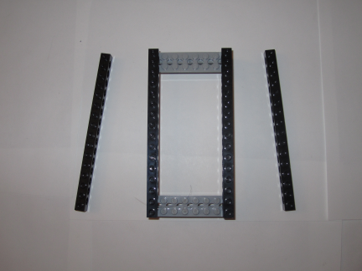

**Figure 5B:** Connect bricks in pattern shown

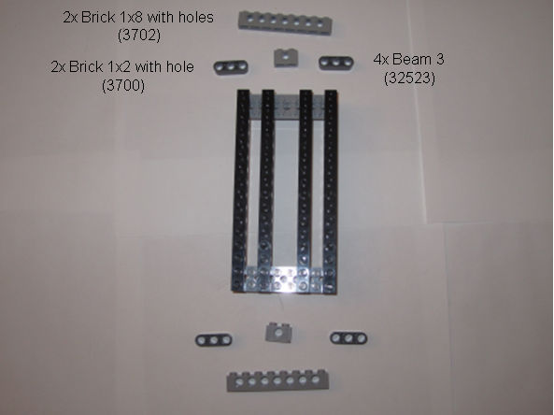

**Figure 5C:** Parts for base’s upper/lower sides

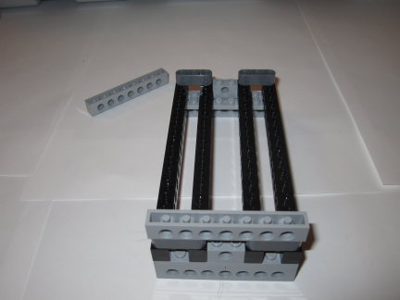

**Figure 5D:** Connect bricks as shown. Note the upside down Brick 6 mounted on Beam 3.

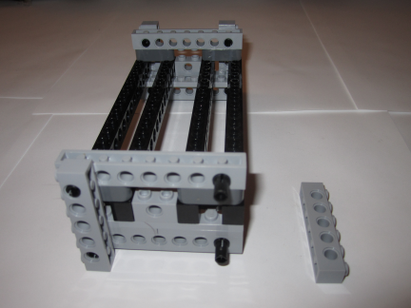

**Figure 5F:** The four Brick 6 parts reinforce the upper and lower sides

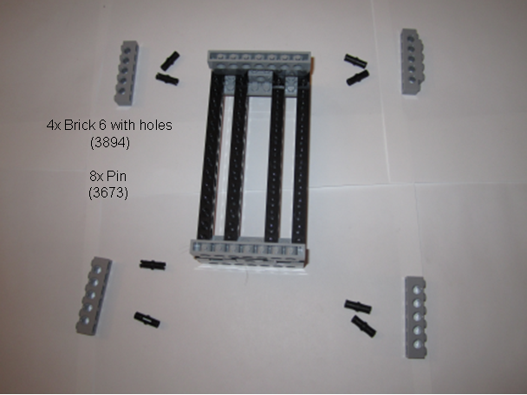

**Figure 5E:** Parts to reinforce upper/lower sides

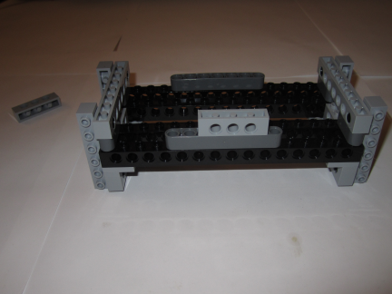

**Figure 5H:** Note position of 1x4 brick on top Beam 7

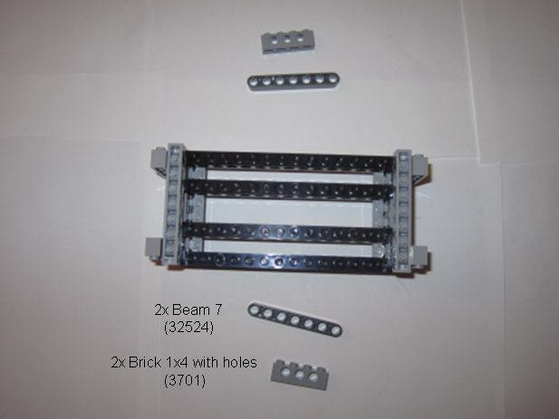

**Figure 5G:** Parts for left/right sides

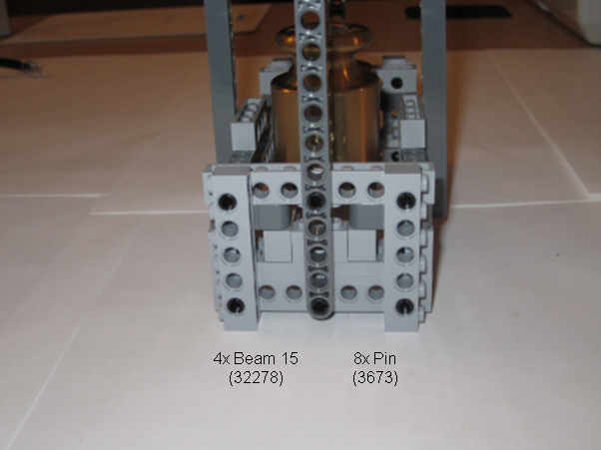

**Figure 5I:** Beam 15s serve as cart struts

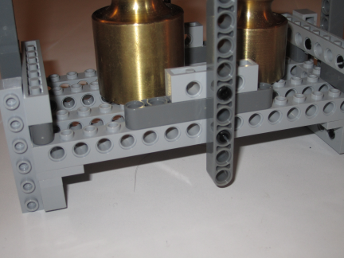

**Figure 5J:** Struts for left/right sides

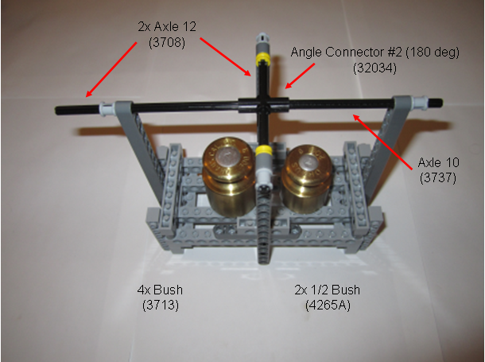

**Figure 5K:** Axles as Crossbars. Note that base has sufficient space to hold masses

Summary: Except for the wheel, masses, clamp and fishing tackle, the NXT Education Kit (Part 9797) contains all the parts to fabricate a Motorized Winch-and-Cart system. This system can be clamped to a flat surface, like a desk. However, a typical desk is about 29-inches high. This does not give much time to truly capture current and motor velocity data. Another configuration (see **Figure 6**) is to clamp the system to a door. This gives about 80-inches of motion and hence adequate time to capture data. The electrical connections for capturing current data will be detailed in Part 2 of this lab.

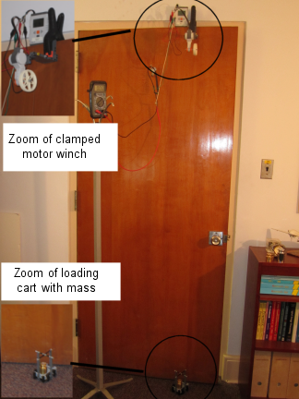

**Figure 6:** The motorized winch-and-cart can be clamped to a door. This gives about 80-inches of vertical motion and hence adequate time to observe steady-state motor current