**LEGO NXT Wheeled Inverted Pendulum (WhIP) Build Plans**

**Last Updated 10/23/15**

**Step 1-1**: Motors – use the following photos to gather parts

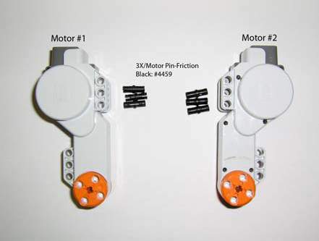

**Figure 1A**: 2 Motors & 3x/Motor Pin

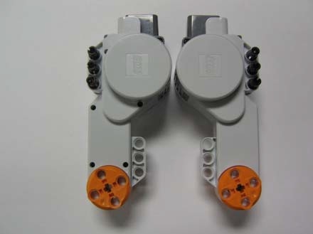

**Figure 1B**: Attach Pins to Motor

**Step 1-2**: Motors & Base Assembly

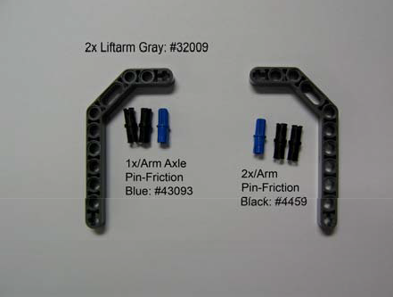

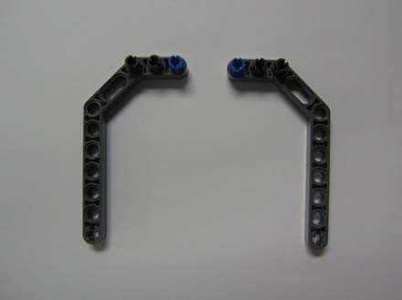

**Figure 2A**: Motor mount components **Figure 2B**: Attach Pins to Arms

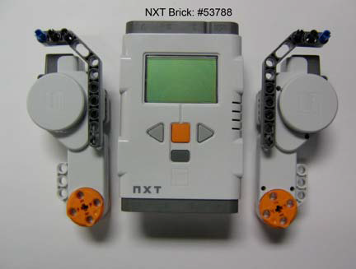

**Figure 2D**: Attach Motors to NXT Brick

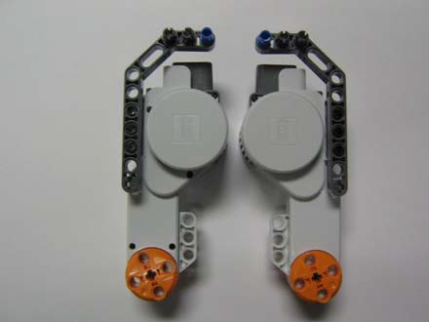

**Figure 2C**: Attach Arms to Motors

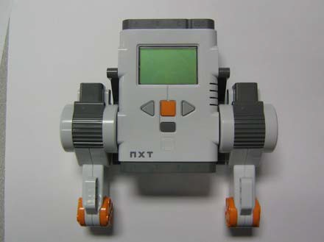

**Figure 2E**: Base Assembly from Step 2

**Step 1-3**: Wheels

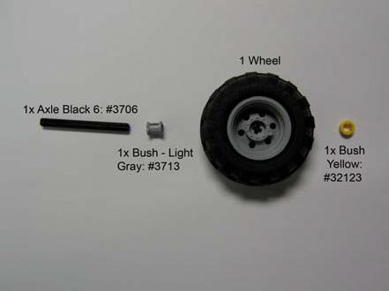 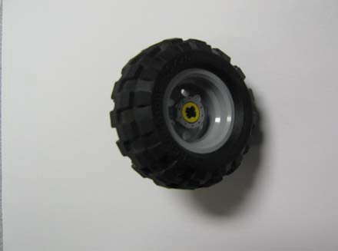

**Figure 3C**: Alternative View **Figure 3D**: Make 2 wheels w/ opposite axle directions

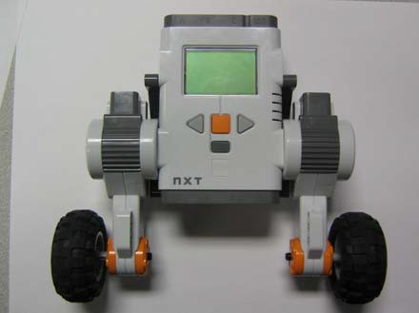

**Figure 3E**: Attach Wheel/Axle to Motors

**Step 1-4:** Front Bracket

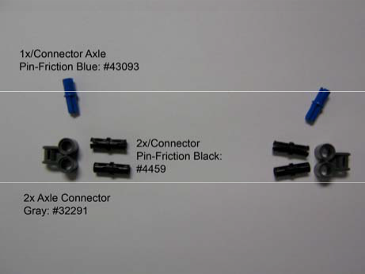 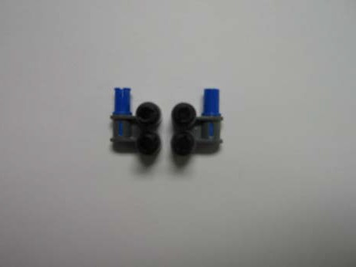

**Figure 4A**: Front bracket mount

components

**Figure 4B**: Connect pins to axle connector

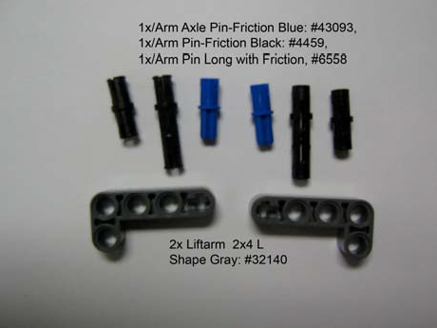 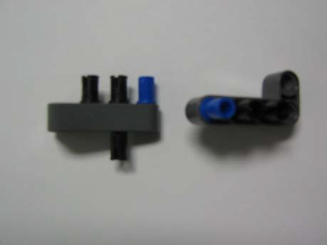

**Figure 4C**: Arm Components

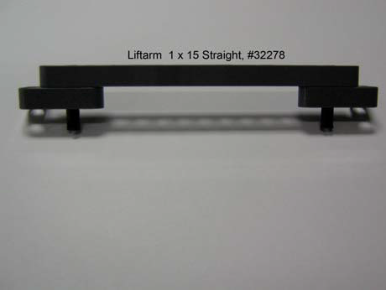

**Figure 4E**: Connect 2 Arms from 4D using a liftarm

**Figure 4D**: Connect pins to arms

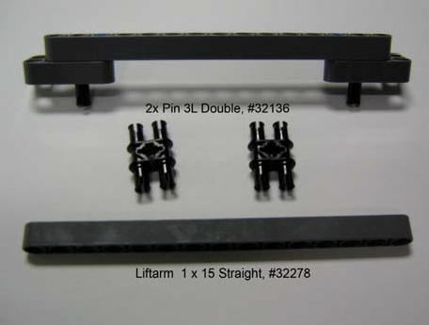

**Figure 4F**: Add another liftarm and connect with pins

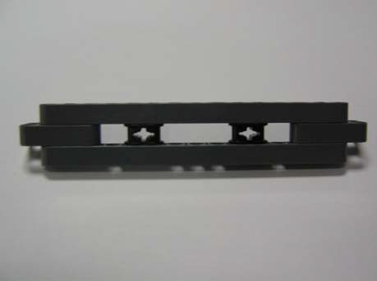 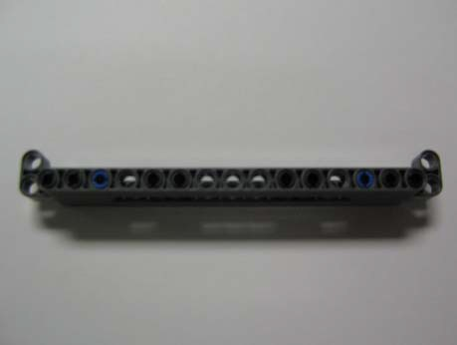

**Figure 4I**: Add the side connector from part 4B to bracket

**Figure 4J**: Attach bracket to front of motor

**Step 1-5**: Rear Bracket

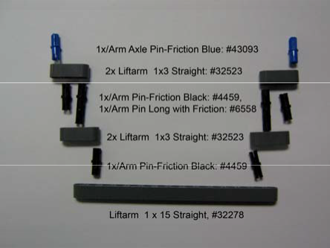

**Figure 5A**: Rear bracket components

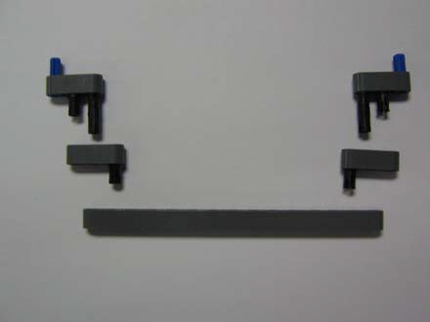

**Figure 5B**: Attach pins from 5A to respective arms

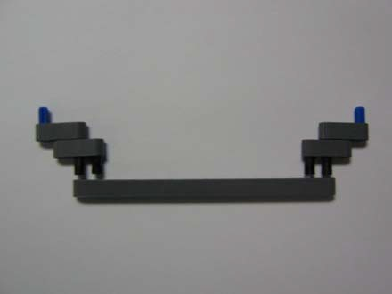

**Figure 5C**: Attach arm from 5A to 5B

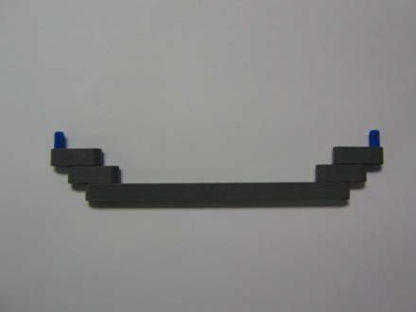

**Figure 5D**: Attach arms together

**Figure 5E**: Rear bracket mount components

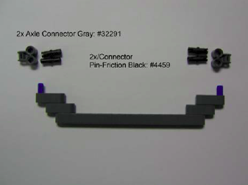

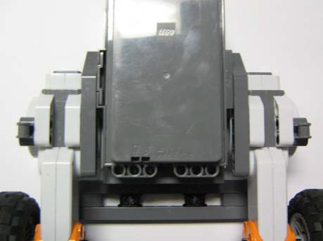

**Figure 5H**: Attach axle connector from 5F to rear of motors

**Figure 5F**: Attach pins to axle connector

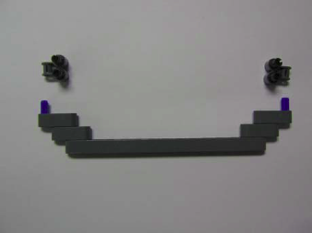

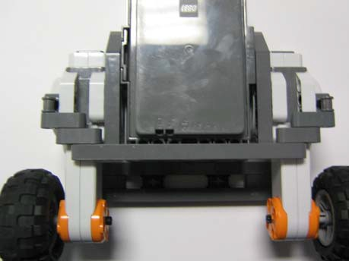

**Figure 5I**: Attach bracket to the connector

**Step 1-6**: Gyro Sensor

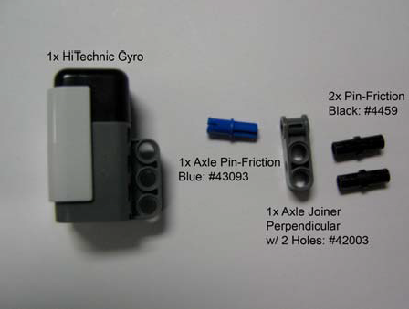 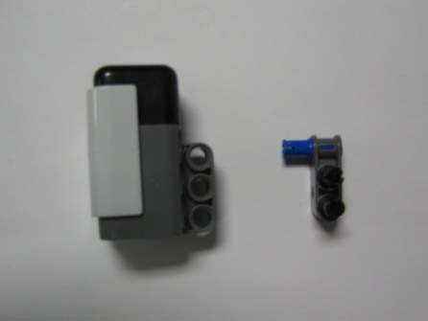

**Figure 6A**: Gyro mount components

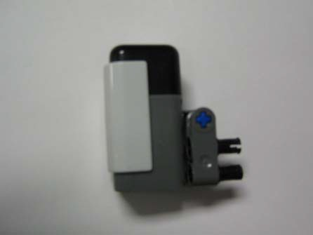

**Figure 6C**: Attach connector to gyro

**Step 1-7**: Final Wiring

**Figure 6B**: Attach pins to connector

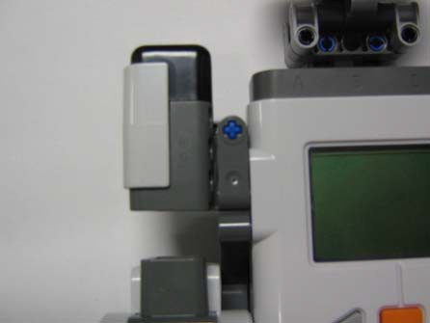

**Figure 6D:** Attach gyro to the left side of NXT Brick

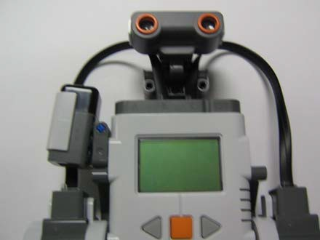

**Figure 7A**: Wire Left motor to Motor Port A & Right motor to Motor Port C (ignore ultrasonic sensor)

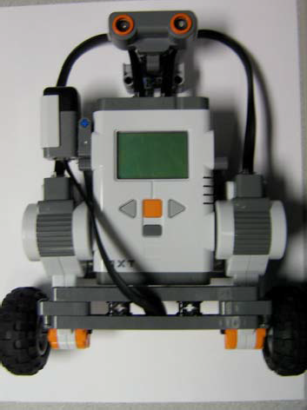 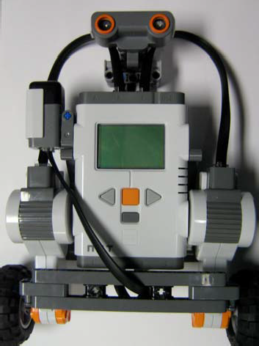

**Figure 7B**: Wire Gyro to

Sensor Port 1 (ignore ultrasonic sensor)

**Figure 7C**: Final Wiring (ignore ultrasonic sensor)

This concludes the instruction. Some of these parts can be replaced with others so that the structure is sturdier. More brackets can be added to the front and rear such that the motors are more securely fastened to the NXT brick. Note: that any changes to the physical dimensions of the balancing-bot will require re-tuning of the gain parameters to allow balancing, this especially includes type of wheels used on the bot.