**Mid-term – Part 2 Hands-on Section (Open Book) – 90 minutes time limit**

**Instructions:** Complete your answers in the space below (do not use back of paper).

**Student Name** _________________________ **Final Score** out of 50: ________

1. Construct and demonstrate a double-crank (10%)



1. Construct and demonstrate a cam-follower



1. Construct and demonstrate a 1:1 gear train using 8-tooth Lego Gears



1. Construct and demonstrate a pin wheel with 24T Crown and 8T Gears



1. Construct and demonstrate a 1:1 pin wheel using a pair of 4T knob gears



1. Construct and demonstrate a worm gear



1. Construct and demonstrate a rack-and-pinion drive



1. Construct and demonstrate a friction drive where the input and output planes are at 90-degrees



1. Use a 16T and 24T gear and axles to create a 2:3 gear train

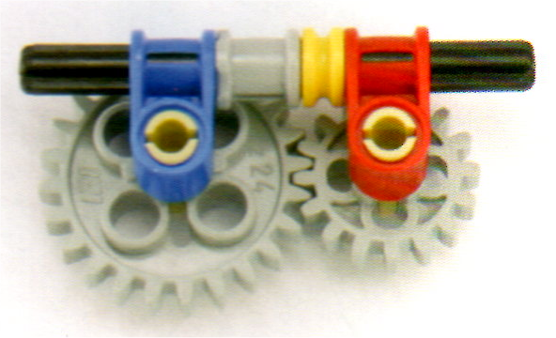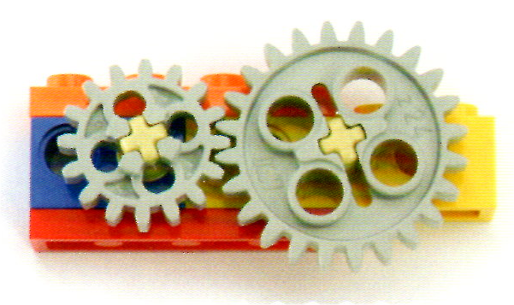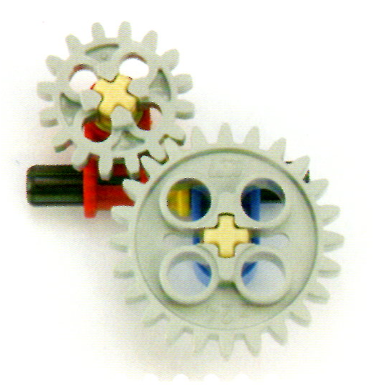

1. Construct and demonstrate a 3:7 outside planetary gear train using 24T and 56T Lego Gears



**Grading Rubric:** Each question is worth 5 points. Deduct 3 points if cannot successfully demonstrate the mechanism. Deduct 2 points if parts specified in the question are not used.