**Homework**

1. Fill in the blanks for the following (20%)
   1. Ratchets give stepped motions
   2. For ratchets, the detent stops the wheel from slipping back
   3. Drives and Gearing provide rotary-to-rotary connections
   4. In friction drives, a flange is often employed to prevent belt slip
   5. An idler (or jockey wheel) is a tensioning mechanism is used to take up slack in a belt
   6. In timing belts, the belt has teeth to engage the notches in the pulley wheels
   7. In chain and sprocket drives, links can be added or removed
   8. Spur gears have the same number of teeth.
   9. In a rack-and-pinion drive, the geared wheel meshes with a toothed rack
   10. In a worm drive, the shaft has a screw thread that meshes with a toothed wheel
   11. In bevel gears, the 2 wheels mesh at 45 degrees
   12. The pin wheel is simpler form of the bevel gear and is easier to fabricate
   13. In bevel gears, the plane of rotation changes from horizontal to vertical (and vice-versa)
2. Answer the following (10%)
   1. Sketch a friction belt drive where the driving and driven wheels counter-rotate
   2. Sketch a friction belt drive where the driving and driven wheels are rotating in different rotational planes





1. Define (1 to 2 sentences), describe (1 to 3 paragraphs) and provide sketches to support you definitions and descriptions for the following (10%)



* 1. Worm Gears
* Worm gear: shaft has a screw thread
* Screw thread meshes with the toothed wheel
* Gives a very slow but powerful force to the toothed wheel
  1. Ratchets used to lift heavy loads



* Ratchets are also used as locking mechanisms
* The ratchet stops the wheel from turning the “wrong” way
* Heavy weights can be moved in short steps
* The pawl stops ratchet from turning very far in CCW direction
* Pawl’s release mechanism allows lift to be lowered

1. Sketch and describe the 4 cycles of an 8-notch ratchet-crank mechanism (10%)

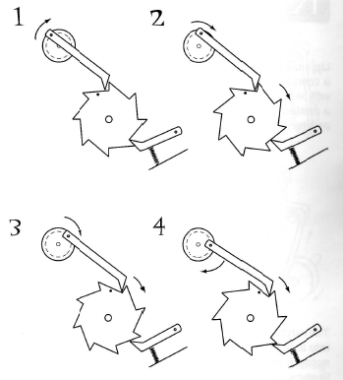

* Crank drives the ratchet
* One crank revolution moves ratchet one step
* There are 8 notches. So 1 ratchet revolution = 8 crank revolutions
* Observe dot on ratchet

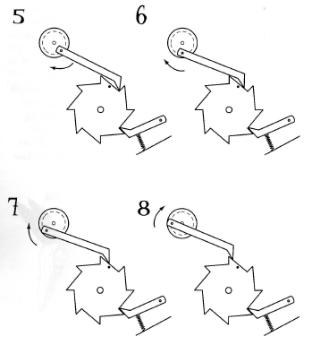

* Observe pawl; ratchet must stop at correct point
* At correct point, ratchet will be in position for next push from crank pawl
* Detent pawl often has spring to ensure it contacts the ratchet

1. Automaton Project: Your Assembly should be reproduced by classmates. Bring Hardcopy of Build Instructions (50%)