Homework – Ratchets, Drives and Gearing

- Fill in the blanks for the following (20%)

  - Cams turn ____________ rotary motion into an upward and downward motion
  - ____________ is difference between a cam’s minimum and maximum radii
  - Eccentricity means to be __________
  - Unlike cranks, cams have the ability to store __________
  - Cams are the ____________ version of computer programs
  - A ____________ crank converts up-down motion to side-to-side motion
  - A 3-bar (linkage) is for _____________ motion
  - A slider-crank with a ___________ increases lever sway
  - Levers move in a ___________ arc
  - A ___________ can be used to keep the lever against the cam so it follows the profile
  - Springs in cam-followers increase _________, so tensioners are used

- Answer the following (10%)

  - List, sketch and give examples of the 4 types of springs
  - Explain how cams examples of memory and storage

- Define (1 to 2 sentences), describe (1 to 3 paragraphs) and provide sketches to support you definitions and descriptions for the following (10%)

  - Lobe Cams
  - Dwell (or Pause)
  - 3-bar linkages

- Sketch and describe the 4 cycles of a 3-bar linkage. In your sketch show where the straight line motion is and in your description, explain how the straight motion arises (10%)

- An example of the common car windshield wiper (2 blades) is shown. Before searching, think and sketch how you think the wiper works; what is the input and output? Next, do a web search to study how wipers work. Construct a Lego-based version using an NXT motor and NxC program. Create Build Instructions as a 4-step build plan (one a single slide). Capture a 10-second WMV video of your wiper in action (25%)
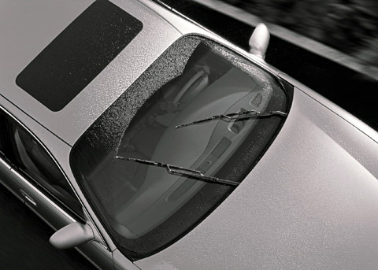

- Use MLCAD to create build instructions for the Lego-based folding chair assembly. Recall, you constructed this assembly for a previous Homework assignment. Bring a hardcopy of the build instructions to next class). Grading will depend on how easily your classmate can recreate your assembly using only the build instructions (25%)

