Homework – Cranks, Cams, Linkages

- Fill in the blanks for the following (20%)

  - A ____________ is something that modifies force
  - A ____________ is when force comes from an outside source
  - The mechanical action of the machine produces __________
  - All machines (almost) always employ at least one __________
  - Mechanical ____________ is the ratio of load versus effort
  - Leverage is the ratio distances of the _________ and load to the fulcrum
  - A lever of the second order is also known as a force ___________
  - A lever of the third order is also known as a force ___________
  - Part with the hole that supports the shaft is called the ___________
  - A ___________ converts rotation to reciprocation

- Answer the following (10%)

  - State Newton’s 3 Laws of Motion
  - List, sketch and give examples of the 5 simple machines
  - Name, sketch and give examples of the 3 levers

- Define (1 to 2 sentences), describe (1 to 3 paragraphs) and provide sketches to support you definitions and descriptions for the following (10%)

  - Shafts and Bearings
  - Cams
  - Cranks

- Sketch and describe the 4 cycles of a simple crank-lever and slotted crank-lever (10%)

- Recall that a walker was configured using a single NXT motor and 4-bar linkage. Write an NxC program where the walking speed is proportional to values reported by an ultrasonic sensor; when the sensor is close to (far away from) an object, it walks slowly (quickly). (25%)

- Some examples of common folding chairs are shown. Study how it works and then construct a scaled Lego-based version that mimics the chair’s function. Your Lego structure should fold flat and unfold to act like a chair. Create Build Instructions with photos: showing all parts (and annotated by their part number), and 4-step build plan (see example on right) (25%)
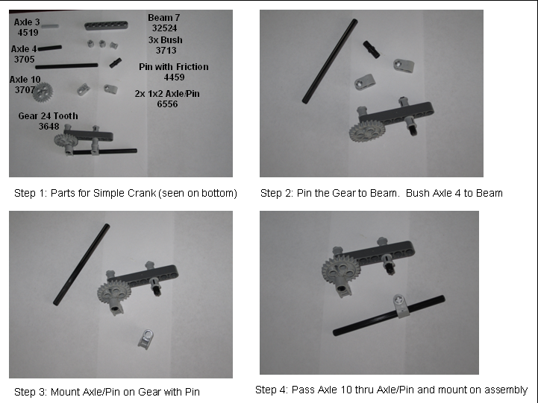
EG: Simple Crank 4 photo Build Steps




