Homework Cranks, Cams, Linkages

- Fill in the blanks for the following (20%)

  - A machine is something that modifies force
  - A input is when force comes from an outside source
  - The mechanical action of the machine produces output
  - All machines (almost) always employ at least one lever
  - Mechanical advantage is the ratio of load versus effort
  - Leverage is the ratio distances of the effort and load to the fulcrum
  - A lever of the second order is also known as a force multiplier
  - A lever of the third order is also known as a force reducer
  - Part with the hole that supports the shaft is called the bearing
  - A crank converts rotation to reciprocation

- Answer the following (10%)

  - State Newton’s 3 Laws of Motion

- Law 1: motion does not require force; force only needed to accelerate motion
- Law 2: the greater the force, the greater the acceleration
- Law 3: action and reaction; if object pushed, it will push equally in opposite direction

  - List, sketch and give examples of the 5 simple machines

- Inclined Plane (or slope)
- Wedge
- Screw
- Lever
- Wheel

  - Name, sketch and give examples of the 3 levers

2nd order lever: load between fulcrum effort e.g. wheel barrel

3rd order lever: effort between fulcrum and load effort e.g. fishing rod

1st order lever: fulcrum between load and effort e.g. scissors

- Define (1 to 2 sentences), describe (1 to 3 paragraphs) and provide sketches to support you definitions and descriptions for the following (10%)

  - Shafts and Bearings

- Shafts can be anything: from stiff piece of wire or wooden dowel, to accurately engineered rod
- Part with hole that supports shaft is called the bearing
- Shaft must be strong enough to support mechanisms they carry
- Shaft must fit the bearings; not too tight (friction) or not too loose (wobble)
- Bearing keeps the rotating shaft stable and running smoothly
- Must be chosen together with shaft

  - Cams

Note to self: wasn’t really covered in this lecture

  - Cranks
A lever attached to a rotating shaft – cranks convert rotation to reciprocation

- Sketch and describe the 4 cycles of a simple crank-lever and slotted crank-lever (10%)

- At “1” vertical rod at highest point
- At “3” vertical rod at lowest point

- Recall that a walker was configured using a single NXT motor and 4-bar linkage. Write an NxC program where the walking speed is proportional to values reported by an ultrasonic sensor; when the sensor is close to (far away from) an object, it walks slowly (quickly). (25%)

- Some examples of common folding chairs are shown. Study how it works and then construct a scaled Lego-based version that mimics the chair’s function. Your Lego structure should fold flat and unfold to act like a chair. Create Build Instructions with photos: showing all parts (and annotated by their part number), and 4-step build plan (see example on right) (25%)
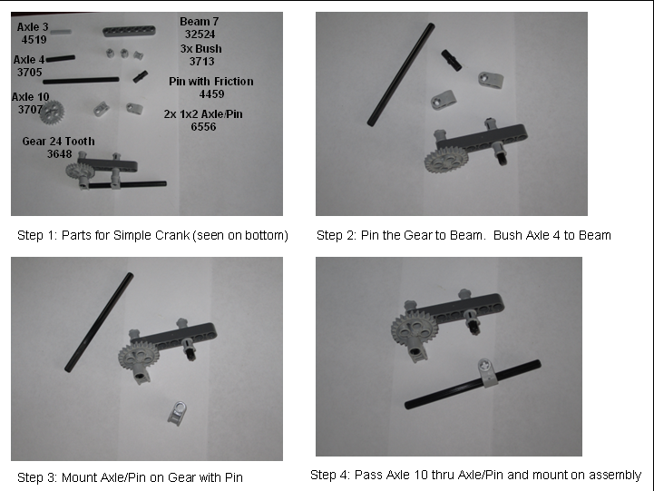
EG: Simple Crank 4 photo Build Steps




