Homework – Levers, Shafts and Cranks

Levers, Shafts and Cranks were covered in Lecture and Lab. Using these as reference, complete the following problems:

- A simple crank was demonstrated in an exercise of the Lego Lab Slides. Below is a typical diagram of a slider-crank mechanism. With Lego, construct fabricate your own slider-crank. Using the “Simple Crank” slides as a template, take photos and videos to create 2 slides:

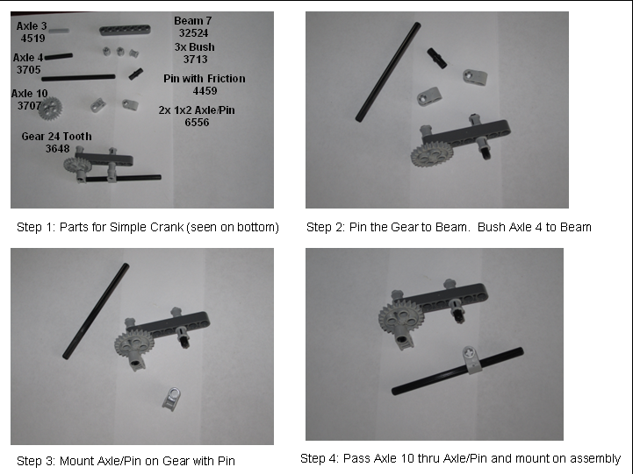
EG: Simple Crank 4 photo Build Steps

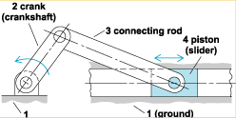

Typical Slider-Crank

  - Slide 1: Photo of your slider-crank. A 10-second WMV-format video in operation
  - Slide 2: 4 photos (e.g. above figure) with parts (part names/numbers) and steps

NB: For parts names and numbers see: http://guide.lugnet.com/partsref/technic

- Refer to the Lego BricxCC Programming Lab. In one exercise, you made motors rotate. Write a program (with comments on each line), that makes a motor on Port A rotate from 180 to -180 degrees, 3 times.

- Refer to Exercises 2 and 3 where you respectively made NXT motors rotate and respond to the touch sensor. Write a program where the motor rotates clockwise when the touch sensor is not pressed and rotates faster counter-clockwise when the touch sensor is pressed

