**Homework – Relays and Transmitters**

Email PDF version no later than beginning of next class.

1. Fill in the blank *(20 points)*
2. The digital input and output lines can be used to actuate binary devices like switches, relays and transistors, and 8-bit peripherals like external LCD screens.
3. The PCF8574 is an I2C chip that when connected to an NXT, gives the Brick 8 digital lines.
4. A relay is an electromechanical switch.
5. A reed relay has a small form factor and is capable of handling low voltage, low current devices.
6. A SPST (single pole, single throw) relay has 4 pins.
7. Since the PCF8574 can only source about 20 mA, an external power supply is needed.
8. Unlike a relay, transistors do not have any mechanical parts.
9. Popular NPN transistors include the TIP31 and IRF510 which both come in TO-220 packages.
10. The TIP31 is a current-driven transistor
11. The IRF510 is called a MOSFET and allows current to flow when its gate pin is above a certain voltage (about 5 Volts).
12. Back-EMF from the motor could kick-back enough current to damage the digital line.
13. In the schematic below, the motor runs when the relay’s switch is closed and turns off when the relay’s switch is open. Redraw a schematic for the reverse; the motor is on when the relay’s switch is open and turns off when the relay’s switch is closed. If any additional components are used, state their value and how you selected them (*10-points*).

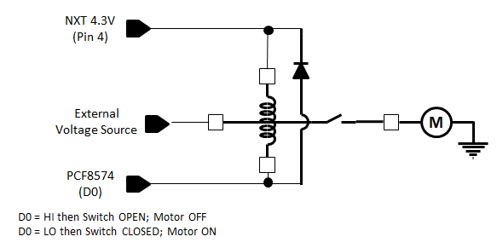

1. The circuit below is sloppy; motor back-EMF could ruin the MOSFET and even the digital line. Draw a schematic to prevent back-EMF from destroying circuitry. If any additional components are used, state their value and how you selected them (*10-points*).

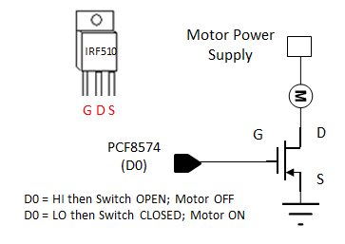

1. Refer to Lab Exercise 2. Write a program that reads DIP switch positions, and when the value is one, turn on the motor. For any other DIP switch value, the motor turns off. You can use either a reed relay or IRF510 circuit. Include a link to a YouTube video that demonstrates your program and circuit working. Include photos of your circuit and annotate components and wiring with their names and/or functions. Include a printout of your NXC code. Include a schematic of your circuit. Points deducted for not labeling your schematic and photos with appropriate annotation, symbols, text and/or values *(60-points)*