Homework: Op-Amps

Due: 1-week later

NB: Only hardcopies (with handwritten answers) will be accepted and graded. Any homework that is emailed will be unopened, deleted and unrecorded for credit.

- What are the two rules for op-amps? What are the 5 properties of op-amps? (10 points)

- Derive the input-output relationship and describe its physical functional (20 points)

A.

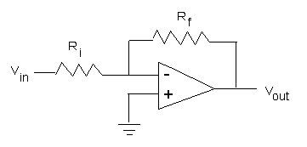

B.

C.

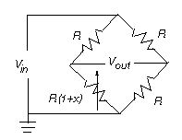

D.

- Write a LabVIEW program that implements a function generator. Create a front panel that lets the user select a sine, square, or saw tooth wave. Use dials for the user to select frequency and amplitude. Display the resulting waveform on the front panel. Include hardcopies of the Front Panel and Block Diagram. Include program notes in the Block Diagram that describe how the program works (20 points)

