**Homework – DC Motor Theory, Open-Loop Step Response, Files and Timing**

1. Fill in the blanks (10-points)
2. Lorentz’s law states that a current-carrying wire in a _____ field will induce an electromotor force
3. In a DC motor, ______ allow the loops of copper wire to rotate 180 degrees
4. An _____ is another term for a coil or loop of wire
5. Inductors _____ the change in current
6. Induced ____ is called the back EMF
7. In DC motors, torque is _____ of voltage
8. Motor speed _____ then torque decreases
9. A DC motor with negligible inductance is a ____ order system
10. The rise time (or time constant) is the time to reach _____ of the steady-state value
11. It takes ___ time constants for the system to reach 99% of the steady-state value.
12. Refer to lecture notes. Given that the Open Loop Transfer Function for the NXT motor is given by $G_{OL}=\frac{b}{s+a}=\frac{Ω\left(s\right)}{V\left(s\right)}$ where the input is the motor command $V\left(s\right)$ and the output is motor velocity $Ω\left(s\right)$ (10 points total)

Given a step input $v\left(t\right)=\left\{\begin{aligned}0: t≤0 \\ M: t>0\end{aligned}\right.$

1. Show using ordinary differential equations that $ω\left(t\right)=\frac{Mb}{a}\left(1-e^{-at}\right)$
2. Show using Laplace transform techniques that $ω\left(t\right)=\frac{Mb}{a}\left(1-e^{-at}\right)$. NB: explicitly show any partial fraction expansion techniques if used.
3. Write an NXC program using best practices. The program Iterates integers from -10 to +10 incrementally by 1. Compute the cube and save to a file named “cubic.csv”. Export the data file and plot the curve in Excel. Show your NXC code (10-points) and Excel plot (10-points)

4. Refer to the lab on NXC Timers. Using best practices, write an NXC program that mimics a smart phone’s timer (10-points)

On the left is a screenshot of a smartphone timer. One sets a time to count down from e.g. 1 minute and 10 seconds. Once the timer reaches zero, a sound is played.

Include: (1) your NXC code for a timer that counts down from 1 minute and 10 seconds; and (2) URL to a YouTube video demoing your Brick counting down and playing a sound when the timer reaches 0.

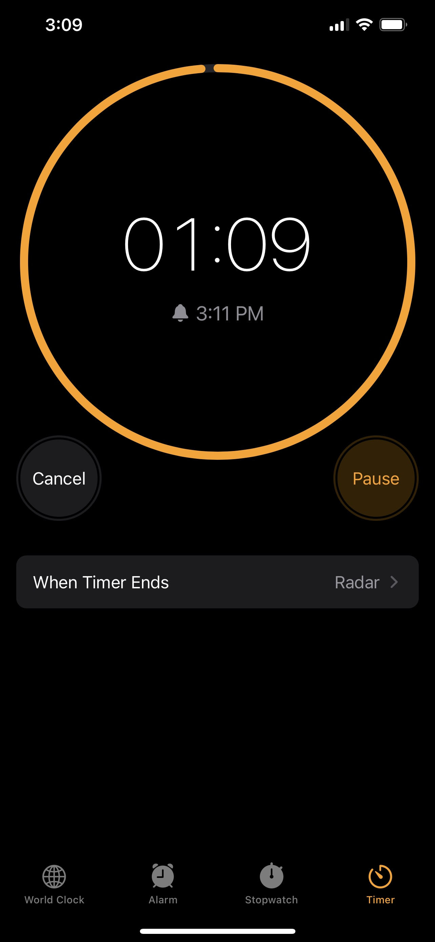

1. Refer to the lab on the Open-Loop Step Response of a Lego NXT motor. Using best practices, write an NXC program that writes the motor’s rotational speed (RPM and rad/sec) and time (at 40 msec sampling rate) to a step input of 75% motor power (10-points total)
2. Below is an example of what’s expected. Provide a screen shot of your scatter plot of the data your Brick collected. (5-points)

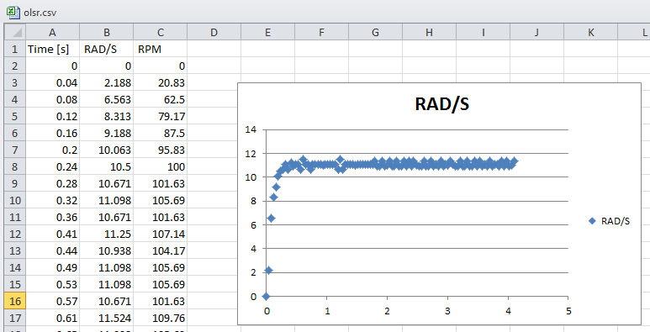

1. Eyeball your plot. What is the steady-state RPM and rise time (i.e. 63% value of steady-state)? (5-points)