**Hands-on Lab**

**Lego NXT Domabot – Wall-following PID**

An ultrasonic sensor (US) is mounted on the Domabot’s portside (left). The US measures the distance of a wall on the Domabot’s portside. A PID controller is used to regulate a desired wall-to-portside distance.

# **Concept 1 – Program Structure:**

**Step 1:** Create a new file called **wfPid1_0a.nxc**

// FILE: wfPid1_0a.nxc - Works!

// DATE: 10/27/22 12:22

// AUTH: P.Oh

// DESC: Domabot US sensor (Port 4) senses a wall left of it. Domabot always

// turns left (CCW yaw) as it moves along wall. PID or bang-bang (i.e.

// when PID gains all are zero) is used to calculate turning speed

// VERS: 1.0a: ME 425 release

// REFS: wfbb0_1a3.nxc; x^2File1.0.nxc; wf2Us0_3a1.nxc

// Global variables -----------------------------------------------------------

int xWall; // wall distance [cm]

int dWall; // desired wall distance [cm]

float wKp, wKi, wKd; // wall PID gains;

float wE, wEDot, wEInt; // wall error and its derivative and integral

float wEPrev; // wall error previous value

float wCorr; // wall related motor power correction [0, 100]

int speedA, speedC; // motor speed for A (right) and C (left)

int speedBase; // motor base speed

bool orangeButtonPushed, rightButtonPushed, leftButtonPushed; // NXT buttons

task main() {

// Variable initializations ------------------------------------------------

xWall = 0; // initialize wall distance to 0

dWall = 10; // Desired distance from wall [cm]

wKp = 0.0; // Wall P gain e.g. (PID)=[1.5, 0.005, 30.0]

wKi = 0.0; // Wall I gain

wKd = 0.0; // Wall D gain

wE = wEDot = wEInt = 0.0; // initialize wall error-related values to 0

wEPrev = 0.0; // initialize previous wall error to 0

speedBase = 30; // Domabot base motor speed at 50% i.e. mid-point

// Algorithm begins ---------------------------------------------------------

TextOut(0, LCD_LINE2, "-> BTN to proceed" );

SetSensorLowspeed(IN_4); // Wall on Left US (Port 4)

do {

rightButtonPushed = ButtonPressed(BTNRIGHT, FALSE);

xWall = SensorUS(IN_4); // for wall detection (on left, Port 4)

TextOut(0, LCD_LINE3, FormatNum("Wall = %3d cm" , xWall));

} while(!rightButtonPushed);

ClearLine(LCD_LINE2);

TextOut(0, LCD_LINE2, "<- BTN to QUIT" );

do { // continue wall following until left button pushed

leftButtonPushed = ButtonPressed(BTNLEFT, FALSE);

xWall= SensorUS(IN_4); // left US (Port 4)

TextOut(0, LCD_LINE3, FormatNum("Wall = %3d cm" , xWall));

// (1) Calculate wall-following PID gains

Add PID control effort here by calculating error, derivative of error, and integral of error

// (1A) Check for motor staturation i.e. resulting wCorr forces

// motor getting > 2*speedBase (if speedBase > 50, this means > 100)

if(wCorr > 0 && wCorr > speedBase) {

wCorr = speedBase; // saturated so set correction to speedBase

// So Motor A speed max will be 2*speedBase

};

if(wCorr < 0 && wCorr < -speedBase) {

wCorr = -speedBase; // saturated so set correction to -speedBase

// So Motor C speed min will be 0

};

// (1B) If PID gains all zero, then wCorr = 0 so do bang-bang

if(wCorr == 0 && xWall < dWall) {

wCorr = -speedBase; // Move away from wall: C = basespeed, A = 0

};

if(wCorr == 0 && xWall >= dWall) {

wCorr = speedBase; // Move towards wall: A = basespeed, C = 0

};

// (2) Command motors

speedA = speedBase + wCorr;

speedC = speedBase - wCorr;

OnFwd(OUT_C, speedC);

OnFwd(OUT_A, speedA);

// (3) update wall errors for next derivative calculation

wEPrev = wE;

} while( (!leftButtonPushed) ); // end do-loop

// (4) User pushed <-- (Left) Button, so exit gracefully

Off(OUT_AC);

PlaySound(SOUND_DOUBLE_BEEP);

Wait(5000);

StopAllTasks();

} // end main

} // end of main

**Step 2:** Using the variables declared in **wfPid1_0a.nxc** one sees that the current wall error wE is the difference between the measured wall distance xWall and desired wall distance dWall. That is wE = xWall – dWall. The derivative of the wall error wEDot is just the difference between the current wall error wE and previous wall error prevWPrev. Highlighted in yellow one sees that before the loop returns for the next iteration, the previous wall error wEPrev is set equal to the current wall error wE. Lastly, the sum (i.e. integral) of the wall error wEInt is the sum of current wall error wE and previous sum of the wall errors wEInt. With this knowledge one can add PID correction as

wCorr = wKp * wE + wKi * wEInt + wKd * wEDot;

**Step 3:** Contrast bang-bang and P-only control performance. For bang-bang set wKp = wKi = wKd = 0.0. For P-only control, set wKp = 1.5; wKi = 0.0; and wKd = 0.0. Set the Domabot 4 to 5 cm from the wall (see photos below) and observe its performance trying to maintain a wall-to-portside distance of 10 cm (marked by blue painters tape on the floor).

Blue tape is 10 cm from wall baseboard. Ultrasonic sensor shows portside sensor at 10 cm

Domabot portside tire touches the baseboard. Ultrasonic sensor shows this is 4 cm

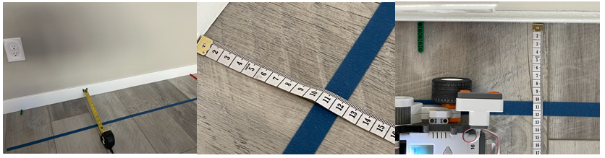

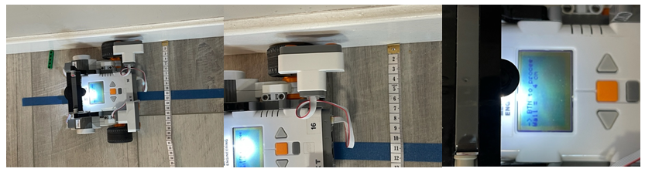

# **Concept 2 – Data acquisition of wall-following performance**

**Step 1:** Create a new file called **wfPidFile1_0a.nxc**

Recalling w^2File1_0.nxc, add file saving functions to wfPidFile1_0a.nxc.

**Step 2**: Re-run your programs to contrast bang-bang and P-only control. Confirm that your Excel plots look similar to the following

**Figure A:** Excel plots of bang-bang and P-only control

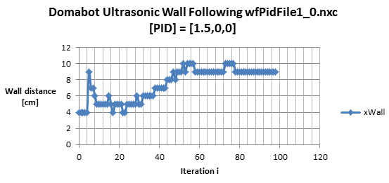

YouTube: <https://youtu.be/edauCdpyZMA>

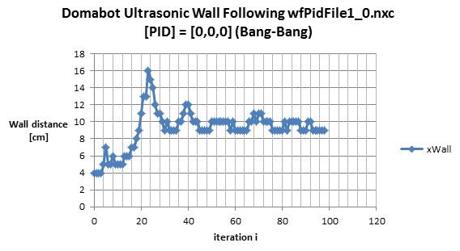

YouTube: <https://youtu.be/DlVmcWBeccw>

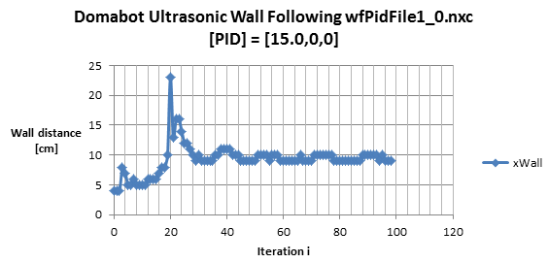

YouTube: <https://youtu.be/YWy7kzwAUnM>

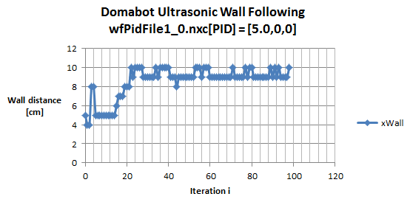

YouTube: <https://youtu.be/edauCdpyZMA>