**Homework – DC Motor Theory and Open-Loop Step Response**

1. Given that the Open Loop Transfer Function for the NXT motor is given by $G_{OL}=\frac{b}{s+a}=\frac{Ω\left(s\right)}{V\left(s\right)}$ where the input is the motor command $V\left(s\right)$ and the output is motor velocity $Ω\left(s\right)$**(10 points; 5 points each)**

Given a step input $v\left(t\right)=\left\{\begin{aligned}0: t≤0 \\ M: t>0\end{aligned}\right.$

1. Show using ordinary differential equations that $ω\left(t\right)=\frac{Mb}{a}\left(1-e^{-at}\right)$
2. Show using Laplace transform techniques that $ω\left(t\right)=\frac{Mb}{a}\left(1-e^{-at}\right)$
3. In lab, you performed an open-loop step response to an NXT motor. The resulting time plot looked similar to (exact speed values may be different):

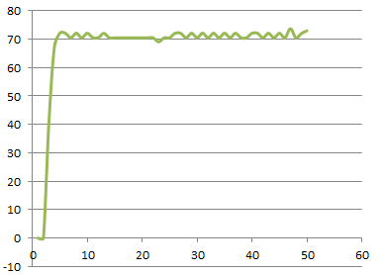

**Figure 1A:** Excel plot of nxtMotorData.csv

Figure 1A is an example of an open-loop step (velocity) response to a 75% motor command.

* Provide a copy of your plot (provide units!)
* On your plot, show what the steady-state velocity is (provide units!)
* On your plot, show the rise time, also known as a time constant. Recall that rise time is defined as 63.3% of the steady-state value.

(**5 points**)

1. Theory states for a first-order system, that at 3 time constants, the response will be within 1% of steady-state.

* On your plot, show the time and motor value at 3 time constants
* Show that the velocity at 3 time constants is indeed with 1% of the steady-state velocity

**(5 points)**