**Hands-on Lab**

**Line Following**

In a previous lab, the Lego NXT light sensor was introduced. This sensor doesn’t measure color per se, but rather (reflected) intensity. By measuring the intensity of line’s outermost edge, a robot can follow the line. Three concepts are sensor calibration, and then line following using bang-bang and proportional control approaches.

**Concept 1:** NXT Lego Light Sensor Calibration

With a black line on a white mat, the human eye may only distinguish 2 colors. However, a light sensor can actually measure gradients (i.e. a range of greyscale values) as it passes from the black line to the white background. The gradients depends on one’s sensor, the mat’s paper quality (e.g. glossy versus flat), and ambient light (e.g. fluorescent versus incandescent or sunlight).

**Step 1:** First construct a light sensor that mounts on the Domabot’s front (see Figure 1-1 below). It’s better if it’s centered and about 2-mm (or the thickness of 2 pennies) from the ground. If the sensor is too close to the ground, the transmitted light will be obscured by the ground. The result is that the receiver won’t capture the transmitted light well. If the sensor is too high from the ground, the transmitted light might become diffuse (i.e. sprayed out). Again, the receiver might not capture enough transmitted light.



1. Visit <http://www.ldraw.org/help/getting-started.html>
2. Select step-by-step instructions based on your computer operating system
3. Click and desired LDraw file to download. Once downloaded, execute [**LDraw_AIOI_2014-02_setup_32bit_v1.zip**](http://media.peeron.com/ldraw/LDraw_AIOI_2014-02_setup_32bit_v1.zip) and accepted terms of agreement

**Step 2:** Installation Steps (Installation will take several minutes, so be patient)

1. Accept the default directory e.g. C:\Program Files (x86)\LDraw
2. Accept the "Shortcut Folder" e.g. LDraw
3. If you'd like these tools on your Desktop, click "Next" otherwise uncheck these (which I did; I don't like a cluttered desktop)
4. As installation progress, accept the default directories

**Step 3:** Launch MLCAD to see that it works

1. Under "Start - Programs – LDraw”, select **MLCAD**
2. If prompted, set the "Base Path" to C:\LDraw and click OK

The MLCAD screen should open (**Figure 1A**). By default, the lower left pane only shows the parts tree. Click and vertically drag the lower left pane, so you can see parts (**Figure 1B**)

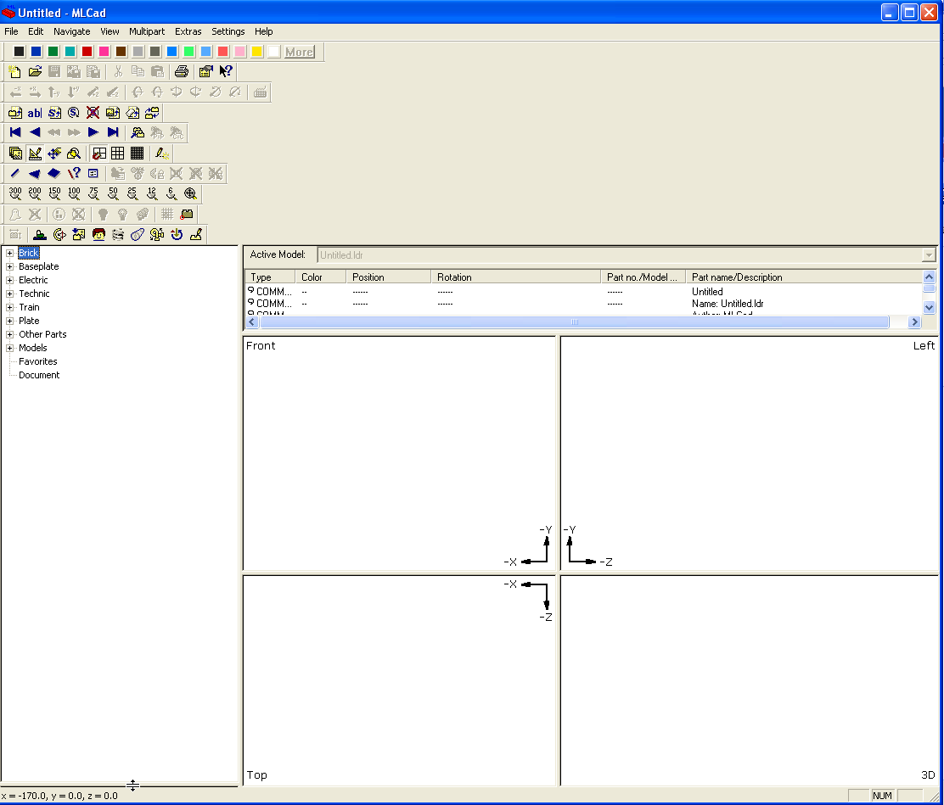

**Figure 1A:** MLCAD opening screen. Place mouse on lower left pane and drag up

**Figure:** If installed properly, launching “Bricx Command Center” will result in this prompt

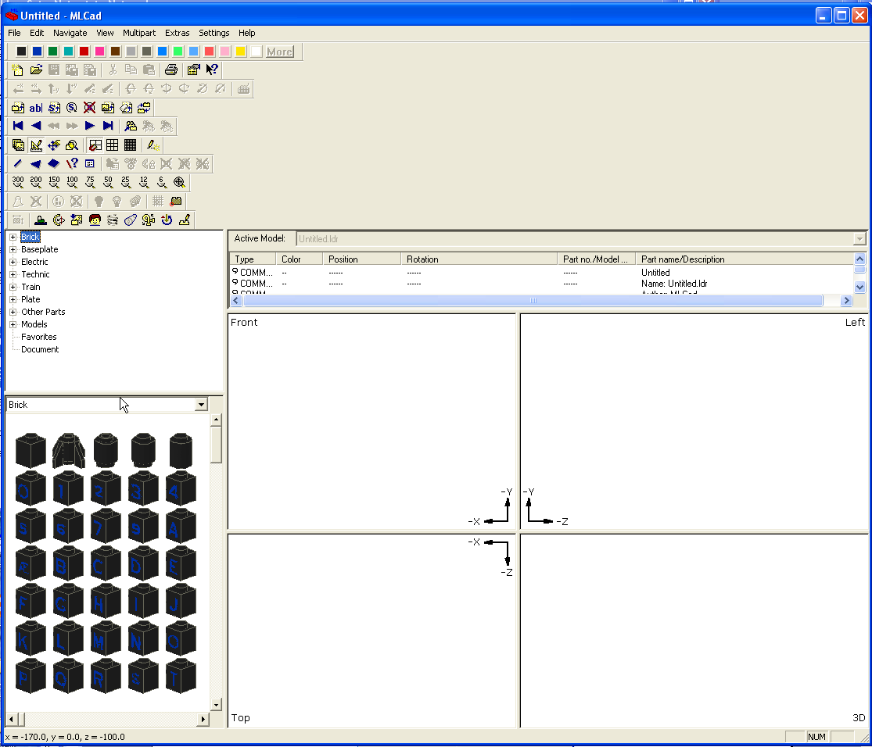

**Figure 1B:** MLCAD after dragging pane up. Lower left pane reveals Lego parts available

**Step 5:** See if Mindstorms parts available

1. From Upper Left Pane parts tree, open "Electric" and scroll down to see "Electric Mindstorms NXT..." You should be able to click any of these and drag unto the main quad (front, left, top views). See **Figure 1C** for example.

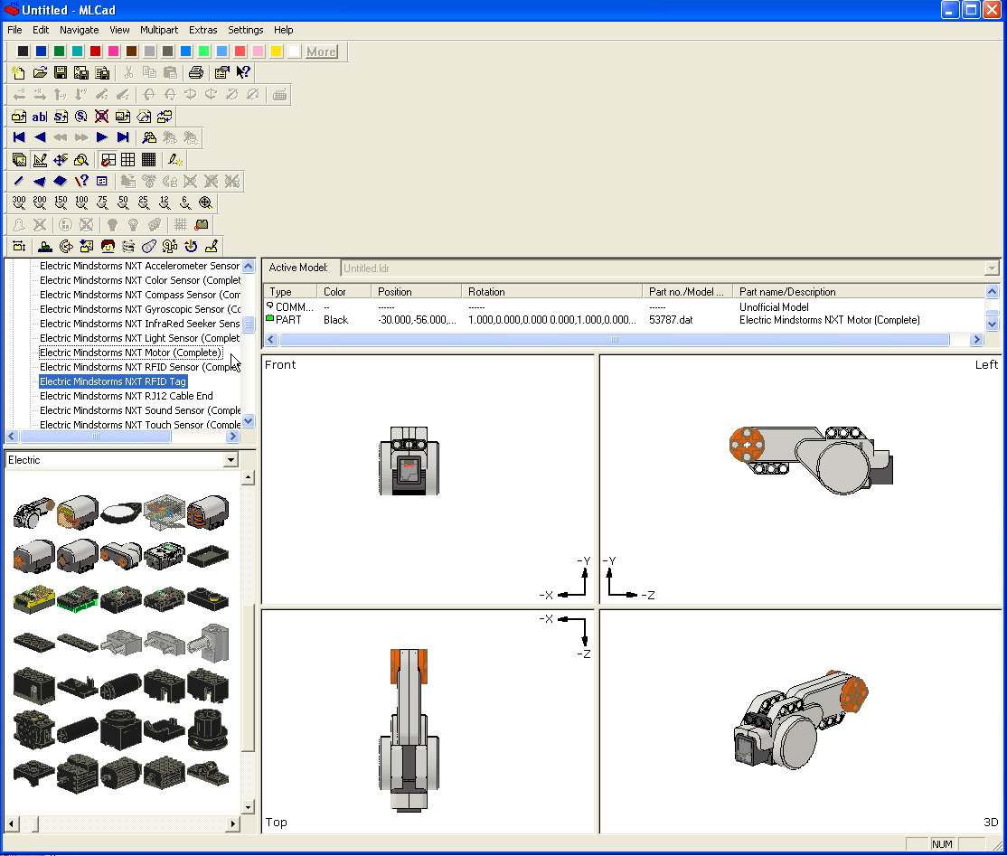

**Figure 1C:** MLCAD with NXT parts

Congratulations! You should now be able to save and open your Lego-based assemblies

# **Concept 1 – helloMlcad3Bar:** Creating your first MLCAD based assembly and build instructions. For this exercise, you will create the CAD version and build instructions for the assembly (3-bar crank) shown below



3-bar crank to be documented in MLCAD

**Step 1:** Click File – New. Click on the “+” sign next to the Technic heading. This will open up the list of available Technic parts (see **Figure 2A**).

**Step 2:** Scroll along the list of parts to “Technic Beam 5” (part 32316). Click and drag onto the “Front” panel as shown in **Figure 2B**

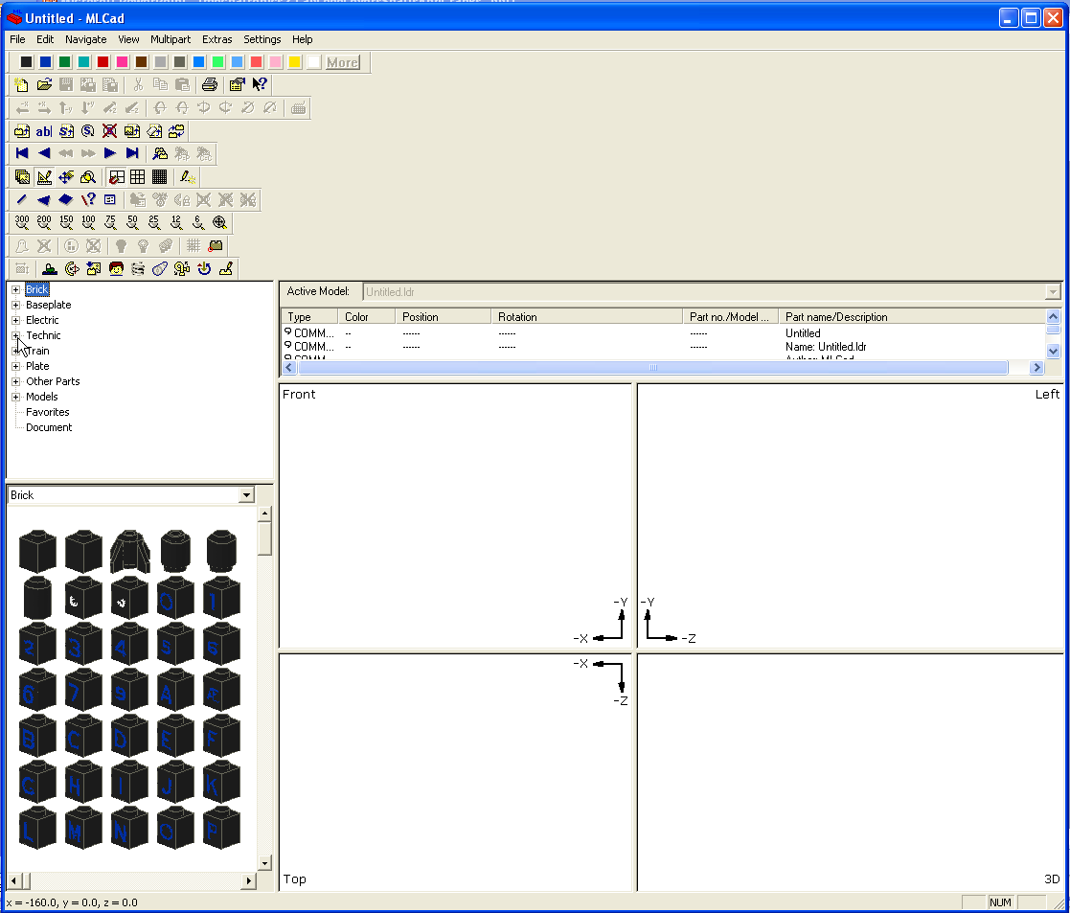

**Figure 2A:** As described in Step 1, click on the “+” sign alongside the Technic heading

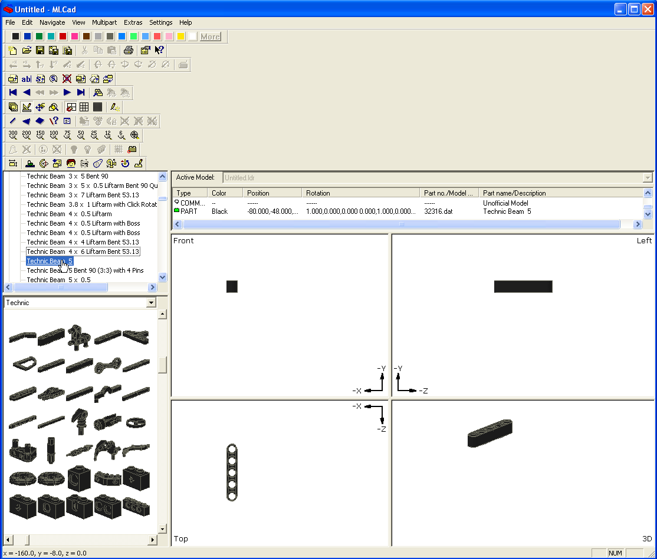

**Figure 2B:** As described in Step 2, scroll down to “Technic Beam 5”, click and drag to the Front panel (top left one)

**Step 3:** Click and drag the following parts to the Front panel

* + Technic Beam 7 (part 32524)
  + Technic Pin with Friction (part 4459)
  + Technic Gear 24 Tooth (part 3648)
  + Technic Pin with Friction (part 4459)

Save your work as “**helloMlcad3Bar**”. Your GUI should look like Figure 3A below

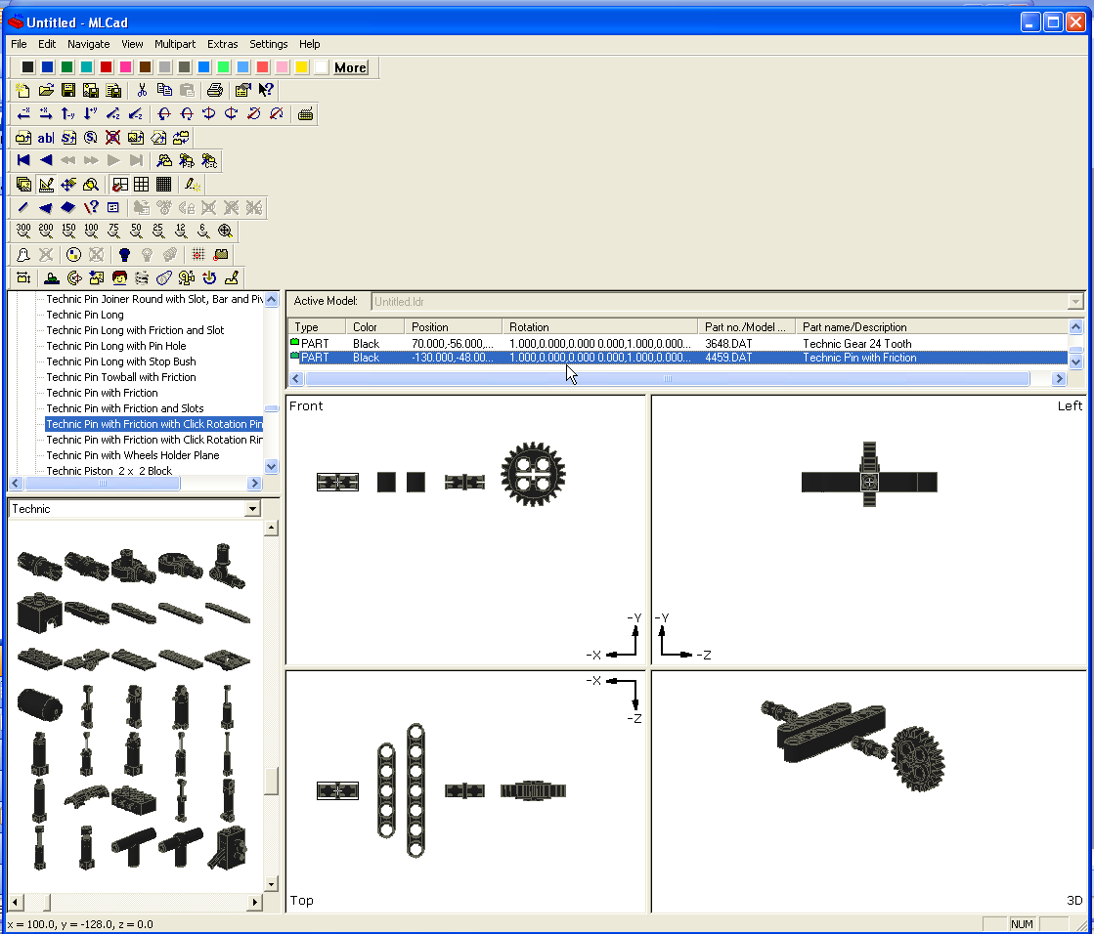

**Figure 3A:** As per Step 3, click and drag parts to look like this

**Step 4:** Establish a Build Instruction Step. Under the “Active Model” pane, click the last part to highlight it. Right click – Add – Step (see **Figure 4A**)

Next, click on the Friction Pin. Rotate it by going to the tool menu bars. Click on the “Rotate along Y-axis” icon to rotate the part (**Figure 4B**). Insert the pin into the 24T gear. Arrange parts to look like **Figure 4C**.

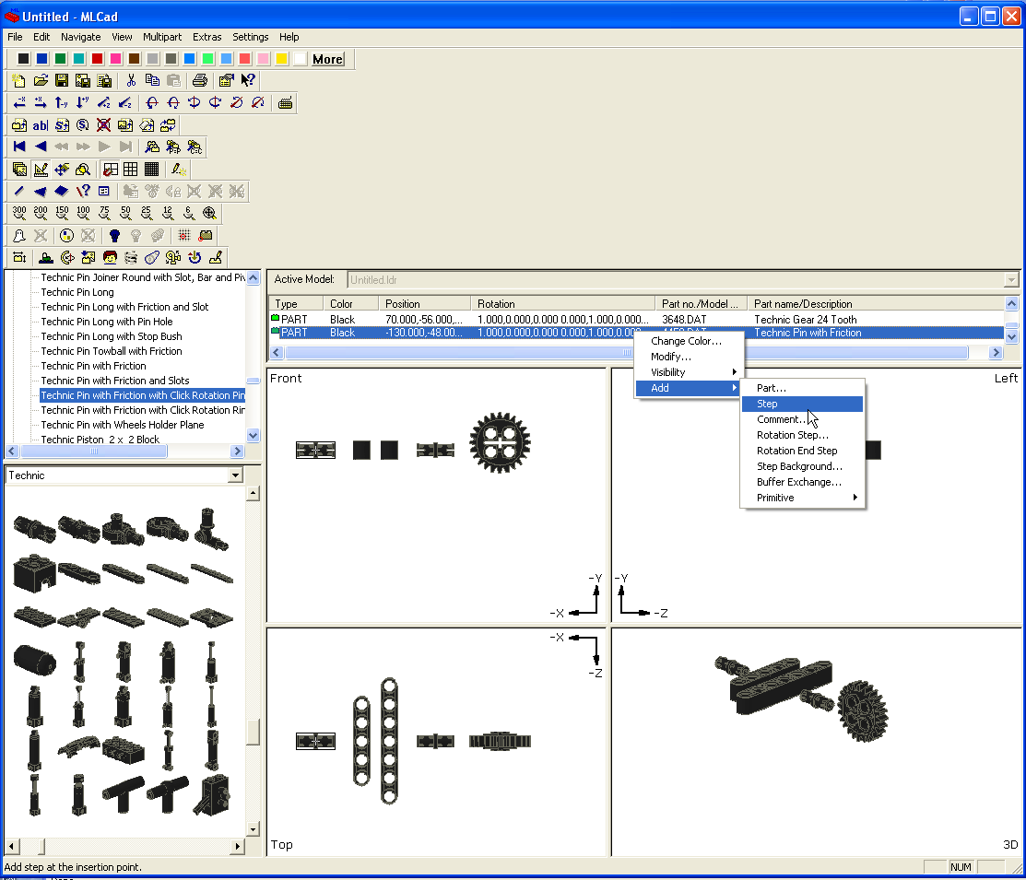

**Figure 4A:** Establish a “Step” – this is used to create a new graphic depicting the build instructions.

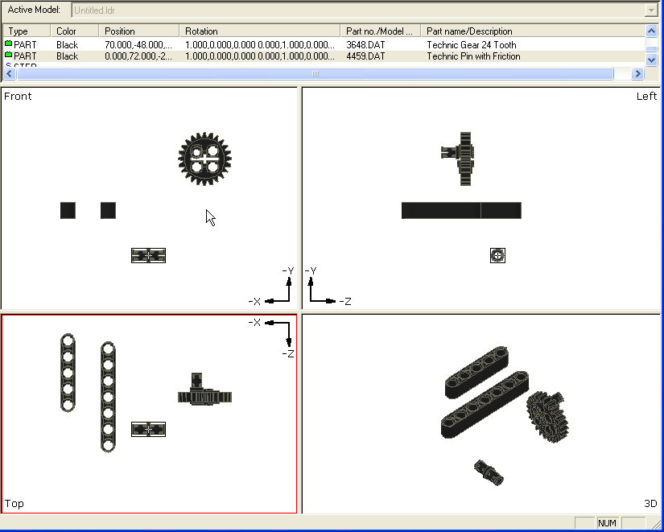

**Figure 4C:** Click and drag to arrange parts. Insert the friction pin the 24T gear.

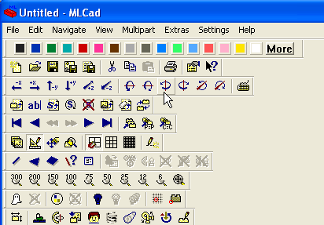

**Figure 4B:** Cursor shows some of the rotate options

Experiment with rotations and color changes. The 3D prospective view (lower right pane) is what the build instruction step will ultimately look like. To move parts more accurately, click the “Grid Fine” icon (see **Figure 4D**). Arrange parts to look like **Figure 4E**.

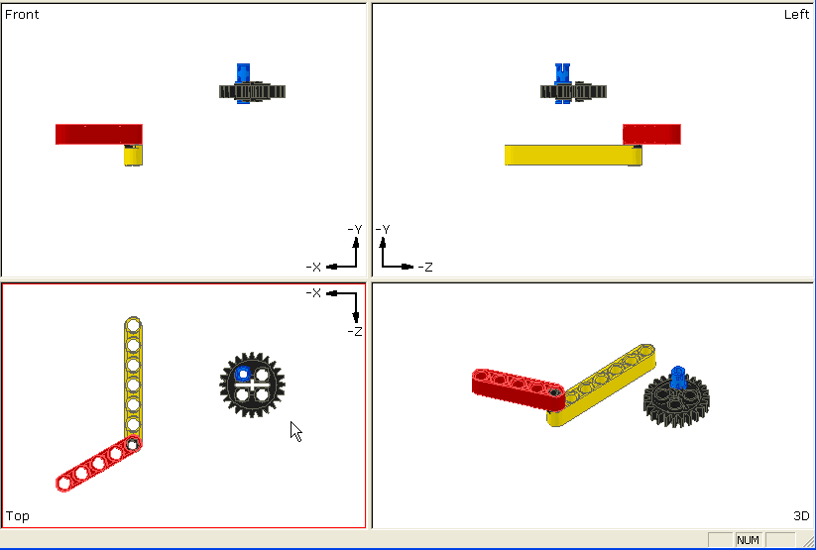

**Figure 4E:** Arrange parts to establish your first build step (depicted by the lower right pane).

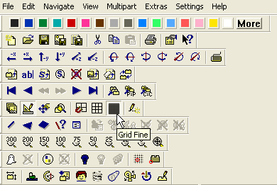

**Figure 4D:** Use the Grid Fine icon to move parts more accurately

Step 5: Add the next set of parts towards creating the next build instruction step

* + Technic Axle 3 (part 4519)
  + Technic Beam 7 (part 32524)
  + Technic Pin with Friction (part 4459)

Arrange parts (rotating as needed), insert pin, and arrange 3D perspective view to the build instruction figure you like. See **Figure 5A** for example. Once done, add a Step by highlighting the last part Active Model pane, right click – Add – Step.

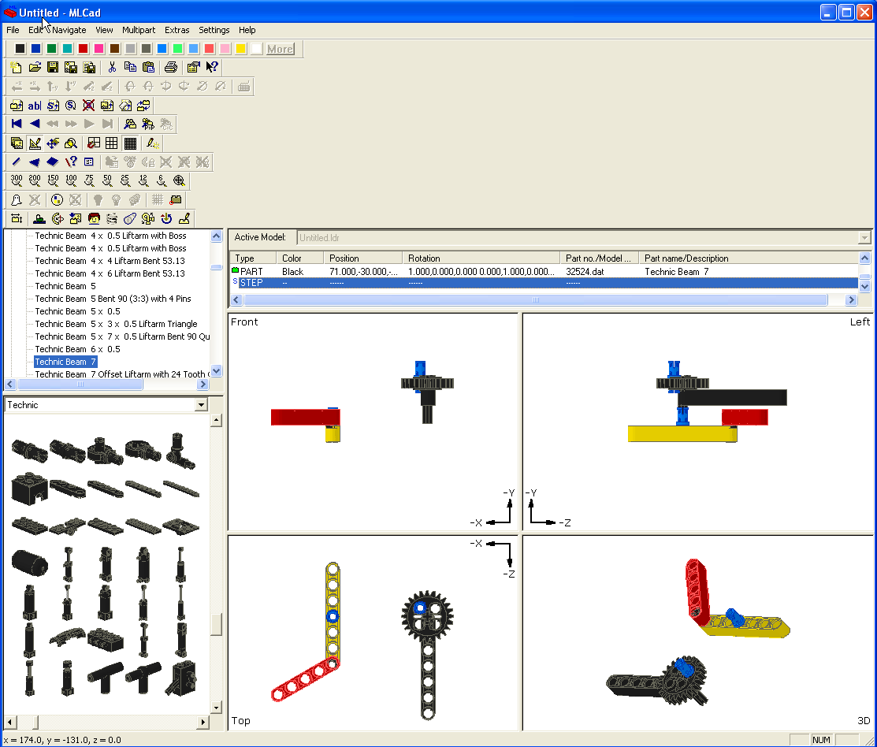

**Figure 5A:** The Axle 3 was aligned with the 24T Gear’s axis and Technic Beam 7. Another friction pin was inserted into the original Technic Beam 7 (yellow one)

Step 6: Add the next set of parts towards creating the next build instruction step

* + Technic Bush (part 3713) – color this gray
  + Technic Pin with Friction (part 4459) – color this blue

Arrange parts (rotating as needed), insert pin, and arrange 3D perspective view to the build instruction figure you like. See **Figure 6A** for example. Once done, add a Step by highlighting the last part Active Model pane, right click – Add – Step.

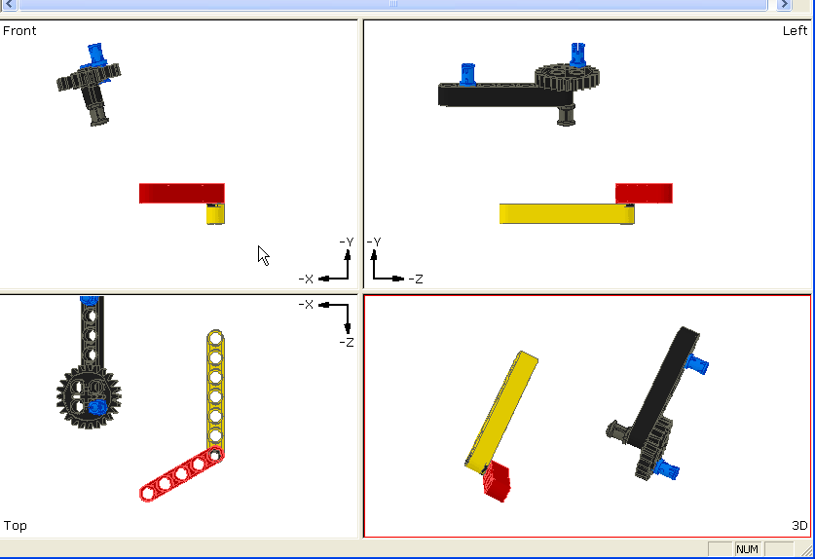

**Figure 6A:** With your mouse, you can group parts and thus rotate them together. Attach the bush to the axle. You can also delete parts. For example, the blue friction pin that was attached the yellow beam was a mistake and thus deleted.

# Step 7: Add another build instruction step (last one) as shown in **Figure 7A**

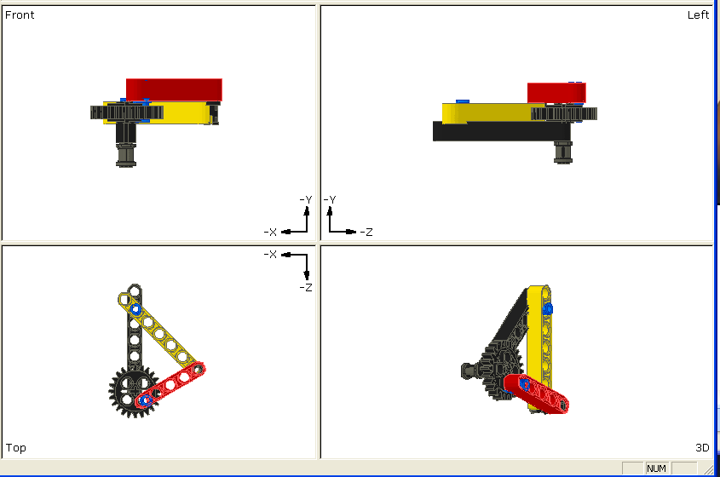

**Figure 7A:** After oriented the parts for the final connections, add a (final) build step

# **Step 8:** Create the Build Instructions.

# Start – My Programs – LDraw – LPub will launch the LPub program. Once LPub is launched, a window. Click File – Open LDRAW File and browse to where you saved helloMlcad3Bar. Once loaded, click on Configuration – Bill of Materials Setup.

You can assemble all the build instruction images into a Word or PPT file as depicted below. Click File – Export As – Export as BMP Images. Or you can save as a PDF file.

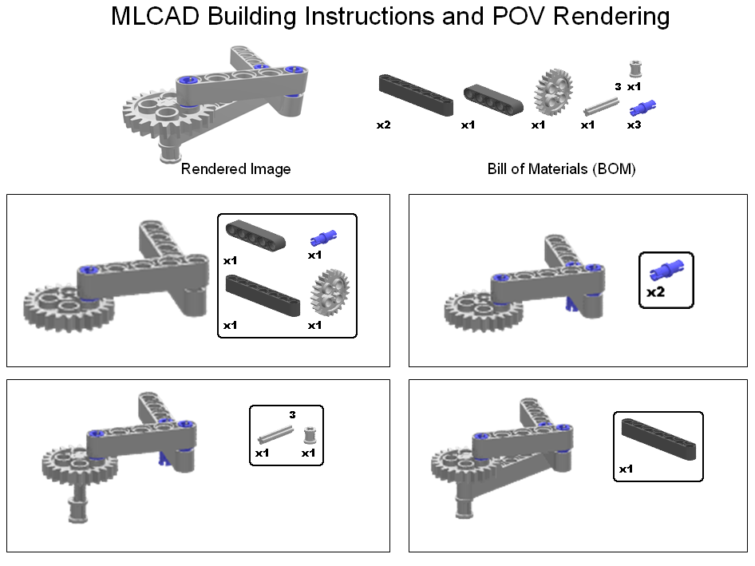

**Figure 9A:** Images from “…\LPub\Images” were imported into PPT to create the following building instructions. The result is a document that archives the mechatronic assembly.

**End of Document**