**Hands-on Lab**

**Lego Programming – BricxCC Basics**

This lab reviews the installation of BricxCC and introduces a C-like programming environment (called NXC) for the Lego NXT system. Specific concepts include: text display, button presses, looping (for and do-while), if conditionals and motor commands

**Preliminary:** BricxCC Installation and Integrated Development Environment (IDE) setup

The Bricx Command Center (BricxCC) is a single software program (called an IDE) that enables one to compose, compile and download/run C-like programs for all Lego-based bricks (e.g. NXT and the older RCX unit). Versions for Win95 to Vista exist and the IDE includes languages like C/C++, Pascal, and Java. This Hands-on Lab will focus exclusively on NxC (Not eXactly C). This has various advantages. First, C is a universally used programming language and most the common one in the embedded micro-controller community (e.g. robotics). Second, C is platform independent, meaning that code developed for one platform, should operate on other platforms (as long as ANSI standards are used). Third, unlike other C compilers for the NXT, NxC is freely available under the GNC public license. The net effect is that NxC will enable developers to quickly and painlessly develop code for their NXT-based systems.

**Step 1:** Download

1. Visit <http://sourceforge.net/projects/bricxcc/files/bricxcc/>.
2. We will use Version Build 3.3.8.9. Click **bricxx 3.3.8.9**
3. Download file “**bricxcc_setup_3389.exe**”

NB: As of 09/20/12, NXT Brick is installed with Firmware 1.28. Versions greater than 1.28 (e.g. 1.31) should also work.

**Step 2:** Once downloaded, double-click the EXE file and install in a desired directory

**Step 3:** Connect the USB cable between your PC and NXT. Turn on the NXT

**Step 4:** Launch Program

1. “Start – Programs – Bricx Command Center – Bricx Command Center”
2. You should see the following prompt

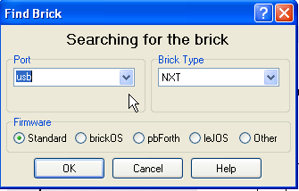

**Figure:** If installed properly, launching “Bricx Command Center” will result in this prompt

1. Select “USB” and “NXT” respectively for the “Port” and “Brick Type” pull-down menus. Click OK.

**Step 5:** See the IDE

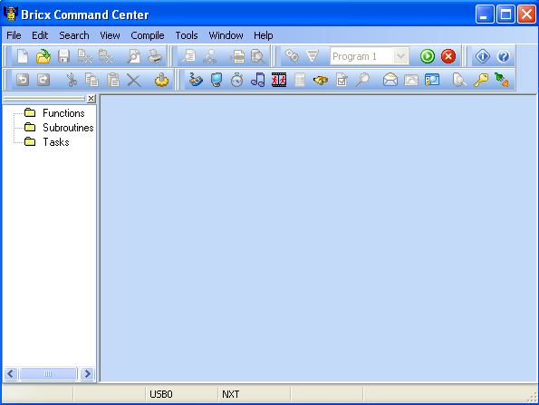

**Figure:** The IDE (Integrated Development Environment). The top bar reveals menus that enable one to compose, compile and download code to the NXT

# **Concept 1 – Hello World:** Creating your first NxC Program to display text on the NXT Brick

**Step 1:** Click File – New. Click File – Save As and save in a directory e.g. “myPrograms” with the name “helloWorld”.

**Step 2:** Enter the following text

**Code Example:** helloWorld.nxc

task main ()

{

TextOut (10, LCD_LINE4, "Hello World");

Wait (SEC_2);

}

**Step 3:** Click File – Save All.

**Step 4:** Compile

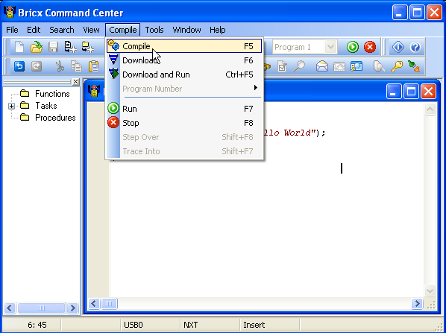

**Figure:** Select Compile - Compile

**Step 5:** Execute: Follow the left figure below. Your NXT should display your text (right figure)

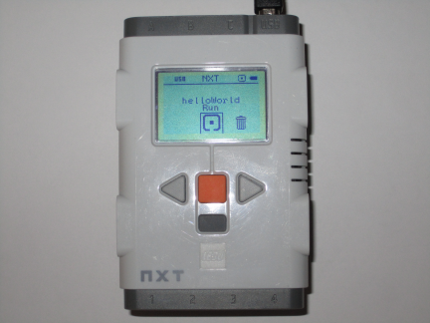

**Figure:** The text is displayed on NXT brick

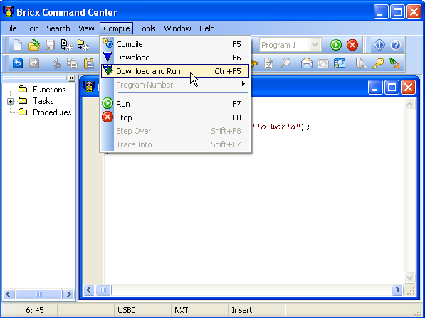

**Figure:** Click Compile – Download and Run

# Congratulations! You’ve composed, compiled and executed your first NxC program.

**Code Explanation:** Like all C programs, code execution begins with a main function. NxC implements this with the syntax task main() and executes code between the parenthesis. In the program helloWorld.nxc, one sees the TextOut() function. According to the manual (online version is located at <http://bricxcc.sourceforge.net/nbc/nxcdoc/nxcapi/index.html>), searching for TextOut() reveals the following syntax:

char TextOut(int x, int y, string str, unsigned long options)

In helloWorld.nxc, the statement:

TextOut(10, LCD_LINE4, “Hello World”);

suggests that the characters between the quotations i.e. a string, will be displayed on the Brick at the location x = 10 and y = LCD_LINE4. Searching for LCD_LINE4 on the online manual reveals that LCD_LINE4 is a defined constant in NxC and is equal to 32. Thus, ultimately the message Hello World is displayed 10 pixels from the left and 32 pixels from the top.

After displaying the message, a Wait statement is executed. Searching for Wait reveals

void Wait(unsigned long ms)

and serves to wait a prescribed number of milliseconds. This statement essentially causes the program to “sleep” or delay for a specified amount of time.

Searching for SEC_2 reveals that this is also a defined constant in NxC and is equal to 2000. Thus the statement

Wait(SEC_2)

makes the task main go to sleep for 2000 milliseconds (or 2 seconds).

**Exercise 1:** In NxC create programs for the following:

* 1. Search for LCD_LINE and experiment displaying the message Hello World at various rows on the LCD Brick
  2. Introduce a string variable as follows and display it at position x=10, y=16

string strMessage;

strMessage = “Bye Cruel World”;

* 1. Look up PlaySound. Execute a program that displays Hello World, waits 2 seconds, plays the error sound and then displays Bye Cruel World below the Hello World message
  2. Look up ClearScreen. Rewrite 1-3 so that the LCD is cleared before the Bye Cruel World message is displayed

**Concept 2A – Variables:** An NxC program intro to variables

From Concept 1 create a new program, save as displaySquareAndSquareRoot1_0.nxc, compile and execute.

// File: displaySquareAndSquareRoot1_0.nxc

// Date: 08/31/12 13:04

// Desc: Display number, its square and square root

// Vers: 1.0 - works!

task main ()

{

int x; // integers from 1 to 10

int xSquared; // square of x

float xSquareRoot; // square root of x

x = 3;

xSquared = x*x;

xSquareRoot = sqrt(x);

// TextOut (xPosition, yPosition, string) put string on LCD's x,y position

// NB: x = y = 0 is lower left corner of LCD; +x goes rights, +y goes up

// FormatNum is a string with sprintf syntax

TextOut (10, LCD_LINE4, FormatNum("x = %d" , x));

TextOut (10, LCD_LINE5, FormatNum("xSquared = %d" , xSquared));

TextOut (10, LCD_LINE6, FormatNum("sqrt(x) = %3.3f" , xSquareRoot));

Wait (SEC_2);

}

**Code Example:** displaySquareAndSquareRoot1_0.nxc

**Code Explanation:** Like C, NxC allows one to assign variables and uses ANSI-C standards like int and float to define 16-bit whole numbers ranging from -32768 to +32768 and 32-bit real numbers. The above program creates 2 integer variables x and xSquared. As their names suggest, they will store whole numbers. The float variable xSquareRoot will store real numbers (since square roots typically yield numbers with decimals).

**Concept 2B – for Statement:** Repeat execution of code

The for statement is part of the ANSI-C standard and is used to repeatedly execute a block of code. Modify the program in Concept 2 with the following for statement. Execution reveals that the variable x increments from 1 to 10, displaying the square and square root.

for (x = 1; x <=10; x++) {

xSquared = x*x;

xSquareRoot = sqrt(x);

// TextOut (xPosition, yPosition, string) put string on LCD's x,y position

// NB: x = y = 0 is lower left corner of LCD; +x goes rights, +y goes up

// FormatNum is a string with sprintf syntax

TextOut (10, LCD_LINE4, FormatNum("x = %d" , x));

TextOut (10, LCD_LINE5, FormatNum("xSquared = %d" , xSquared));

TextOut (10, LCD_LINE6, FormatNum("sqrt(x) = %3.3f" , xSquareRoot));

Wait (SEC_2);

}

**Code Explanation:** The variable x begins with 1 and executes the statements between its parentheses. These statements compute the square and square root and display their values using the TextOut statement at various rows of the LCD. The program waits 2 seconds, checks if x less than or equal to 10. If it is x increments and again goes through computation and display. If x is greater than 10, then the loop is bypassed – which ultimately leads the termination of main.

**Concept 2C – do-while Statement:** Repeat execution of code

The Do-While statement is also a part of the ANSI-C standard for looping. Do-While is often used to execute code until some condition is met. Write the following program, save as displaySquareAndSquareRoot1_1.nxc, and execute.

**Code Example:** displaySquareAndSquareRoot1_1.nxc

// File: displaySquareAndSquareRoot1_1.nxc

// Date: 08/31/12 13:04

// Desc: Display number, its square and square root

// Vers: 1.0 - works!

// 1.1: Push orange button to begin - works!

task main ()

{

int x; // integers from 1 to 10

int xSquared; // square of x

float xSquareRoot; // square root of x

bool buttonPushed;

TextOut (0, LCD_LINE1, "Push Orange" );

TextOut (0, LCD_LINE2, "button to start" );

do {

// nothing if Orange center button is not pushed

buttonPushed = ButtonPressed(BTNCENTER, FALSE);

} while(!buttonPushed);

// exit loop when BTNCENTER = true i.e. pushed

for (x = 1; x <=10; x++) {

xSquared = x*x;

xSquareRoot = sqrt(x);

// TextOut (xPosition, yPosition, string) put string on LCD's x,y position

// NB: x = y = 0 is lower left corner of LCD; +x goes rights, +y goes up

// FormatNum is a string with sprintf syntax

TextOut (10, LCD_LINE4, FormatNum("x = %d" , x));

TextOut (10, LCD_LINE5, FormatNum("xSquared = %d" , xSquared));

TextOut (10, LCD_LINE6, FormatNum("sqrt(x) = %3.3f" , xSquareRoot));

Wait (SEC_2);

}

} // end main

**Code Explanation:** The do-while statement polls the ButtonPressed statement. In the NxC manual, ButtonPressed is used to check if a specified button is pressed. Int his case, the defined constant BTNCENTER refers the Brick’s orange button. When pressed, the Boolean variable buttonPushed becomes TRUE. The exclamation mark (!) in ANSI-C refers to negation. In other words, the do-while keeps polling ButtonPressed while buttonPushed remains not-TRUE (i.e. FALSE).

**Concept 2D – if Statement:** Conditional statement

The if statement is the ANSI-C standard to conditionally execute a statement. To appreciate this, write the following program, save as displaySquareAndSquareRoot1_1.nxc and execute.

**Code Example:** displaySquareAndSquareRoot1_1.nxc

// File: displaySquareAndSquareRoot1_2.nxc

// Date: 09/04/12 11:14

// Desc: Display number, its square and square root

// Vers: 1.0 - works!

// 1.1: Push orange button to begin - works!

// 1.2: Arrows to increment, grey button to quit - works!

task main ()

{

int x; // integers from 1 to 10

int xSquared; // square of x

float xSquareRoot; // square root of x

bool orangeButtonPushed;

bool greyButtonPushed;

bool leftArrowButtonPushed;

bool rightArrowButtonPushed;

TextOut (0, LCD_LINE1, "Push Orange" );

TextOut (0, LCD_LINE2, "button to start" );

do {

// nothing if Orange center button is not pushed

orangeButtonPushed = ButtonPressed(BTNCENTER, FALSE);

} while(!orangeButtonPushed);

// exit loop when BTNCENTER = true i.e. pushed

ClearScreen(); //clear screen

TextOut (0, LCD_LINE1, "Arrows increment" );

TextOut (0, LCD_LINE2, "Grey quits" );

x = 1; // start with x = 1

do {

// Stay in this loop until grey button pushed

// Check which button pressed

leftArrowButtonPushed = ButtonPressed(BTNLEFT, FALSE);

rightArrowButtonPushed = ButtonPressed(BTNRIGHT, FALSE);

greyButtonPushed = ButtonPressed(BTNEXIT, FALSE);

if(leftArrowButtonPushed) x = x - 1;

if(rightArrowButtonPushed) x = x + 1;

if(x < 0) x = 0; // don't go below 0

xSquared = x*x;

xSquareRoot = sqrt(x);

// TextOut (xPosition, yPosition, string) put string on LCD's x,y position

// NB: x = y = 0 is lower left corner of LCD; +x goes rights, +y goes up

// FormatNum is a string with sprintf syntax

TextOut (10, LCD_LINE4, FormatNum("x = %3d" , x));

TextOut (10, LCD_LINE5, FormatNum("xSquared = %3d" , xSquared));

TextOut (10, LCD_LINE6, FormatNum("sqrt(x) = %3.3f" , xSquareRoot));

Wait (500); // wait 500 msec

} while(!greyButtonPushed);

} // end main

**Code Explanation:** Like displaySquareAndSquareRoot1_1.nxc given in Concept 2C, this version (1.2) adds Boolean variables to the Brick’s 3 other buttons (left and right arrows and the grey center button). The if statement is used to increment or decrement the value of the variable x, and consequently compute and display the x’s square and square root. The do-while statement continues to monitor the status of the grey center button, and if pushed, exits the program.

**Concept 3 – Motors:** An NxC program to command NXT motors to move

**Step 1:** Open a new file and save as “helloMotor.nxc”. Type the following and save

**Code Example:** helloMotor.nxc – Rotate Motors A and C then Counter-rotate them

// FILE: helloMotor1_0.nxc

// AUTH: P.Oh

// DATE: 03/16/11

// DESC: Motors connected to Ports A and C. Command to rotate,

// and counter-rotate fixed amount

task main() {

OnFwd(OUT_AC, 75);

// NXC Guide P. 294 (6.36.2.27): OnFwd(byte outputs, char pwr)

// outputs is OUT_X where X = [A, B, C, AB, AC, BC, ABC]

// pwr is from [0, 100]

Wait(5000); // continues for specified milliseconds

OnRev(OUT_AC, 25);

// NXC Guide P. 300 (6.36.2.37)

Wait(2000);

Off(OUT_AC); // stop and end program gracefully

StopAllTasks();

}

**Step 2:** Attached 2 NXT motors (to Ports A and C) on the Brick

**Step 3:** Save All, Compile, then Download and Run

Code Explanation: The NxC manual describes OnFwd and OnRev statements. These are specific to NxC and not part of the ANSI-C standard. Often, specific hardware (like NXT motors and sensors) dictate using non-ANSI standard statements. The OnFwd statement uses the defined constant OUT_AC to reference Brick ports A and C and commands motors connected to these ports to run at 75% of maximum power. Similarly, the OnRev statement commands the motors to rotate in the opposite direction at 25% of maximum power. Lastly, Off and StopAllTasks are additional non-ANSI statements, to stop the motors and exit the program gracefully.

**Exercise 3:** In NxC create programs for the following:

* 1. The repeat statement (page 25 Section 3.3.3.7) of the NXC_Guide.pdf document, describes looping. Add a repeat(3) statement below the task main() and encase the code with a pair of French braces. This should make your helloMotor code operate 3 times.
  2. Look up the RotateMotor statement (page 308 Section 6.36.2.255). Set Motor A to run at a power level of 75 and rotate to -180 degrees.

**Programming Exercises**

* 1. Write a program that converts your age (in years) and displays your age in the number of days. Don’t worry about fractional years and leap years. For example, if you are 10 years old, then the Brick should compute (365 days per year) and display 3650 days old. Hint: use int or long for variables
  2. Write a program that increments a foot from 1 feet to 10 feet and displays the equivalent in meters (0.3048 meters per foot). NB: only display the 2 digits after the decimal. For example, for 1 foot, display (1 ft = 0.30 meters)
  3. Define 3 string variables called firstName, middleInitial, and lastName that are assigned with your own name. For example firstName = “Paul”, middleInitial = “Y” and lastName = “Oh”. Have the Brick display:

Paul

Y

Oh

Paul Oh

Paul Y. Oh

Look up and use the strcat function to display the 4th and 5th lines above

* 1. Look up strlen and write a program that displays the number of characters for each line in program 1-3. For example, output should look like

Paul: 4

Yu: 2

Oh: 2

Paul Oh: 7

Paul Y. Oh: 10

NB: White spaces count as characters in ANSI-C

* 1. Write a program that uses the variable days to hold a value from 0 to 31. Use a for loop to display days and its equivalent in weeks and days. For example, 8 days would display 1 week and 1 day.
  2. Write a program that computes and displays all the prime numbers smaller than or equal to 55. For example the display should read: 1, 5, 11, 55.