Homework – Levers, Shafts and Cranks

Levers, Shafts and Cranks were covered in Lecture and Lab. Refer to the file “BricxCC – Strings, Motors and Touch Sensor” and complete the following NXC programs. Observe “Best Practices” when writing your code.

- Look up the StrLen function. Modify strcat1_0a.nxc to additionally display the number of characters in firstName, lastName, and nickName. Provide the NXC code, and a screen image (e.g. JPEG) demonstrating your code works (10-points)

- Modify helloMotor.nxc by adding a do-while loop. This loop should repeat the OnFwd(OUT_AC, 75), Wait(5000), OnRev(OUT_AC, 25); Wait(2000) cycle 3-times. Provide the NXC code, and a YouTube URL demonstrating your code works (10-points)

- Look up the RotateMotor statement (page 308 Section 6.36.2.255). Set Motor A to run at a power level of 75 and rotate to -180 degrees. Provide the NXC code, and a YouTube URL demonstrating your code works (10-points)

- In lab, you were constructed a Domabot. Construct a front “bumper” to mount a Touch Sensor. Create two walls (e.g. two stacks of books) and put your Domabot in the middle. Write an NXC program for the Domabot to move forward. When the bumper hits wall 1, the Domabot spins 180-degrees and moves forward again (towards wall 2). When the humper hits wall 2, it again spins 180-degrees and moves forward again (back to wall 1). The Domabot stops when the user hits the Right Arrow button. Provide the NXC code, and a YouTube URL demonstrating your code works (30-points)

- Studio Exercises: Pick any 2 Lift Mechanisms from #12, #13, #14, #16, #17 (see next page). Create the step-by-step Build Plan with Bill-of-Materials (BOM). Construct the mechanism and provide a URL for a YouTube video (max 20-seconds) demonstrating it working. (20-points)

- Same as 4 above, but Pick any 2 Grabbing Things from #19, #20, #21, #22, #24 or #26 (20-points)

Lifting Things

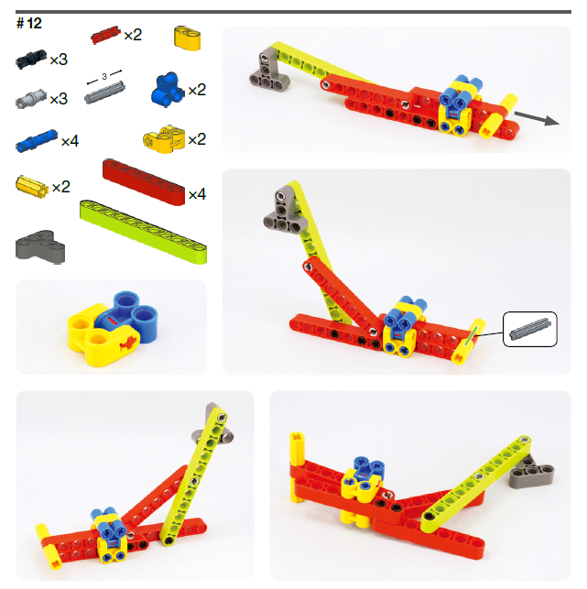

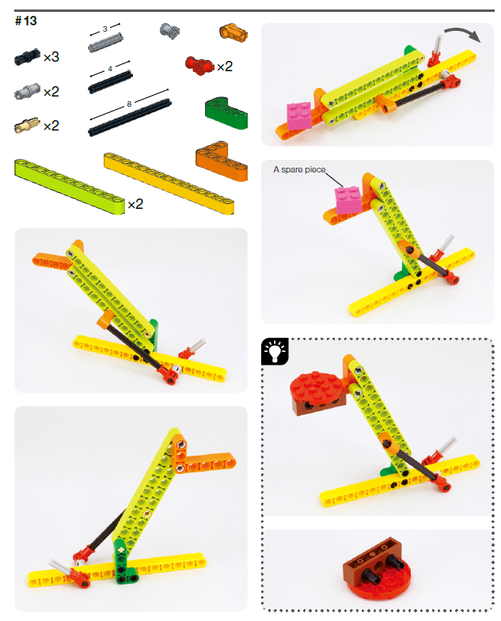
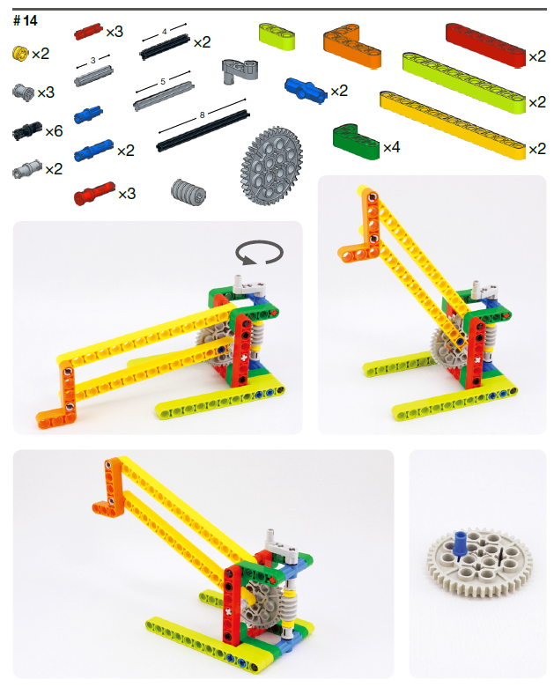
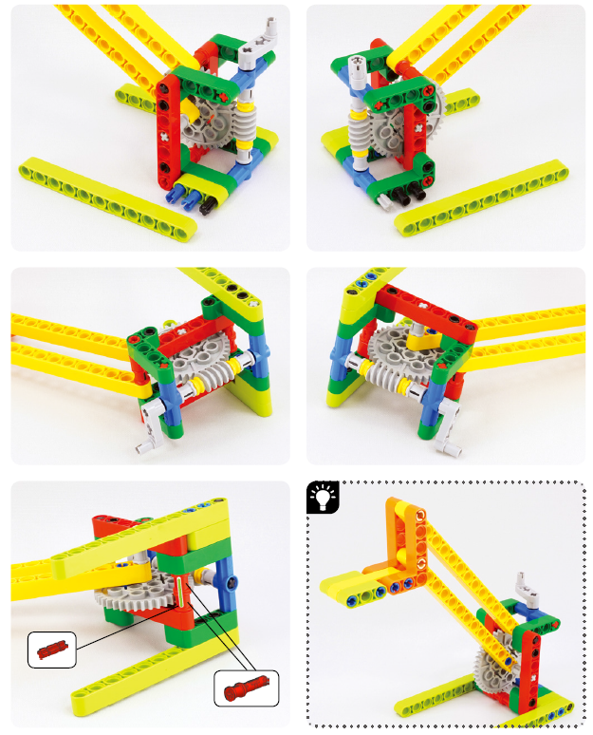
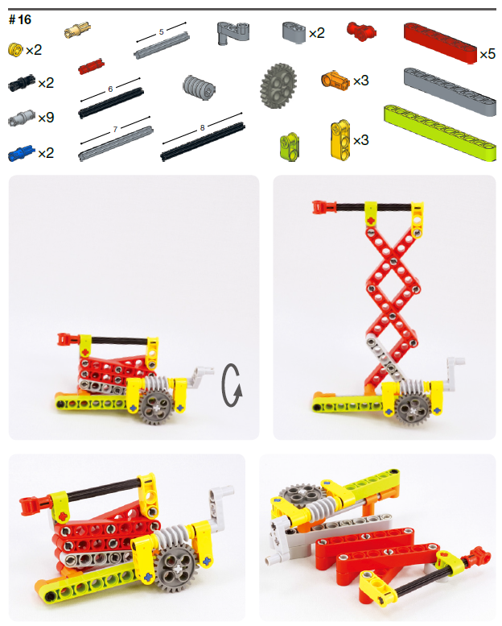
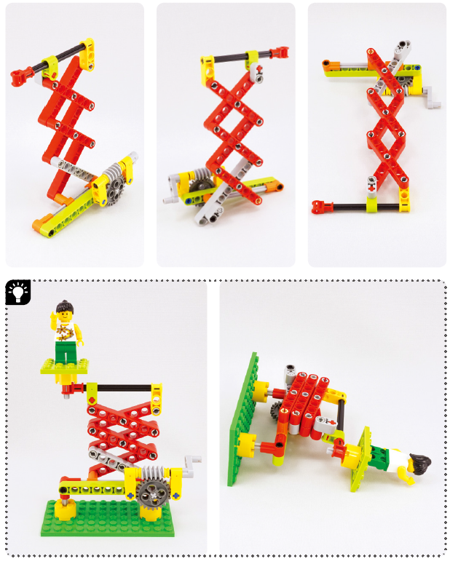

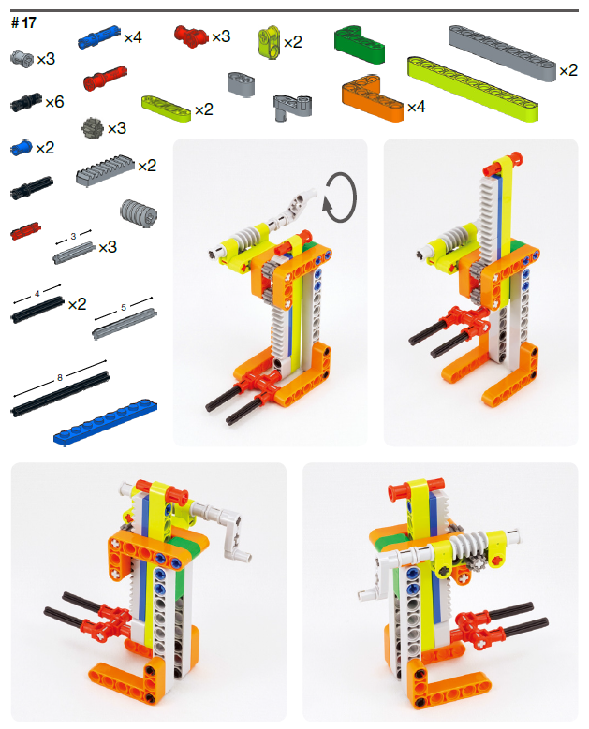
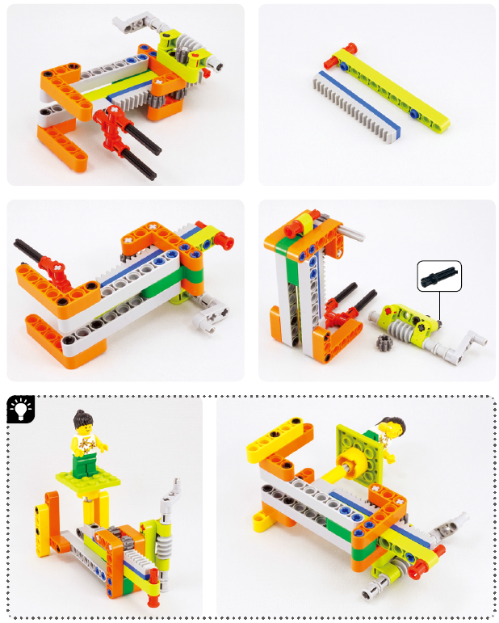
Gripping Things

