Hands-on Lab 3

System Identification with Experimentally Acquired Data

Recall that the course objective is to control the angle, rise time and overshoot of a suspended motor-prop. Towards this, the two previous labs provided the software and hardware foundations for writing LabVIEW programs and both generating and acquiring voltage signals. This lab fulfills our next step – to identify the system’s underlying dynamics. The resulting data will be used in future labs to design a suitable control system. Two concepts will be covered: Reading optical encoders with a counter and writing acquired data to a file that can be displayed in Excel.

Concept 1: Timers and Counters (Optical Encoders)

The PCI-6025E features counters that can be used to read optical encoders interfaced to the NI-DAQ card. A counter will be configured to monitor the optical encoder mounted on the pendulum’s shaft (see Figures A and B). The net result is the pendulum’s angle can be displayed in real-time.

Figure A: Pendulum Setup

Figure B: US Digital Inc. Encoder (with pin out)

Step 1: Launch LabVIEW to create the following (very simple) front panel (Figure 1). NB: the text box should fit 8 digits

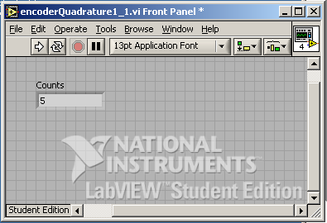
Figure 1: Front panel to display real-time optical encoder counts

Step 2: Start the following block diagram with a case structure enclosed in a while loop. The TRUE and FALSE cases are given in Figures 2A and 2B below. Set the numeric indicator data representation to be Integer 32-bit. For the FALSE case, the counter value is subtracted from the number 16777215 (i.e. $2^{\text{24}}−1$) because a 24-bit optical encoder is used.

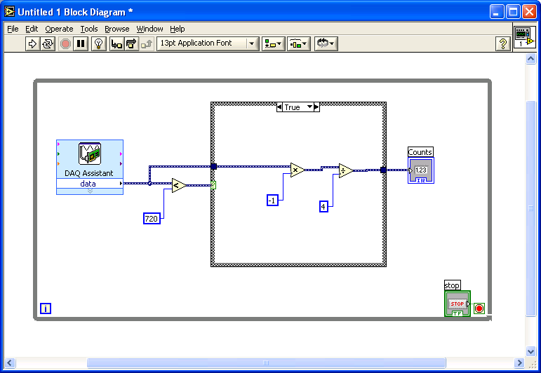
Figure 2A: TRUE Case Structure (counter decrement reflects clockwise rotation)

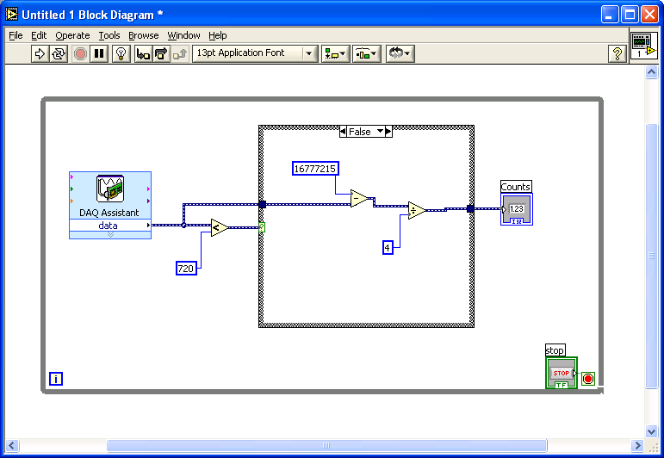
Figure 2B: FALSE Case Structure (counter increment reflects counter-clockwise rotation)

Step 3: Complete the block diagram by adding the DAQ Assistant control. Right Click – Input – DAQ Assist will bring up the screen (Figure 3A). Choose Counter Input and then select Edge Count (Figure 3B).

Figure 3A: Choose Counter Input

Figure 3B: Select Edge Count

Choose ctr0 (counter 0) as shown in Figure 3C. This will invoke the screen shown in Figure 3D. Make sure the “Externally Controlled” option is selected for the Count Direction.

Figure 3C: Select Counter 0 (ctr0)

Figure 2D: The count direction is “Externally Controlled”

Step 4: Wire up the optical encoder to the NI-DAQ screw terminals as follows
PCB | Encoder | Screw Terminal
DGND | DGND | 33
IND | INDEX | NOT CONNECTED
SRC | CH. A | 47
5 V | 5 V | 34
U/D | CH. B | 30

With the pendulum motionless, execute the VI and the numeric indicator should read 0.
Slowly rotate the pendulum counter clockwise and counts should increment (i.e. positive angle). Rotate clockwise and counts should decrement. The angle becomes negative if rotated past 0.
NB: This is a 360-counts/revolution encoder. As such, each increment represents 1 degree.
Exercise 1: In LabVIEW create programs for the following:

  - Increase or decrease the counter when rotating clockwise or counter clockwise respectively

  - Let the pendulum’s vertical position (i.e. resting angle or 6 o’clock position) represent 90-degrees. Increase and decrease the counter when rotating the pendulum clockwise and counter clockwise respectively. In other words, the indicator should read 0 at the 3 o’clock position and 180 at the 9 o’clock position.

Concept 2: Write angle data to file and identify parameters

Recall that a virtual data recorder was created in Lab 2 Concept 3. The VI recorded and wrote data acquired from analog channel 0.

Step 1: Create a VI to record the pendulum’s angle data (0, +90 and –90 degrees at the 6, 3 and 9 o’clock positions respectively). Block diagrams given below.

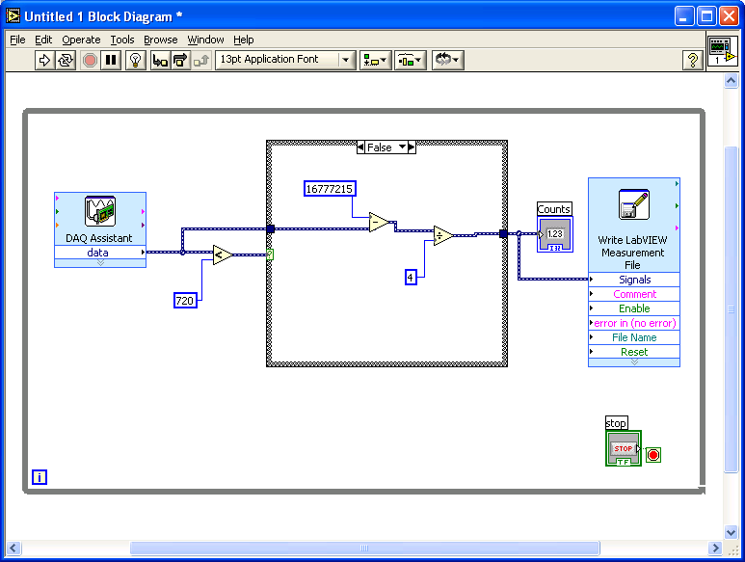
Figure 4A: FALSE case

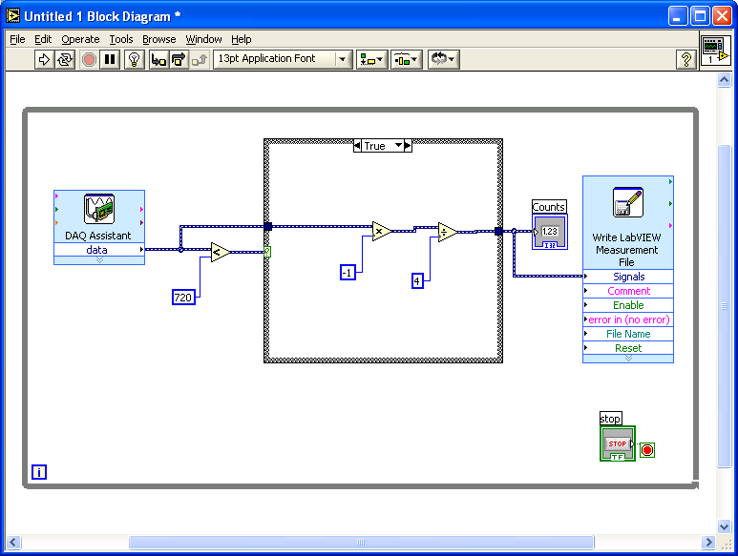
Figure 4B: TRUE case

Step 2: From the pendulum’s rest position (6 o’clock) execute the VI. Rotate the pendulum counter clockwise to approximately +60-degrees and then release. Let the VI run for about 10 seconds and then terminate the VI. Plot the data in Excel, which should look like Figure 5.

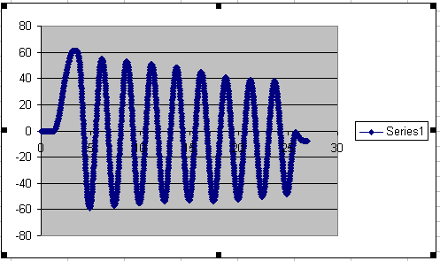
Figure 5: Excel plot of the acquired comma-delimited data

