Hands-on Lab 5

Matlab/Simulink: Designing and Testing Controllers

Lab 5 is a critical turning point towards achieving the course objective. Using computational software tools like Matlab/Simulink allows one to rapidly design, validate and iterate controllers before real-world deployment. Four concepts will be explored: (1) open-loop system response; (2) Matlab as a computation tool; (3) Simulink closed-loop pole placement design and (4) Simulink closed-loop PID control. At the end of this lab, one will be poised to implement the controller design in LabVIEW

Concept 1: Open Loop System

The following block diagram depicts the damped compound pendulum:

The transfer function representation is given by:

(1)

An equivalent representation in state space is given by:
(2)

Step 1: In Simulink create the block diagram given in Figure 1A

Figure 1A: Simulink block diagram for state-space representation

Figure 1B: State space parameters

Here, the state-space block from the Continuous block set was used. The above block diagram sets up a 2 Volt step input into the damped compound pendulum. Note: there is no feedback (or feed-forward) element. Consequently, this is called an open-loop system and the scope will display the open-loop response to a step input

Step 2: Double-click the state space block. Configure the matrices (see Figure 1B) with values given in Equation (2).

Step 3: Execute and verify the step response over 30 seconds looks like the Figure 2 below

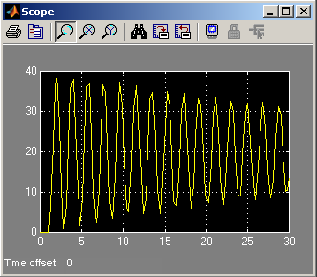
Figure 2: Open loop response to a 2 Volt step input

Exercise 1: In Simulink create programs for the following:

  - Increase the simulation run-time. What is settling angle? How long does the system take to settle? Compare to the formula $t_{s}=4{\text{ζω}}_{n}$

  - Replace the steady-state block element with a transfer function element. Configure the transfer function with values given in Equation (1). Show that the transfer function scope output is the same as the state space output that was given in Figure 2.

Concept 2: Matlab as a Computation Tool

Oftentimes control techniques require calculating values. Matlab is a programming language and has many commands to save one the trouble of computing values by hand. One creates a M-file and executes it in Matlab.

For the damped compound pendulum defined by Equation (2), the current poles are given by (3). There are just the roots of the denominator given in (1)
$$s_{1,2}=−0\text{.}\text{0019}±j3\text{.}\text{28}$$

(3)

These roots can be easily calculated by hand using the quadratic equation. Higher order polynomials are challenging. Matlab will be used to illustrate some computations.

Step 1: Matlab provides commands to quickly calculate control parameters. To verify (3) are poles for (2) create the following script. In Matlab, click File – New – M-File:

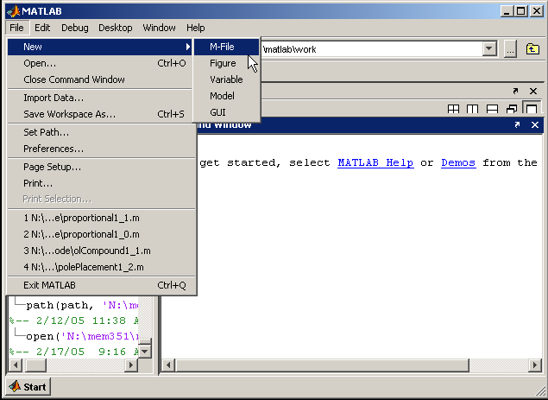
Figure 3: Creating a new M-File

Step 2: Type the following and save the file in your directory as myPoles1_0.m

% FILE: myPoles1_0.m
% DATE: 1.0 02/17/05
% AUTH: P.Oh
% DESC: Damped compound pendulum: pole calculations

% Pendulum properties
J = 0.0090; % Moment of Inertia [kg m^2]
c = 0.00035; % Viscous damping coefficient [Nms/rad]
d = 0.023; % Distance from pivot to center-of-mass [m]
L = 0.495; % Length of bar [m]
z = 0.0059; % Damping ratio
w = 2.50; % Natural frequency [rad/s]
mL = 0.43; % Mass of system [kg]
g = 9.81; % Gravitational constant [m/s^2]
PI = 3.1416; % Pi constant

r = d + (L/2); % Distance between motor-prop and pivot point [m]
Fl = 0.123; % Lift force when applying 2.0 Volts to motor-prop [N]
tor = Fl*r; % Torque when applying 2.0 Volts to motor-prop [Nm]

vTest = 2.0; % Test voltage [Volt]
Km = tor/vTest; % Motor constant [Nm/Volt]

% Open Loop system: xDot = Fol*x + Gol*u where u scalar
% y = Hol*x + Jol*u

Fol = [ 0 1; -(mL*g*d/J) -(c/J) ];
Gol = [ 0; Km/J ];
Hol = [ 1 0];
Jol = 0;

% Create open-loop transfer function using ss2tf command
[oltfNum, oltfDen] = ss2tf(Fol, Gol, Hol, Jol);

Step 3: In Matlab, set the path to point to your file’s folder by clicking File – Set Path.
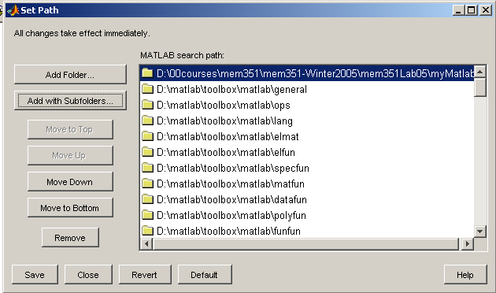
Figure 4: Setting up the path so Matlab can find your files

Step 4: With the path now set up, Matlab knows where to find your M-file. In Matlab type your program name: myPoles1_0. The Matlab function roots displays the roots of a polynomial. Type roots(oltfDen) as shown below.
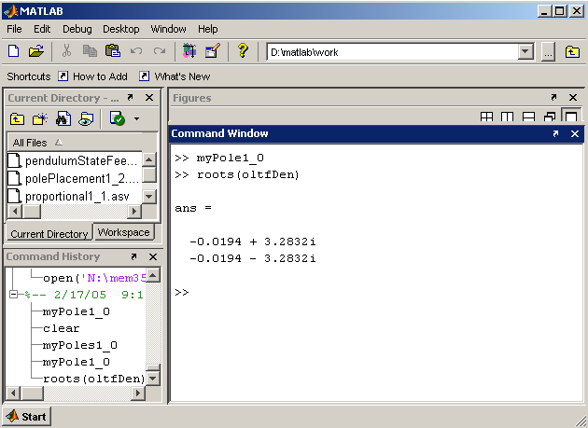
Figure 5: Matlab command window to run files or execute calculations

Step 5: Add the following code to myPole1_0.m and save the file as myPole1_1.m

% Desired pole locations
desiredPole1 = complex(-2.4, 2.4);
desiredPole2 = complex(-2.4, -2.4);
desiredPole = [desiredPole1; desiredPole2];

% Use Matlab's 'place' command to find gains
gainK = place(Fol, Gol, desiredPole);

The Matlab place command calculates the appropriate gains to place poles at desired positions in the Laplace s-domain. Recall that pole placement control uses state feedback to generate the proper command input $u$
Figure 6: Pole placement block diagram

Execute your program myPole1_1 in the Matlab command window. Typing gainK will display the gains needed for pole placement
(4)
and

Concept 3: Simulink Pole Placement

The Matlab place command confirms that (4) meets calculations by hand in Homework 3 Question 6 and places poles in locations given by:

(5)

Homework 3 Question 4 says poles (5) will yield a settling time of $t_{s}=1\text{.}\text{67}\text{sec}$. Simulink will be used to visualize the response.

Step 1: Create the following Simulink block diagram in Figure 7

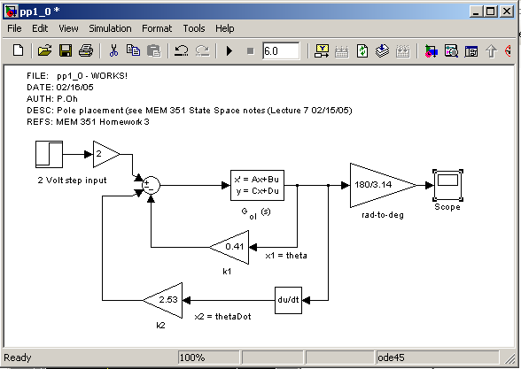
Figure 7: Simulink for pole placement (File: pp1_0.mdl)

Notice that gains given by (4) are used to feedback loop. A derivative block is used for the angular velocity state variable.

Step 2: Configure the state space block element with values (2) and illustrated in Figure 8

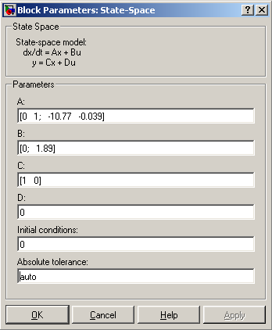
Figure 8: State space parameter values

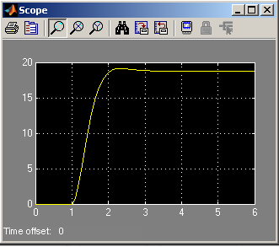
Figure 9: Scope output for pole placement

Step 3: Execute for a 6-second run-time. Figure 9 results when double-clicking the scope.

Exercise 2: In Simulink create programs for the following:

  - Add a scope sink between the summation and state space blocks in Simulink. This scope displays the voltage commands to the pendulum’s motor-propeller. What conclusions can be made?

  - Change the gains to $k_{1}=k_{2}=1\text{.}0$and contrast results with Figure 9. Show that the resulting poles are placed at $s_{1,2}=−0\text{.}\text{944}±j3\text{.}\text{43}$. Hint: create a new program myPole1_2.m by modifying myPole1_1.m with

2-3 Design a pole placement controller such that the settling time is $t_{s}=2\text{.}5\text{sec}$ and the damping ratio is $ζ=0\text{.}\text{95}$. Display both theta output and voltage input

gainK = [1 1];

Fcl = Fol - Gol*gainK;
Gcl = Gol;
Hcl = Hol;
Jcl = Jol;
[cltfNum, cltfDen] = ss2tf(Fcl, Gcl, Hcl, Jcl);

Concept 4: Simulink PID control

Calculating suitable pole locations, while meeting control input limitations (e.g. the motor’s maximum operating voltages), can get tedious. A controller with gains that can be quickly tuned reduces this chore. As such, proportional-integral-derivative (PID) control is a popular technique.

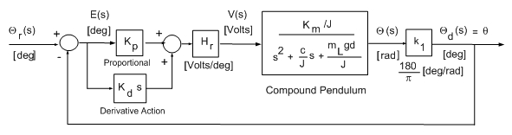
Figure 10: PID block diagram (only P and D action is illustrated).

As Figure 10 illustrates, the voltage command $V(s)$is proportional to the error and the time derivative the error. In other words, for large differences in the desired and measured angles ($Θ_{r}(s)$and $Θ_{d}(s)$respectively), will result in large voltage inputs. The extra block constants $H_{r}$and $k_{1}$are used to get the proper measurement units.

Step 1: Create the following Simulink program as in Figure 11. Use $±\text{10}$for saturation limits
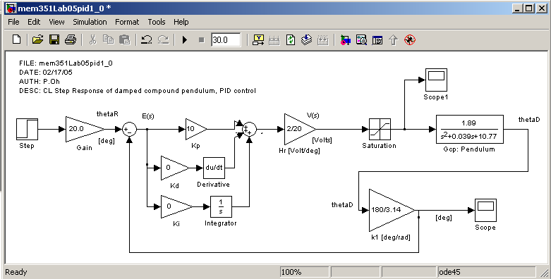
Figure 11: Simulink for PID control. Note: only proportional control is applied (File: mem351Lab05pid1_0.mdl)

Step 2: Double click the scope to show the angular output matches that of Figure 12. This should not come as any surprise. While the error does reach zero, it takes time.

Figure 12: Angle with

Figure 13: Angle with
and

Exercise 3: In Simulink create programs for the following:

  - Try various combinations for $K_{p}$, $K_{i}$and $K_{d}$ to get a response similar to Figure 13. Is this more tedious than pole positioning? What sort of control input voltages are required?

