Homework: Pole Placement and PID Simulation

- In Lab 5, you designed a pole placement controller for the following system
$$\frac{Θ(s)}{V(s)}=\frac{1\text{.}\text{89}}{s^{2}+0\text{.}\text{039}s+\text{10}\text{.}\text{77}}=G_{\text{ol}}(s)$$

Create a pole placement controller in Simulink so that the rise time $t_{s}=3\text{.}0\text{sec}$ with damping$ζ=1\text{.}0$. Submit and/or answer the following:

- Simulink block diagram (use screen capture) (5 points)
- Printout of Matlab code for pole and gain calculations (5 points)
- Screen capture displaying the resulting poles and gains from Matlab code (5 points)
- Scope output hardcopy (angle versus time response) to a 2.0 Volt step input (5 points)

- Given$k_{1}G_{\text{cp}}H_{r}=\frac{\text{10}\text{.}\text{823}}{s^{2}+0\text{.}\text{039}s+\text{10}\text{.}\text{77}}$ where $G_{\text{cp}}$represents the compound pendulum block, the following is a block diagram of PD control:
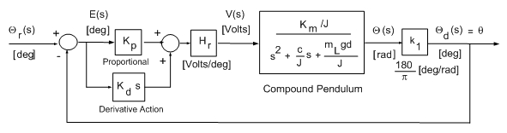

Where recall that:
$$L$$ | Bar length | 0.495 | $$m$$
$$d$$ | Pivot to CG distance | 0.023 | $$m$$
$$m_{L}$$ | Mass of pendulum | 0.43 | $$\text{kg}$$

$$J$$ | Moment of Inertia | 0.0090 | $${\text{kgm}}^{2}$$
$${\text{kgm}}^{2}$$ | Viscous damping | 0.00035 | $${\text{Nms}}/{\text{rad}}$$

A. Show that the closed-loop transfer function is given by (10 points)

$$\frac{Θ_{d}}{Θ_{r}}=\frac{\text{10}\text{.}\text{823}\left(K_{p}+K_{d}s\right)}{s^{2}+\left(0\text{.}\text{039}+\text{10}\text{.}\text{823}K_{d}\right)s+\left(\text{10}\text{.}\text{77}+\text{10}\text{.}\text{823}K_{p}\right)}=G_{\text{cl}}$$

- Look up the Final Value Theorem and state what it is (5 points)
- Use the Final Value Theorem to show $θ_{d}(∞)≈\text{20}$when $K_{p}$is large and a step input $Θ_{r}(s)={\text{20}}/s$ is applied to the system in Question A above (5 points)
- Provide a hard copy printout of the scope output using gains$K_{p}=0\text{.}\text{25}$, $K_{D}=0\text{.}5$ (5 points)
- Provide a set of gains so that the settling time is less than 3.0 seconds and no overshoot. Include a hard copy printout of the scope output at these gains (5 points)

