Hands-on Lab 6

PID Control of a Damped Compound Pendulum

In Lab 1, the stated final course objective was “position regulation using computer-controlled state feedback”. Looking back, one reached today’s lab as follows:
Lab | Title | Lessons Learned
1 | NI-DAQ Basics 1 | Software tools: LabVIEW Basics
2 | NI-DAQ Basics 2 | Hardware tools: Data acquisition, aliasing
3 | System Identification | Sensors: Encoders and 2nd order systems
4 | Simulink Primer | Simulation: Computer tools for controller design
5 | Designing Controllers | Pole placement and PID (tuning for performance)
6 | Real-world control | Implementing design in Real-World system

Lab 6 is the culmination of all this effort and PID control will be applied so that the pendulum swings to the desired position angle with desired overshoot and desired settling time. One will see the tradeoffs between different gain settings and the stability or instability that results.

Concept 1: Open-loop Step Response
Equation of Motion
Recall that the above system has a block diagram given by:

The element $K_{m}$relates voltage into the motor $V$ to torque $T$applied to the pendulum. Given a step input voltage, the pendulum will eventually reach a steady-state angle$θ_{\text{ss}}$. This point is called dynamic equilibrium and dictates that:
(1)

As such, one will create a LabVIEW program to apply a voltage to the motor and display the angle position. When the motor stops oscillating, one can calculate $K_{m}$using equation (1).

Step 1: Create the following LabVIEW panel and block diagram
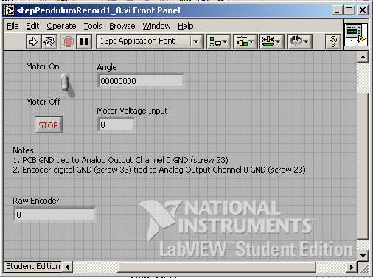

Step 2: The block diagram for the above is given by

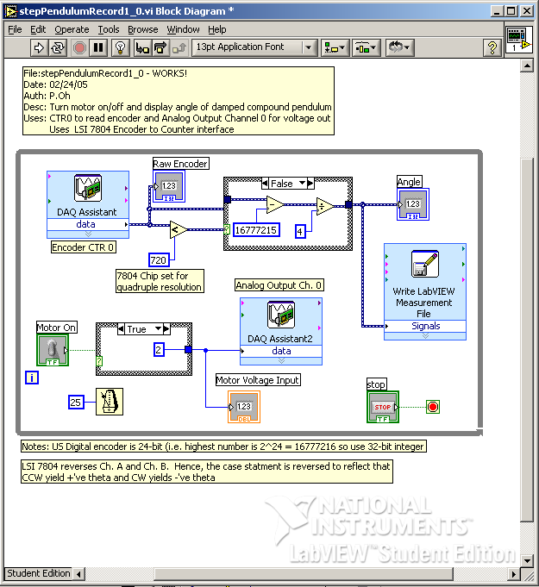

Step 3: Motor, power op-amp and encoder wire up

Turn off Power Supply before making the following connections!

Part 1 | Part 2
Motor +’ve | PCB +Motor pin
Move –‘ve | PCB -Motor pin
Power Supply +12 Volts | PCB PWR pin
Power Supply Ground | PCB GND
Encoder 5-pin Female | PCB 5-pin Male header
PCB U/D pin | LabVIEW pin 30 (Counter 0 Up/Down)
PCB SRC pin | LabVIEW pin 47 (Counter 0 Source)
PCB GND pin | LabVIEW pin 33 (Digital Ground)
PCB +5V pin | LabVIEW pin 34 (+5V)
PCB INP pin | LabVIEW pin 20 (A0)
Power Supply Ground | LabVIEW pin 23 (A0 Ground)

Step 4: Turn on the Power Supply and Execute your VI (stepPendulumRecord1_0)

The motor should turn and eventually stop oscillating about 15 seconds. Record the angle displayed on your VI. Use the acquired data to plot in Excel the following:

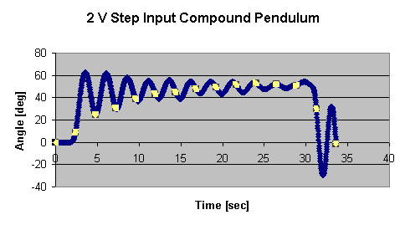

Exercise 1

  - Using Equation (1), calculate the constant$K_{m}$. What is your steady state angle for a 2 Volt step input?

Concept 2: Simulink Simulation

Step 1: Using your constant $K_{m}$create the Simulink block diagram in Figure 1
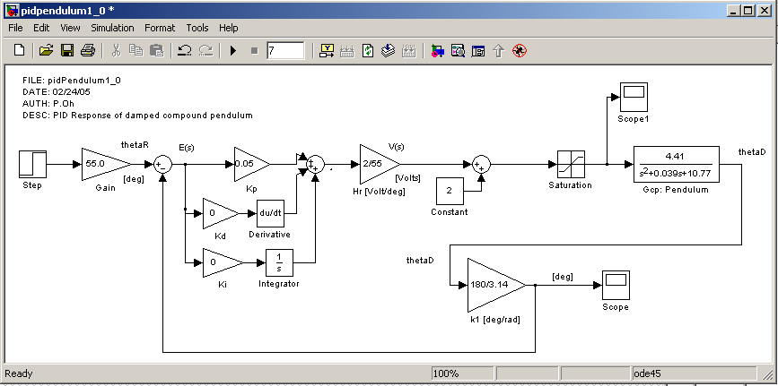
Figure 1: Simulink block diagram for a PID controller. Note: incorporate$K_{m}$into the transfer function. Also, the set-point angle should correspond to the steady-state angle calculated in Exercise 1-1.

Step 2: Run the simulation with the gains$K_{p}=0\text{.}\text{25}$, $K_{I}=0$, $K_{D}=0\text{.}5$to get a response similar to Figure 2
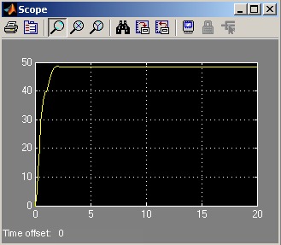
Figure 2: Scope output for PID gains (0.25, 0, 0.5)

Step 3: PID Implementation in LabVIEW. Create the following front panel
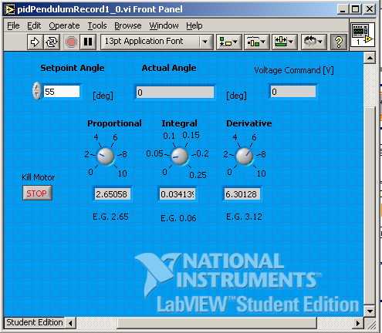
Figure 3: PID front panel (pidPendulumRecord1_0)

Step 4: The associated block diagram is given as

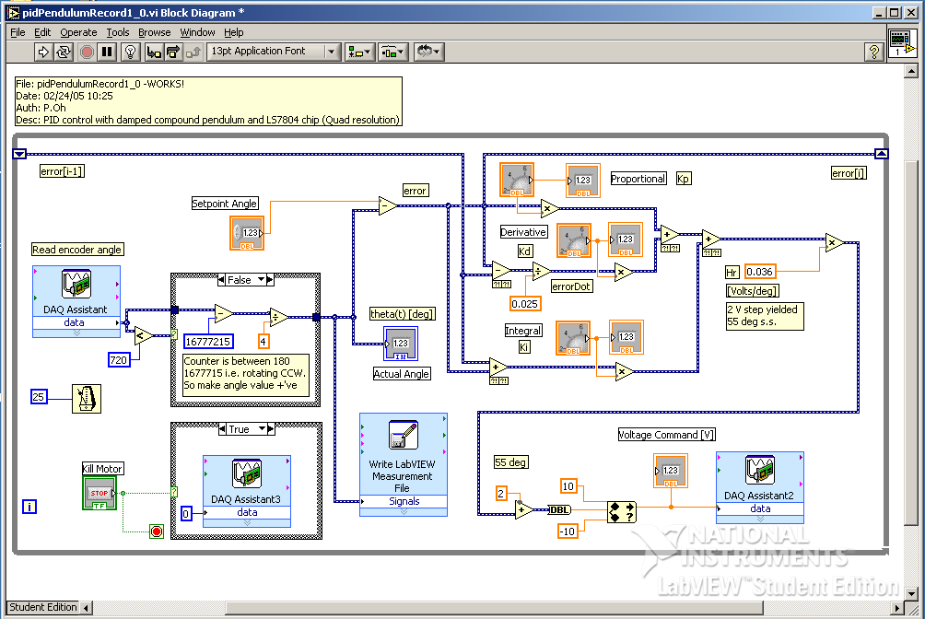
Figure 4: Block diagram for PID controller. Note: “In Range and Coerce” control (All functions – Comparison) is used to limit output voltages between -10 to +10 Volts. The input into this control is type cast to be a double (All functions – Numeric – Conversion – To Double Precision Float)

Step 5: Execute your VI using the gains you used in the Simulink simulation in Step 2 by turning the virtual dials:$K_{p}=0\text{.}\text{25}$, $K_{I}=0$, $K_{D}=0\text{.}5$. Plot out the data acquired. It should look like Figure 5.

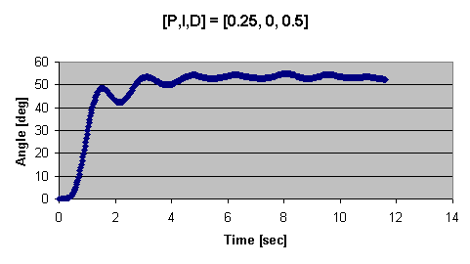
Figure 5: Excel plot with gains set in Step 5. Note how it resembles the Simulink response in Figure 2.

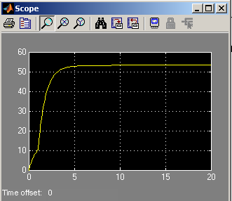
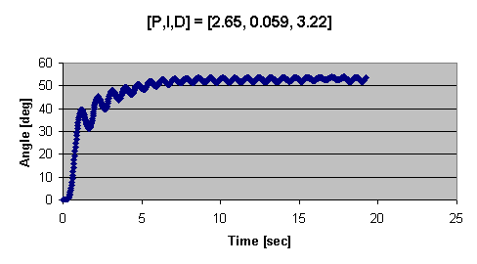
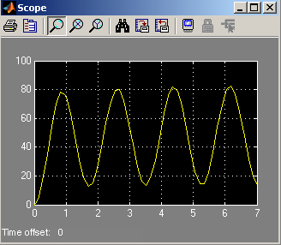
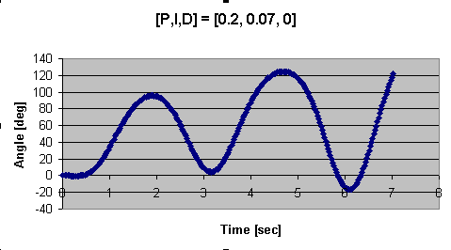
Exercise 2

In Simulink capture the scope figure for gains
In LabVIEW plot the Excel plot for the gains in 2-1

In Simulink capture the scope figure for gains
In LabVIEW plot the Excel plot for the gains in 2-3. Please take care not to damage the pendulum if the system goes unstable.

Sketch a diagram of the experimental setup – this will be needed for your Final Lab Report.

Move the pivot point to a position a few notches away from the pendulum’s center-of-mass. Capture the data with gains
. Compare the plot with the one acquired in Exercise 2-2.

Adjust the VI knobs to get a better steady-state response. Plot the acquired data. What is the rise time, overshoot (if any) and settling angle?

