Hands-on Lab 1:

LabVIEW – NI-DAQ Basics 1

This lab reviews LabVIEW concepts needed towards the course’s final objective of position regulation using computer-controlled state feedback. Specific LabVIEW concepts include: creating a VI (front panel and block diagram), case structures, while loops and shift registers.

Concept 1: Creating your first VI: Front Panels and Block Diagrams (reference: Bishop p. 66)

LabVIEW stands for Laboratory Virtual Instrument Engineering Workbench. In LabVIEW, a virtual instrument has two parts, namely a front panel (the visual front-end) and a block diagram (underlying high-level graphics-based code). One creates the front panel and block diagram by clicking and dragging icons (called controls). The objective in this exercise is to create a simple program that adds displays the sum and product of two numbers.

Step 1: Launch LabVIEW to create the following front panel (Figure 1A below). Right-clicking the mouse will bring up a menu of graphical elements (NI calls them controls). One can then click and drag the desired control into the front panel (gray area).

Figure 1A: Front Panel

Figure 1B: Block Diagram

Step 2: Create the block diagram. The block diagram (Figure 1B above) is invoked by clicking Window – Show Block Diagram from the panel’s menu bar. Again, one right clicks the mouse to bring up a menu of block element functions.

Step 3: Click the play button (arrow icon) on the front panel’s menu bar. Contrast this with clicking the Continuous Play button (arrows in a circle icon) Experiment by clicking on the rocker switches or typing numbers (e.g. integers and reals) in the text box.

Exercise 1: In LabVIEW create programs for the following:

  - Accepts temperatures in Celsius and displays its Fahrenheit equivalent (try pointer slides)
  - Accepts 3 numbers and displays the average
  - Accepts 2 numbers and displays which is the maximum

Concept 2: Case Structures (reference: Bishop p. 204)

Branch statements are those that test a condition (true or false) and execute commands based on those conditions. LabVIEW has several controls for branching. In the block diagram programming, the Case Structure control is invoked under the Executive Control category.

Step 1: Create the following LabVIEW front end – Note that toggle switch by default is FALSE by with a “Switch When Pressed” mechanical action.

Step 2: Create the Block Diagram (True Case: adds the two numbers). Note: clicking the down arrow in the Condition Terminal sets the True condition.

Step 3: Create the False Case condition (False case: subtracts the two numbers)
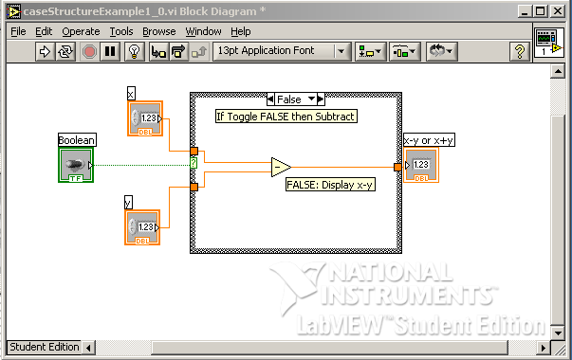

Exercise 2: In LabVIEW create programs for the following:

  - Given an input in inches, the equivalent in centimeters is displayed (by default) and the equivalent in feet is displayed (if the switch is toggled)
  - The maximum or minimum of two numbers is displayed based on toggle position

Concept 3: While Loops (reference: Bishop p. 185)

Loops that repeat until a condition is met are found in every programming language and LabVIEW is no exception. The While-loop repeats commands in its block control while the condition is TRUE. The While-loop control also has an iteration terminal that increases each time the block is executed.

Step 1: This LabVIEW VI counts the number of times the switch is toggled. Create the following front panel. Note: the toggle switch should have its mechanical action set to “Latch when released”.
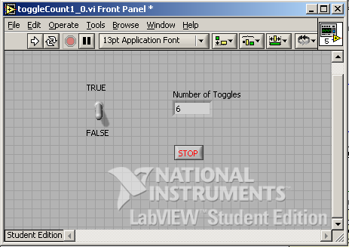

Step 2: Create the following block diagram. A case structure control is inside a while-loop control. When the case is TRUE, a variable (shift register) increases, thereby displaying the number of toggles. The while-loop control stops when the user hits the Stop button.

Step 3: Add the False condition in the conditional terminal. Note that there are no contents (i.e. do nothing) in the case structure
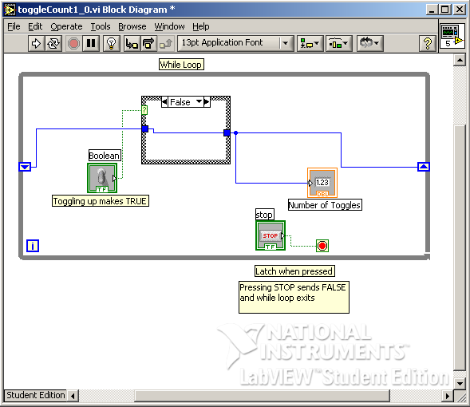

Step 4: Run your program and toggle the switch. Also, try clicking on the Highlight Execution (light bulb icon) button from the Block Diagram menu bar and notice what happens when you execute your program.

Exercise 3: In LabVIEW create programs for the following:

  - The display increases by 2 each time the switch is toggled
  - Increments or decrements depending on the users choice (i.e. using a 2nd toggle switch)
  - Create a for-loop example (Bishop p. 179).

