Closed-Book Quiz 2

- With the graph below, calculate the damping ratio $ς$ and natural frequency $ω_{n}$given that

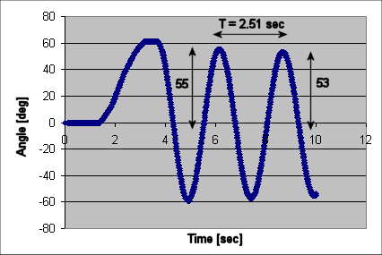
- `Express the following transfer function in state space given $x_{1}=θ$ and $x_{2}=\overset{˙}{θ}$
and
$$\overset{¨}{θ}+\frac{c}{J}\overset{˙}{θ}+\frac{m_{L}\text{gd}}{J}θ=\frac{K_{m}}{J}V$$

- Derive the closed-loop transfer function for the following block diagram. To simplify the math, let $G_{\text{cp}}$denote the block labeled “Compound Pendulum”
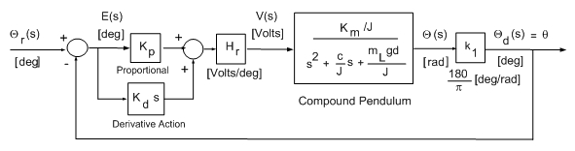

- A PID controller for a 2nd order damped system needs to be tuned. With the current settings, the system overshoots and takes a while to settle. What would you do to reduce the overshoot and why?

- On a different set of gains, the system above displays noticeable steady-state error. What would you do to eliminate it and why?

