Quiz 1

- With the graph below, calculate the damping ratio $ς$ and natural frequency $ω_{n}$given that (5 points)

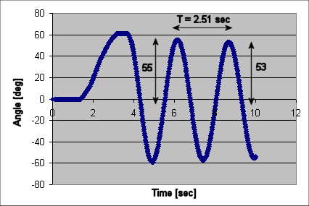
`
and
- Calculate the poles for the following closed-loop transfer function (5 points)
$$\frac{Θ(s)}{V(s)}=\frac{1\text{.}\text{89}}{s^{2}+0\text{.}\text{039}s+\text{10}\text{.}\text{77}}$$

- Given the following block diagram and values, show that the open-loop transfer function is given by (5 points)
$$\frac{Θ(s)}{V(s)}=\frac{1\text{.}\text{89}}{s^{2}+0\text{.}\text{039}s+\text{10}\text{.}\text{77}}=G_{\text{ol}}(s)$$

$$J$$ | = 0.0090 | $$\text{kg}⋅m^{2}$$
$$c$$ | = 0.00035 | $${\text{Nms}}/{\text{rad}}$$
$$m_{L}$$ | = 0.43 | $$\text{kg}$$
$$d$$ | = 0.023 | $$m$$
$$g$$ | = 9.81 | $$m/{s^{2}}$$
$$K_{m}$$ | = 0.017 | $${\text{Nm}}/V$$

- Show that the time constant $T_{c}=0\text{.}\text{01475}\text{sec}$and settling time $t_{s}=\text{271}\text{.}2\text{sec}$for the damped compound pendulum given that $ζ=0\text{.}\text{0059}$and natural frequency$ω_{n}=2\text{.}\text{50}$${\text{rad}}/s$ (5 points)

- Show that the complex poles $s_{1,2}=−2\text{.}4±j2\text{.}4$will yield $ω_{n}=3\text{.}\text{39}$${\text{rad}}/s$and phase angle $θ=0\text{.}\text{785}$$\text{rad}$(5 points)

- Express the following transfer function in state space given $x_{1}=θ$ and $x_{2}=\overset{˙}{θ}$(5 points)
$$\overset{¨}{θ}+\frac{c}{J}\overset{˙}{θ}+\frac{m_{L}\text{gd}}{J}θ=\frac{K_{m}}{J}V$$

7. What is the course objective for MEM 351? (5 points)

