Homework: Modeling and System Identification

Below is a free-body diagram of the damped compound pendulum, dimensions and experimental data plotting the time response from free fall.
$$L$$ | Bar length | 0.495 | $$m$$
$$d$$ | Pivot to CG distance | 0.023 | $$m$$
$$m_{L}$$ | Mass of pendulum | 0.43 | $$\text{kg}$$

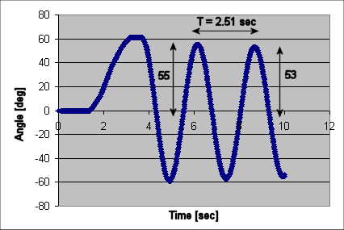

- Prove the moment of inertia $J$about the pivot point is 0.0090 $\text{kg}⋅m^{2}$. Assume a slender rigid bar and use the parallel axis theorem (5 points)

- Use the experimental data above to show that $ζ=0\text{.}\text{0059}$and $ω_{n}=2\text{.}\text{50}$rad/sec. (5 points)

- The equation for the experimental data is given by $\overset{¨}{θ}+2{\text{ςω}}_{n}\overset{˙}{θ}+ω_{n}^{2}θ=0$. Compare this to equation of motion $\overset{¨}{θ}+\frac{c}{J}\overset{˙}{θ}+\frac{m_{L}\text{gd}}{J}θ=0$ to show that $c=0\text{.}\text{00035}$$\frac{N⋅m⋅s}{\text{rad}}$ and $ω_{n}=3\text{.}\text{28}$$\frac{\text{rad}}{s}$ (5 points)

- Include an Excel plot of the data you acquired in Lab (where you used the encoder to capture angle data). Label consecutive peaks and period. Show calculations for $ζ$and $ω_{n}$ (20 points)
$$\overset{¨}{θ}+\frac{c}{J}\overset{˙}{θ}+\frac{m_{L}\text{gd}}{J}θ=\frac{K_{m}}{J}V$$

- Given the following differential equation

Use state variables $x_{1}=θ$ and $x_{2}=\overset{˙}{θ}$ to show that the state space realization is (5 points)
$$\begin{aligned}\left[\begin{matrix}{\overset{˙}{x}}_{1} \\ {\overset{˙}{x}}_{2}\end{matrix}\right]=\left[\begin{matrix}0 & 1 \\ −\frac{m_{L}\text{gd}}{J} & −\frac{c}{J}\end{matrix}\right]\left[\begin{matrix}x_{1} \\ x_{2}\end{matrix}\right]+\left[\begin{matrix}0 \\ {K_{m}}/J\end{matrix}\right]u \\ \vec{y}=\left[\begin{matrix}1 & 0\end{matrix}\right]\left[\begin{matrix}x_{1} \\ x_{2}\end{matrix}\right]+\left[\begin{matrix}0 \\ 0\end{matrix}\right]u\end{aligned}$$

