Pole-Zero Locations

For the damped compound pendulum given below and acquiring angle encoder data, one was able to calculate the damping ratio and natural frequency based on the logarithmic decrement (i.e. ratio of subsequent peaks and time between peaks).

$$L$$ | Bar length | 0.495 | $$m$$
$$d$$ | Pivot to CG distance | 0.023 | $$m$$
$$m_{L}$$ | Mass of pendulum | 0.43 | $$\text{kg}$$

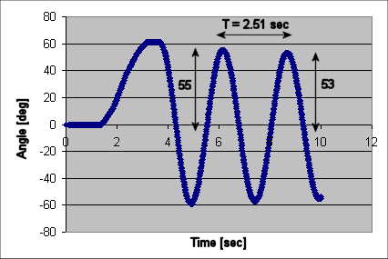
Peak heights and time measurements

Assuming a linear (i.e. small angle approximations) 2nd order differential equation

(1)

One calculated that:

$$ς$$ | Damping ratio | 0.0059
$$ω_{n}$$ | Natural frequency | 2.50 ${\text{rad}}/s$

(2)

Substituting these values into (1) and taking the Laplace equation gives a characteristic equation:

$$s^{2}+2⋅0\text{.}\text{0059}⋅2\text{.}\text{50}s+2\text{.}{\text{50}}^{2}=s^{2}+0\text{.}\text{0295}s+6\text{.}\text{25}=0$$

The roots of the equation are

$$s_{1,2}=\frac{−b±\sqrt{b^{2}−4\text{ac}}}{2a}=\frac{−0\text{.}\text{0295}±\sqrt{0\text{.}{\text{0295}}^{2}−4⋅1⋅6\text{.}\text{25}}}{2}$$

Or
(3)

The roots of the characteristic equation (also called poles) in (3) are complex variables. The poles are related to the damping ratio $ζ$ and natural frequency $ω_{n}$in the following figure

We thus have
rad
(4)

The angle $θ$ is related to the damping ratio (see figure) as:

(5)

Also:
(6)

We see that (5) and (6) correspond to the values given in (2)

Conclusions: Poles characterize the stability of the system. The poles are calculated by taking the Laplace transform of the (homogeneous) differential equation and are the roots of the characteristic equation. The endeavor of control design is to apply compensators to place poles in desired locations in the s-plane. The net effect of this will be a new damping ratio and natural frequency that meets desired overshoot and rise times.

