Homework – Representations, Poles and Zeros

Below is a free-body diagram of the damped compound pendulum, dimensions and experimental data plotting the time response from free fall.
$$L$$ | Bar length | 0.495 | $$m$$
$$d$$ | Pivot to CG distance | 0.023 | $$m$$
$$m_{L}$$ | Mass of pendulum | 0.43 | $$\text{kg}$$

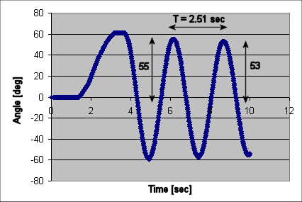

- If $c$is the viscous damping coefficient, show that the equation of motion for the damped compound pendulum sketch above is given the equation below (10 points)
$$\overset{¨}{θ}+\frac{c}{J}\overset{˙}{θ}+\frac{m_{L}\text{gd}}{L}θ=0$$

- Given the following block diagram and values, show that the open-loop transfer function is given by (5 points)
$$\frac{Θ(s)}{V(s)}=\frac{1\text{.}\text{89}}{s^{2}+0\text{.}\text{039}s+\text{10}\text{.}\text{77}}=G_{\text{ol}}(s)$$

$$J$$ | = 0.0090 | $$\text{kg}⋅m^{2}$$
$$c$$ | = 0.00035 | $${\text{Nms}}/{\text{rad}}$$
$$m_{L}$$ | = 0.43 | $$\text{kg}$$
$$d$$ | = 0.023 | $$m$$
$$g$$ | = 9.81 | $$m/{s^{2}}$$
$$K_{m}$$ | = 0.017 | $${\text{Nm}}/V$$

- Show that the time constant $T_{c}=0\text{.}\text{01475}\text{sec}$and settling time $t_{s}=\text{271}\text{.}2\text{sec}$for the damped compound pendulum given that $ζ=0\text{.}\text{0059}$and natural frequency$ω_{n}=2\text{.}\text{50}$${\text{rad}}/s$ (5 points)

- Show that the complex poles $s_{1,2}=−2\text{.}4±j2\text{.}4$will yield $ω_{n}=3\text{.}\text{39}$${\text{rad}}/s$and phase angle $θ=0\text{.}\text{785}$$\text{rad}$(5 points)

